

**System Administrator’s Manual**  
for the Caltrans  
Pavement Management System

**(PaveM)**

*Caltrans Implementation • May 2012*

 

Revision History

|  |  |  |  |
| --- | --- | --- | --- |
| Date | Revision Number | Document Manager | Revision Purpose |
| 03/27/2012 | v0.1 | Eugene Simon | Initial development. |
| 04/25/2012 | v0.2 | Eugene Simon | Updated with Caltrans comments on v0.1 |
| 04/30/2012 | V1.0 | Eugene Simon | Final. |
|  |  |  |  |

Caltrans PaveM: System Administrator’s Manual, May2012

©2012 AgileAssets Inc.

All rights reserved. All text and figures included in this publication are the exclusive property of AgileAssets Inc. for the sole use of its clients and employees. This material may not be copied, reproduced, or used in any way without the express written permission of AgileAssets Inc.

Information in this document is subject to change without notice and does not represent a commitment on the part of AgileAssets Inc.

This document may contain registered trademarks, trademarks and service marks that are owned by their respective companies or organizations. AgileAssets Inc. disclaims any responsibility for specifying which marks are owned by which companies or organizations.

If you have any comments or suggestions regarding this document, please send them to:

AgileAssets Inc.

3144 Bee Caves Road, Austin TX 78746

Phone (512) 327-4200 • Fax (512) 328-7246

www.agileassets.com

Table of Contents

[1. Introduction 5](#_Toc323086176)

[2. Security 5](#_Toc323086177)

[2.1 Configuring an Access Scheme 5](#_Toc323086178)

[2.1.1 Access Level Settings Window 6](#_Toc323086179)

[2.1.2 Columns Window 7](#_Toc323086180)

[2.1.3 Actions Rights Window 9](#_Toc323086181)

[2.2 Configuring Access to the Application 10](#_Toc323086182)

[2.2.1 Access to the Application using Caltrans LDAP eDirectory 10](#_Toc323086183)

[2.2.2 User Accounts 11](#_Toc323086184)

[2.2.3 User Security Roles and Administrative Units Access 11](#_Toc323086185)

[2.2.4 Configuring a User Account 11](#_Toc323086186)

[2.2.5 Configuring a User Account 11](#_Toc323086187)

[2.2.6 Passwords 15](#_Toc323086188)

[2.2.7 Forgotten Password Feature 15](#_Toc323086189)

[3. Basic Configuration 17](#_Toc323086190)

[3.1 Agency Organization 17](#_Toc323086191)

[3.2 System Parameters 18](#_Toc323086192)

[3.3 Configuration Windows for Systems 23](#_Toc323086193)

[3.3.1 Asset Types Setup 23](#_Toc323086194)

[3.4 Linear Reference System Configuration 25](#_Toc323086195)

[3.4.1 Background Information on AgileAssets Linear Referencing 25](#_Toc323086196)

[3.4.2 Location Reference 29](#_Toc323086197)

[3.4.3 Mapping between Base and Alternate LRM’s 34](#_Toc323086198)

[3.4.4 Setup Reference Location Methods Window 34](#_Toc323086199)

[3.4.5 Setup Network Lines 39](#_Toc323086200)

[3.4.6 Concurrent Location 40](#_Toc323086201)

[3.4.7 Network Lanes 40](#_Toc323086202)

[3.4.8 Manage GIS Data Sources 41](#_Toc323086203)

[3.4.9 Manage GIS Layers 43](#_Toc323086204)

[3.4.10 GIS Images 43](#_Toc323086205)

[3.4.11 GIS Coordinate Reference System 44](#_Toc323086206)

[3.4.12 Network Transactions 44](#_Toc323086207)

[3.4.13 Updating Network Geometries 48](#_Toc323086208)

[4. Appearance Customization 53](#_Toc323086209)

[4.1 Windows That Control Appearance 53](#_Toc323086210)

[4.2 Menu Hierarchy 53](#_Toc323086211)

[4.3 Setup Window Titles 54](#_Toc323086212)

[4.4 Setup Popup Window Titles 55](#_Toc323086213)

[4.5 Text Resources descriptions 56](#_Toc323086214)

[4.6 Design Mode 57](#_Toc323086215)

[4.7 User Control Properties Dialog Box 58](#_Toc323086216)

[4.7.1 Description of the User Control Properties Dialog Box 59](#_Toc323086217)

[4.7.2 OnItemChanged Script Information 66](#_Toc323086218)

[5. System Tools 68](#_Toc323086219)

[5.1 System Job Executables 68](#_Toc323086220)

[5.1.1 Description of the System Jobs Executables Window 68](#_Toc323086221)

[5.2 System Job Schedules 69](#_Toc323086222)

[5.2.1 Description of the Systems Jobs Schedules Window 69](#_Toc323086223)

[5.2.2 Example of Scheduling a System Job 71](#_Toc323086224)

[5.3 Notifications 72](#_Toc323086225)

[5.4 Notification Types 74](#_Toc323086226)

[5.5 System Logs 75](#_Toc323086227)

[5.6 Groovy Scripts 76](#_Toc323086228)

[5.6.1 Groovy Scripts Window 77](#_Toc323086229)

[5.6.2 The Groovy Script Dialog Box 78](#_Toc323086230)

[5.6.3 Groovy Script Types and Parameters 78](#_Toc323086231)

[6. Database Management 81](#_Toc323086232)

[6.1 Columns 81](#_Toc323086233)

[6.2 Tables 84](#_Toc323086234)

[6.2.1 Description of the Tables Window 85](#_Toc323086235)

[6.2.2 How to Create a Table with Location Data 89](#_Toc323086236)

[6.2.3 How to Make a Data or List Window 91](#_Toc323086237)

[6.2.4 How to Make a Popup Window 93](#_Toc323086238)

[6.2.5 How to Make a Graph Window 95](#_Toc323086239)

[6.2.6 How to Create a List Table 95](#_Toc323086240)

[6.2.7 How to Create an Inventory Table 96](#_Toc323086241)

[6.2.8 How to Create a Generic Table 100](#_Toc323086242)

[6.2.9 How to Add a New Column to a Table 101](#_Toc323086243)

[6.2.10 How to Add an Existing Column to a Table 102](#_Toc323086244)

[6.2.11 How to Create an Index for the Table 102](#_Toc323086245)

[6.2.12 How to Modify Column Definitions 103](#_Toc323086246)

[6.2.13 How to Change the Order of Columns 103](#_Toc323086247)

[6.2.14 How to Modify Update Source for Calculated Columns 104](#_Toc323086248)

[6.2.15 How to Update When Source Data Changes 104](#_Toc323086249)

[6.3 Create the Import Procedure 105](#_Toc323086250)

[6.3.1 Test the import in Import Log 112](#_Toc323086251)

[6.4 Views 113](#_Toc323086252)

[6.4.1 How to Create a View 114](#_Toc323086253)

[6.4.2 How to Make a View Window 114](#_Toc323086254)

[6.4.3 Configuring Views for Generating Reports 115](#_Toc323086255)

This page left intentionally blank.

# Introduction

This document describes how to utilize the various windows of the System module that may be useful to a Caltrans PaveM Application Administrator in the performance of his or her tasks. The PaveM Application Administrator group will be drawn from the Office of Pavement Management (OPM), to provide technical support for the Caltrans Pavement Management System (PaveM) application. For more information about any PaveM system window, please consult the online Help that accompanies the application (or the PaveM User Manual).

# Security

The system provides two levels of access to users: access to the application and access to particular windows, columns, and commands within the application. Access to the application (that is, a user account) is configured **after** the access scheme is configured. This is necessary because a user is assigned an access scheme (“**security role**”) when his or her user account is established.

This section describes how to configure these two types of access.

## Configuring an Access Scheme

An access scheme, or access profile, determines what a user may see and do within the application. It determines what modules are available to the user, what windows within the module are displayed, and what columns within the window are displayed (and whether the data in the columns may be edited). It also determines what commands are available to the user in the shortcut menus displayed by right-clicking. (Commands may optionally be configured to require a password for execution.)

Three windows are used to create an access scheme:

* Access Level Settings window.
* Columns window.
* Actions Rights window.

### Access Level Settings Window

(System Module > Utilities > Access Level Settings)  
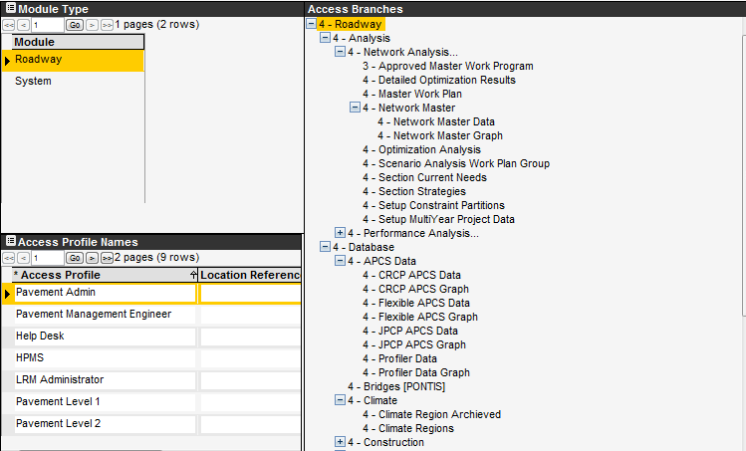

The Access Level Settings window is the primary location for establishing an access scheme. For the module selected in the Module pane and the access profile selected in the Access profile pane, the Module Menu hierarchy shows the access permission assigned to each menu item. (The access permission appears as a number to the left of the name of the menu item.)

In this window, each module has its own group of access profiles (which is the “security role” that is assigned to a user). For the selected module and access profile, the right pane shows the menu hierarchy of the module along with a number that denotes what the user assigned the access profile is allowed to see and do. The access levels range from 0 (most restrictive) to 7 (most permissive) as shown below:

* (0) Invisible – The user cannot see the menu item.
* (1) Disabled – The user can see the menu name, but cannot open the window.
* (2) Read Only – The user can see the window content, but cannot modify it.
* (3) Read/Write – The user can read and write data.
* (4) Accept/Confirm – The user can read and write data and has approval capability.
* (5) - (7) "Super Users" – The user has all the rights to edit data and grant approvals plus the additional rights defined in the Actions Rights and Columns windows.

An access level is assigned by selecting the module (top left pane) and access profile (lower left pane). Then locate the desired menu item for which access is to be set in the right pane, right-click on it and click Set Access Value. This displays a dialog box from which you select the desired access level for the menu item which you right-clicked.

### Columns Window

(System Module > Utilities > Columns)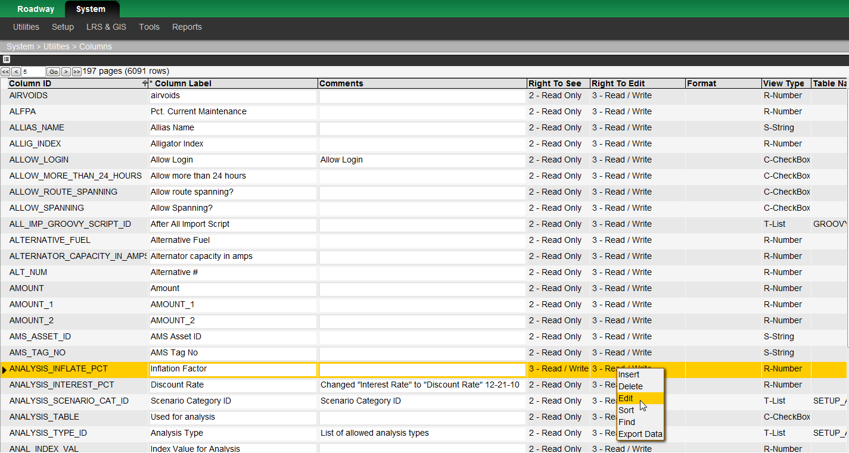

The Access Level Settings window discussed in the previous section essentially determines which windows are accessible to a user with a particular access profile (“security role”). The Columns window carries this further by determining which columns within a window are accessible to a user. An example of the Columns window is shown on the next page.

Each column has two access level values — one for “right to see” (that is, whether the column is visible) and one for “right to edit” (that is, whether a user may modify the data in the column). The values for access levels range from 0 (most restrictive) to 7 (least restrictive) just like the values for window access levels (see the previous section).

For most columns in the system, the “right to see” value is equal to the “right to edit” value because most users that can see a column within a window would also have the right to edit the data in the column. However, some columns may require higher values for both these attributes if the data is of a personal or sensitive nature (such as employee pay rates). In addition, some columns may be restricted with higher required access levels for editing than for viewing if the data is critical and should only be changed by authorized personnel.

Note: The “**right to see**” value should **never** be set **higher** than the “**right to edit**” value.

The access level set for a column is affected by the access level assigned to the window in which the column appears. The following table shows how the access level setting for a window interacts with the access level setting for a column to determine what a user with a certain access profile can do:

| Access Level Setting for the Window | Column's "Right to See" Setting | Column's "Right to Edit" Setting | The Effect on Access |
| --- | --- | --- | --- |
| 0 – 1 | 0 – 7 | 0 – 7 | Since the user cannot access the window, the user cannot see or edit the column. |
| 2 | 0 – 2 | 0 – 7 | The user can see the column, but cannot edit the column (since the user cannot edit anything in the window). |
| 2 | 3 – 7 | 0 – 7 | The user cannot see (nor edit) the column. |
| 3 | 0 – 3 | 0 – 3 | The user can see and edit the column. |
| 3 | 0 – 3 | 4 – 7 | The user can see the column, but cannot edit the column. |
| 3 | 4 – 7 | 0 – 7 | The user cannot see (nor edit) the column. |
| 6 | 0 – 6 | 0 – 6 | The user can see and edit the column. |
| 6 | 0 – 6 | 7 | The user can see the column, but cannot edit the column. |
| 6 | 7 | 0 – 7 | The user cannot see (nor edit) the column. |

To set the default access level for a column, follow these steps:

1. Display the Columns window (System > Utilities > Columns).
2. Locate the name of the column in the table.
3. Right-click the record showing the column and then click Edit. The application displays a dialog box for setting attributes of the column.
4. Use the Right to See and Right to Edit fields to enter the appropriate access levels for the column.

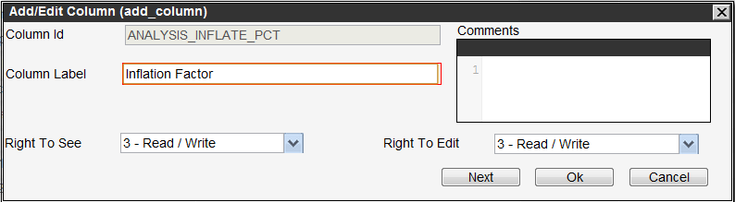

1. Click OK to close the dialog box.
2. Click the icon_save icon.

### Actions Rights Window

(System Module > Utilities > Actions Rights)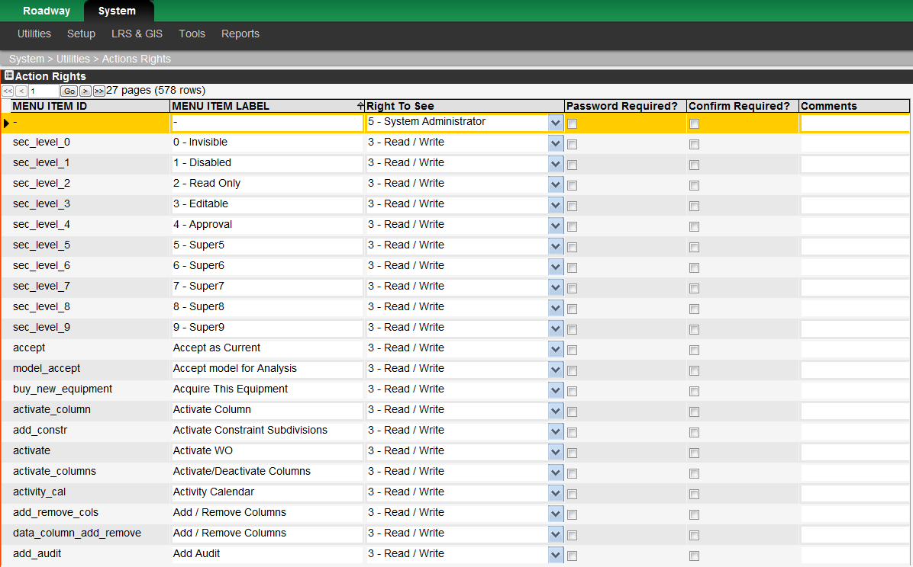

The previous two sections describe how an access profile determines the windows and columns that are available to a user. The final dimension of the access scheme is the commands that are found in a shortcut menu that is displayed by right-clicking a record or pane.

The ability of a user to execute a right-click command is determined by the “right to see” (more accurately, “right to execute”) access level configured in the Actions Rights window. An example of this window is shown below. As with columns, the access level for the window is compared to the access level for a right-click command to determine if the right-click command is enabled for a user. In addition, the application checks whether the user’s password is required to execute the command.

The following table shows the results of the interaction between the access level setting for the window and the access level setting for the right-click command.

| The Access Level Setting for the Window | Right-click Command's "Right to See" Setting | The Effect on Access |
| --- | --- | --- |
| 0 – 1 | 0 – 7 | Since the user cannot access the window, the user cannot use the command. |
| 2 | 0 – 2 | The user can use the command, but cannot edit data in the window. This may cause difficulties when the command requires subsequent editing in the window. |
| 2 | 3 – 7 | The user cannot use the command. |
| 3 | 0 – 3 | The user can use the command. |
| 3 | 4 – 7 | The user cannot use the command. |
| 6 | 0 – 6 | The user can use the command. |
| 6 | 7 | The user cannot use the command. |

To set the default access level for a right-click command, follow these steps:

1. Display the Actions Rights window (System > Utilities > Actions Rights).
2. Locate the name of the right-click command in the table.
3. In the Right to See column of the command’s record, click the down arrow to display the list of access level settings and then click the desired access level setting.
4. Click the icon_save icon.

## Configuring Access to the Application

A user needs three pieces of information to access the application:

* A User ID.
* A password.
* An administrative unit.
* A security profile

Note that if a user is assigned to only one administrative unit, then the application will not prompt for the user to select a unit when he or she logs on.

In addition, a user must be assigned an access profile (“security role”) to determine what windows, columns, and right-click commands he or she will be allowed to utilize. Furthermore, outside of the access scheme, certain users may be granted privileges (Is Admin? column) to alter the layout of the windows.

### Access to the Application using Caltrans LDAP eDirectory

Regular access to the PaveM system will be via the system’s login screen however the users are authenticated using Caltrans LDAP identity stores before advancing further. If the authentication is successful a screen opens where users can select the administrative unit they would like to log into (if you have access to more than one) and the security profile you will be using (if you have more than one). Note if you only have access one administrative unit and one security role the system will skip this step.

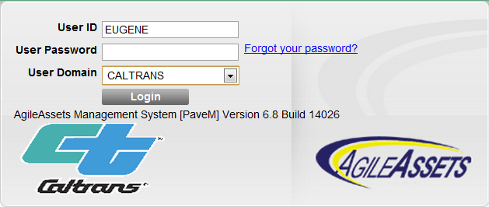

### User Accounts

User accounts (S-Numbers) will be set up manually in the PaveM system. S-Numbers must be used in order to authenticate against the Caltrans identity stores. For non-Caltrans users P-Numbers will be used in the Caltrans identity stores and should also be used in the PaveM system for these users.

### User Security Roles and Administrative Units Access

For each user account created one or more security role(s) and one or more administrative unit(s) must be assigned for the user to have access to the PaveM system. This security role(s) and administrative unit(s) assignment is done in the User Names and Access window (System > Utilities > User Names and Access).

### Configuring a User Account

A user account is configured in the User Names and Access window. An example of this window is shown below.

**User names will have to be created using s-numbers for all users before they can access the system. If there is a situation where the LDAP is not functional for an extensive period of time the LDAP user authentication can be turned off in the application.**

### Configuring a User Account

(System Module > Utilities > User Names and Access)

A user account is configured in the User Names and Access window. An example of this window is shown below.

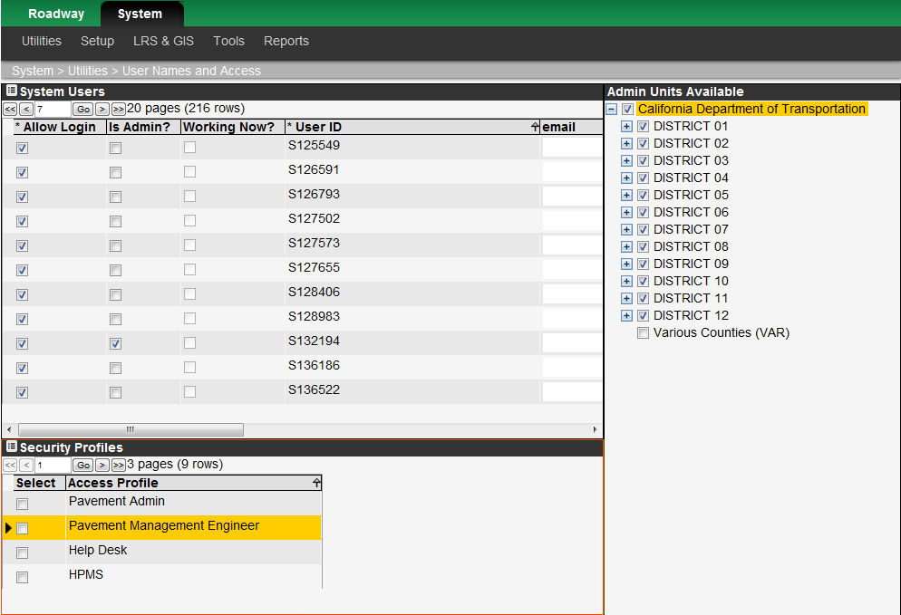

A user account is configured in the User Names and Access window. In the System Users pane, users may be added or deleted, and some of their attributes may be edited. Columns that may be edited are: access profile, the user's administrative unit (although this column has no bearing on what the user may select when logging on; instead the application uses what is configured in the Admin Units Available pane), his or her email address, and whether the user is allowed to log on (that is, whether the user name is "active"). When a new user is inserted, the user's password is also entered as an additional piece of information that is not viewable in the pane.

A check mark in the Allow Login check box indicates that the user is allowed to log on. If a user enters an incorrect password the number of consecutive times set in the System Parameters window, the system disables that user's access and clears the Allow Login check box. The Application Administrator can restore the user's access by clicking the check box and saving the change. The check box may also be used to suspend a user's access privileges.

A check mark in the Is Admin? check box indicates that the user has design privileges. This means that the user is allowed to adjust a window's properties (column widths, sizes and position of panes, labels, titles, etc.). See the Design Mode section below for more information.

A check mark in the Must change password? column indicates that the user will be forced to change their password the next time he or she logs on to the application.

A check mark in the Working Now? column indicates that the user is logged on to the application.

You may use two methods to add a user to the application. One method is to create a new record that is largely a copy of an existing record, and then modify the record. The second method is to simply create a new, blank record and complete the record as needed. These two methods are described in the following paragraphs.

To add a new user by copying an existing user’s record, follow these steps:

1. In the upper left System Users pane of the User Names and Access window, point to an existing user whose settings will serve as the basis for the new user, right-click, and then click Insert Like. A new window will be displayed. 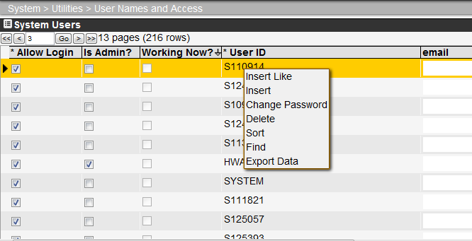
2. Enter the new user's name and then click the OK button. 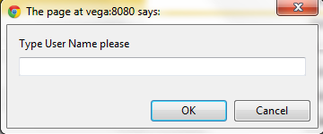

A message window will notify you that the default user password is set to the user's name and that the user should change the password when he or she first logs on. (The user changes his or her password using the Change Password window in the Utilities Menu available in all modules except the System module.)

1. Click OK to close the message window. The system closes the window and adds a record to the User pane.
2. If you know the user's email address, click in the Email column and type the address.
3. In the Security Profiles pane (lower left pane), click in the Select column (so a check mark appears) for each desired access profile, to select and add the access profile(s) to be assigned to the user.
4. In the Admin Units Available pane (right pane), select the administrative unit(s) to which the new user is assigned and which he or she may select when logging on. To accomplish this, point to the desired managerial unit, right-click, and then click Select This. Note that a Select Branches command is also available so you may assign the user all the sub-administrative units beneath an administrative unit header. A Select All command is also available if you wish to assign the user to all managerial units. (If you want to change a user's assignment, "de-select" versions of all these commands are also available.)
5. Note: This step is very important. If you do not assign an administrative unit to the new user, he or she cannot use the system because the user cannot select an administrative unit when logging on. Since it is possible to save the new user and close the window without assigning an administrative unit, and since the system will not warn you of this condition, double-check that these assignments are made before closing the window.
6. Also note that selecting an administrative unit in the Administrative Unit column of the User pane is not the same as selecting an administrative unit in the Admin Units Available pane. The column in the User pane is for informational purposes only and is not used by the system.
7. Once all information is assigned and recorded, clickicon_save. The new user may now access the system.

To add a new user by creating a new, blank record, follow these steps:

1. In the upper left System Users pane of the Users Name and Access window, right-click, and then click Insert. A new window will be displayed.
2. Enter the new user's name and then click the OK button. 

A message window will notify you that the default user password is set to the user's name and that the user should change the password when he or she first logs on. (The user changes his or her password using the Change Password window in the Utilities Menu available in all modules except the System module.)

1. Click OK to close the message window. The system closes the window and adds a record to the User pane.
2. If you know the person's email address, click in the Email column and type the address.
3. In the Security Profiles pane (lower left pane), click in the Select column (so a check mark appears) for each desired access profile, to select and add the access profile(s) to be assigned to the user.
4. In the Admin Units Available pane, select the administrative unit(s) to which the new user is assigned and which he or she may select when logging on. To accomplish this, point to the desired administrative unit, right-click, and then click Select This. Note that a Select Branches command is also available so you may assign the user all the sub-administrative units beneath a managerial unit header. A Select All command is also available if you wish to assign the user to all administrative units. (If you want to change a user's assignment, "de-select" versions of all these commands are also available.)

Note: This step is very important. If you do not assign an administrative unit to the new user, he or she cannot use the system because the user cannot select a managerial unit when logging on. Since it is possible to save the new user and close the window without assigning an administrative unit, and since the system will not warn you of this condition, double-check that these assignments are made before closing the window.

Also note that selecting an administrative unit in the Administrative Unit column of the User pane is not the same as selecting an administrative unit in the Admin Units Available pane. The column in the User pane is for informational purposes only and is not used by the system.

1. Once all information is assigned and recorded, clickicon_save. The new user may now access the system.

** User accounts will be created and maintain by the system administrator, however user authentication will be via the Caltrans LDAP eDirectory therefore the following sections are not applicable during periods of normal operations.**

### Passwords

When a new user account is created, the new password defaults to his or her User ID. After this initial log-on, the user may change his or her password at any time by utilizing the Change Password menu item found in the Utilities menu of all modules. The user will also need to change his or her password after the amount of time since the last change elapses as set by the Life of Password parameter in the System Parameters window. The system will prompt the user in this case.

If the user forgets his or her password, the Application Administrator may utilize the Change Password command found in the User Names and Access window. This command is found on the shortcut menu that is displayed by right-clicking the user’s record. Alternatively, a user may obtain a new password via email if the Forgotten Password feature is implemented. This feature is described in the next section.

Note: Passwords are case-sensitive.

### Forgotten Password Feature

**(Not relevant to PaveM)**. Some clients elect to use the optional Forgotten Password feature. With this feature, when a user first logs on he or she selects and answers security questions. The user can then click a hyperlink on the log-in screen to access the security questions. Provided he or she correctly answers all security questions, a new password will be sent to the user’s email address configured in the User Names and Access window.



# Basic Configuration

This section describes the basic elements that need to be configured for system operation.

## Agency Organization

One of the most fundamental data elements for the application is the administrative units into which the agency is divided. These administrative units are needed for creating user accounts as well as for creating work orders.

**Note**: The terms “Administrative Unit” will refer Headquarters, Districts and Counties in this document.

Administrative units, and the hierarchy into which they are arranged, are configured in the Setup Administrative Units window. An example of this window is shown below.

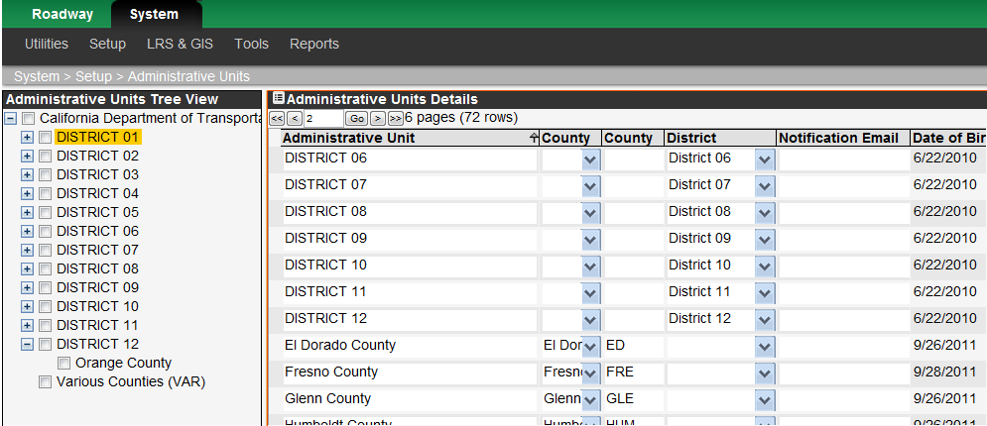

An administrative unit is added to the application by following these steps:

1. Display the Setup Administrative Units window (System > Setup > Administrative Units).

2. In the left pane, locate the name of the Administrative unit under which the new unit will be placed. If necessary, expand the hierarchy by clicking on the plus sign (+).

3. Right-click the name you located in step 2 and then click Add Branch from the shortcut menu. The application responds by adding a new node to the hierarchy as well as a new record to the table in the right pane.

4. In the right pane, click in Administrative Unit column and type the name of the administrative unit that you are adding.

5. If desired, add information to the remaining columns with white backgrounds of the new record.

6. Click the Icon_Save icon to save the new record.

## System Parameters

System parameters establish the basic “operating rules” for the application. They are configured in the System Parameters window (System > Utilities > System Parameters). An example of this window is shown below.

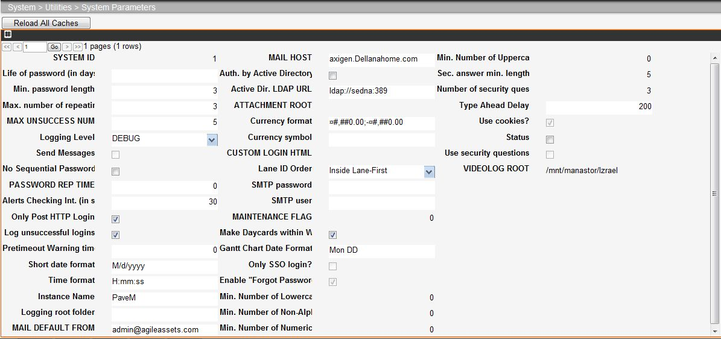

**Note**: The Reload All Caches button at the top of the System Parameters window can be clicked to refresh the system cache on the PaveM application server. This action is required after loading certain system level data to the application.

The following table describes the various system parameters managed in this window. Note: Setting a parameter's value to zero or leaving the field blank means that no constraint is applied. For example, setting Life of Password to 0 (zero) means that a user's password never expires.

| Parameter Title | Parameter Description |
| --- | --- |
| # of Previous Passwords Remembered by the System | The number of previously used passwords the system will record. A user is not allowed to re-use any password "remembered" by the system. For example, if this parameter is set to 3, a user will need to change his or her password three times before the same password can be used again. If this is set to zero, the user may re-use a password for as long as desired provided all other password rules are met. |
| Active Dir. LDAP URL | This field contains the server address where the agency’s Active Directory is stored (if in use). |
| Alerts Checking Int. (in sec) | The value in this field determines how often (in seconds) the system checks for new alerts and messages. |
| Allowed Characters for Password | The set of characters allowed in passwords and user names. The characters are not case-sensitive. Note that the underline character (\_) is always allowed for user names regardless of what is specified for the character set. Consequently, the initially and automatically defined password, which is equivalent to the user name, also allows the underline character. To easily view and edit the character set, double-click the field. |
| Auth. by Active Directory? | When this check box is selected, the password stored in the Active Directory is used for authentication rather than the password stored in the AgileAssets application.  Note: A third field is also added to the log-on window for entry of the domain. The application administrator will need to provide this information to a user to allow her or him to log on. |
| Currency Format | This field sets how monetary values are formatted in column displays. To apply the format to a column, in the Columns window put [Currency] in the Format column for the column that is a monetary value. |
| Custom Login HTML | This field configures any custom text or links to be displayed on the FMS login page. The desired text / links etc can be entered here in HTML format and will be displayed on the main login screen below the User Name / Password box. |
| Date Format | This field sets how dates are displayed. These functions use the same 'format' strings as the java.text.SimpleDateFormat class as shown in the following table:   |  |  |  | | --- | --- | --- | | Value | Format (Full) | Format (Short) | | Year | yyyy (4 digits) | yy (2 digits)  y (2 or 4 digits) | | Month | MMM (name or abbr.)  NNN (abbr.) | MM (2 digits)  M (1 or 2 digits) | | Day of Month | dd (2 digits) | d (1 or 2 digits) | | Day of Week | EE (name) | E (abbr.) |   For example, a typical coding for an American-style date (say, 10/22/2008) would be MM/dd/yyyy and for a sort able date (say, 2008-10-22) it would be yyyy-MM-dd. |
| Instance Name | This field configures the PaveM instance name displayed at the top of the application and on the login page. Ex. ‘Development’, ‘System Test’, ‘Training’, ‘Production’ etc. Note: The system cache and module must be refreshed before any changes take effect. |
| Life of Password (in days) | The number of days that a password can be active. Once expired, on the next user logon, the user will be required to change his or her password. |
| Log Unsuccessful Logins | When this check box is selected, the system tracks and stores information on unsuccessful attempts to log in. This information may be viewed by displaying the standard report for unsuccessful log-in attempts. |
| Logging Level | You may configure logs to be kept each day to monitor system activity. These logs are stored in the location specified by the Logging Root Folder parameter and are accessed via the System Logs window. The following types of logging may be configured by selecting the appropriate type from the drop-down list:  Error – This type logs only that an error occurred.  Debug – This type logs that an error occurred as well as where (in the Java code) that the error occurred.  Performance – This type is the same as Debug but with additional timing statistics.  None – Logs are not generated. |
| Logging Root Folder | All logging files are stored in a folder called Logs. This field specifies where that folder is stored relative to the application root directory. (If the field is blank, the logs are stored in the application root directory under the Logs folder.) |
| Mail Default From | This field configures the server address through which email is routed. |
| Mail Host | This field configures the domain name of the email host used by the agency. |
| Max Idle Session | When the user does not interact with the system for the length of time (in minutes) given in this field, the system will automatically log off the user. |
| Max Unsuccessful Logins Num | The value in this field specifies the number of attempts a user may make to log on before he or she is locked out of the system. When the value in this field is exceeded, the user will need to contact the Application Administrator to unlock his or her account. Currently this is set to ‘5’. |
| Max. Number of Repeating Characters | The maximum number of characters that may repeat consecutively in a password. For example, if this parameter was set to three, a password like AAAA01 would not be allowed (although AAA001 and AA01AA would be allowed). |
| Min. Number of Lowercase Characters | The value in this field indicates the minimum number of lowercase characters that must be in a password. |
| Min. Number of Non-alphanumeric Characters | The value in this field indicates the minimum number of non-alphanumeric characters that must be in a password. |
| Min. Number of Numeric Characters | The value in this field indicates the minimum number of numeric characters that must be in a password. |
| Min. Number of Uppercase Characters | The value in this field indicates the minimum number of uppercase characters that must be in a password. |
| Min. Password Length | The minimum number of characters for a password and user name. |
| Number of Security Questions | When the Forgotten Password feature is enabled, this field sets the number of security questions that the user must configure. |
| Password Rep Time | The value in this field is the amount of time (in days) in which a password cannot be repeated. |
| Prevent Sequential Passwords | If this check box is selected, sequential passwords are not allowed. For example, if a user's current password is USER01, with this check box selected the system would not allow the user to change the password to USER02. |
| Right to Left | When this check box is selected, text in name fields will be positioned so as to read from right to left. When it is clear, text will read from left to right (Not applicable for Caltrans PaveM). |
| Table Import Root | This field is for importing and shows the root of the network share. |
| Time Format | This field sets how time is displayed. These functions use the same 'format' strings as the java.text.SimpleDateFormat class as shown in the following table:   |  |  |  | | --- | --- | --- | | Value | Format (Full) | Format (Short) | | Hour (0 - 11) | KK (2 digits) | K (1 or 2 digits) | | Hour (12 -24) | hh (2 digits) | h (1 or 2 digits) | | Hour (0 - 23) | HH (2 digits) | H (1 or 2 digits) | | Hour (1 - 24) | kk (2 digits) | k (1 or 2 digits) | | Minute | mm (2 digits) | m (1 or 2 digits) | | Second | ss (2 digits) | s (1 or 2 digits) | | AM/PM | a |  | |
| Use Cookies? | When this check box is selected, a User\_ID cookie is saved on the browser. |
| Use Security Questions | This check box is displayed in some applications. When selected, the Forgotten Password feature is enabled. |

## Configuration Windows for Systems

The following sections describe few main windows that are used for high level setups for systems.

### Asset Types Setup

The PaveM application is also an asset management system. To be able to effectively manage your agency’s assets, they must be divided and categorized in a way that facilitates a clear understanding of each asset and how they relate to each other. Furthermore, since only certain work activities may be performed on a particular asset, it makes sense to limit the activities that are associated with an asset. The application provides the following windows for dividing and classifying assets:

1. Setup Asset Type.

Essentially, these windows may be divided into two groups: the one concerned with maintaining the collection of assets for which your agency is responsible and the others that are concerned with maintaining the activities that are performed for a particular asset type. The following sections describe these two groups in more detail. But first we will discuss why having different types of assets is a sound idea.

#### Asset Type Window

An asset is simply anything of value for which your agency is responsible. While every item for which your agency is responsible could be an asset on its own, it sometimes makes more sense to configure what are termed “child assets.” These are simply assets that are associated with other assets and are accessed via a hyperlink column configured in the parent asset window.

Each asset belongs to a category of assets termed “asset type.” The Setup Asset Type window (System > Setup > Asset Type) documents the asset types for which your agency is responsible and how each asset type relates to other asset types. An example of this window is shown below.

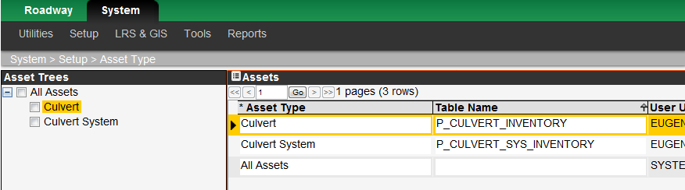

Asset types are added to this window by utilizing the Add Branch command found by right-clicking the node in the hierarchy under which the new asset type will be placed.

#### Asset Assignment to Module

Once asset types are created, they are then assigned to a particular module in the Modules window (System Module > Setup > Module). An example of this window is shown below.

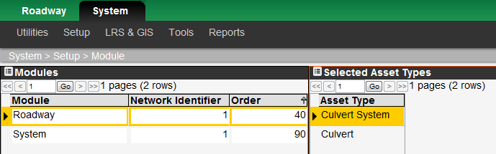

To associate an asset type with a module, select the desired module in the left Modules pane. Then, in the right Select Asset Types pane, right-click and then click Edit Selection in the shortcut menu. This command displays a dialog box that shows all available asset types and their arrangement. Select an asset type by clicking the square next to the name of the asset type. The application colors the square yellow to denote that it is selected. Alternately, you may right-click and use one of the selection commands to select multiple asset types. When all asset types are selected, click OK to close the dialog box and display the selected asset types in the Setup Module window.

## Linear Reference System Configuration

This section discusses the concepts, tables, and windows used for configuring and managing your linear reference system (LRS).

### Background Information on AgileAssets Linear Referencing

This section describes the major location referencing tables within the AgileAssets system.

#### The SETUP\_NETWORK\_LINES Table

The SETUP\_NETWORK\_LINES table lists each unique route within the system along with its initial and final measure value. The primary key of the table is a unique integer linked to the sequence S\_SETUP\_NETWORK\_LINES. The name of each route, contained in the ROUTE\_NAME field must also be unique.

|  |  |  |  |  |
| --- | --- | --- | --- | --- |
| Column Name | Pk | Null? | Data Type | Comment |
| ROUTE\_ID | Y | N | INTEGER | Unique identifier for each route |
| NETWORK\_ID |  | N | INTEGER | Allows multiple networks to be defined (not used) |
| OFFSET\_FROM |  | Y | NUMBER (22,4) | Begin measure of the route |
| OFFSET\_TO |  | Y | NUMBER (22,4) | End measure of the route |
| ROUTE\_NAME |  | N | VARCHAR2 (100 Char) | Unique name of the route |
| IS\_INACTIVE |  | Y | NUMBER (1) | Equals 1 if the route is no longer active in the network |
| GEOM |  | Y | SDO\_GEOMETRY | Geometry of the route for spatial (GIS) representation |

#### The SETUP\_LOC\_IDENT Table

The SETUP\_LOC\_IDENT table contains a record of all the location referenced events within the Agile system. Each event is referenced by a unique identifier LOC\_IDENT that also serves at the primary key for the table. It is important to note that this table stores the location information for each event only. The attribute data for the event is always stored in another table that references the event LOC\_IDENT. To facilitate the location of the associated event table the column SOURSE\_TABLE is used to identify the attribute table name.

*In all the other tables within this document the actual linear reference of a given event is stored in this table. The related key is always the LOC\_IDENT column.*

| Column Name | Pk | Null? | Data Type | Comment |
| --- | --- | --- | --- | --- |
| LOC\_IDENT | Y | N | INTEGER | Unique Event Identifier |
| ROUTE\_ID |  | N | INTEGER | Event Route Location (FK) |
| LANE\_DIR |  | N | INTEGER | Route Direction (0, 1, 2) |
| LANE\_ID |  | N | INTEGER | Lane Identifier |
| OFFSET\_FROM |  | N | NUMBER (22,3) | Begin measure of the event |
| OFFSET\_TO |  | N | NUMBER (22,3) | End measure of the event |
| SOURSE\_TABLE |  | Y | VARCHAR2 (32 Char) | Associated Event Attribute table |
| DATE\_BIRTH |  | Y | DATE | Begin date for event |
| DATE\_DEATH |  | Y | DATE | End date for event |
| CHILD\_LOC\_IDENT |  | Y | INTEGER | Not used |
| LENGTH |  | Y | NUMBER (22,4) | Length of event |
| NETWORK\_ID |  | N | INTEGER | Network Identifier for event (1) |
| PERPEN\_OFFSET |  | Y | NUMBER (22,3) | Distance off route centerline |
| GEOM |  | Y | SDO\_GEOMETRY | Event Geometry |
| CA\_ROUTE\_FROM |  | Y | INTEGER | California Route Number |
| CA\_ROUTE\_TO |  | Y | INTEGER |  |
| CA\_COUNTY\_FROM |  | Y | INTEGER | California County |
| CA\_COUNTY\_TO |  | Y | INTEGER |  |
| CA\_PM\_PREFIX\_FROM |  | Y | VARCHAR2 (1 Char) | California Post Mile Prefix Code |
| CA\_PM\_PREFIX\_TO |  | Y | VARCHAR2 (1 Char) |  |
| CA\_PM\_SUFFIX\_FROM |  | Y | VARCHAR2 (1 Char) | California Post Mile Suffix Code |
| CA\_PM\_SUFFIX\_TO |  | Y | VARCHAR2 (1 Char) |  |
| CA\_RTE\_SUFFIX\_FROM |  | Y | VARCHAR2 (1 Char) | California Route Suffix Code |
| CA\_RTE\_SUFFIX\_TO |  | Y | VARCHAR2 (1 Char) |  |
| CA\_POSTMILE\_BEG |  | Y | NUMBER (22,3) | California Post Mile Begin Measure |
| CA\_POSTMILE\_END |  | Y | NUMBER (22,3) | California Post Mile End Measure |
| DATA\_YEAR |  | Y | INTEGER | For Child Event tables with EFF\_YEAR column this is a copy of the EFF\_YEAR data value. Used for speeding up certain types of queries |

#### The CONCURRENT\_LOCATION\_DOM Table

This table lists the locations of roadway segments that dominate other route names within the system. For example, if two different routes share the same physical roadbed this table contains the location reference (LOC\_IDENT) and unique identifier (DOM\_LOCATION\_ID) for the primary route location. The primary key of the table is the DOM\_LOCATION\_ID column with is a unique integer linked to the S\_CONCURRENT\_LOCATION\_DOM sequence in the database. Subordinate locations all refer to their appropriate dominant location by this field. The LOC\_IDENT column refers to the actual location information associated with each dominant location stored in the SETUP\_LOC\_IDENT table.

|  |  |  |  |  |
| --- | --- | --- | --- | --- |
| Column Name | Pk | Null? | Data Type | Comment |
| DOM\_LOCATION\_ID | Y | N | INTEGER | Unique Integer for each location in the network that dominates any other route |
| LOC\_IDENT |  | N | INTEGER | The location reference for each dominant location (FK to SETUP\_LOC\_IDENT) |
| USER\_UPDATE |  | Y | VARCHAR2 (16 Char) | Last User to Edit record |
| DATE\_UPDATE |  | Y | DATE | Last edit date |
| COMMENT\_STR |  | Y | VARCHAR2 (300 Char) | Comments |
| COMMENT\_ID |  | Y | INTEGER | Attachment Record ID |

#### The CONCURRENT\_LOCATION\_SUB Table

This table lists the set of locations within the network that are dominated by another route. This table lists each location (LOC\_IDENT) and the location that it is dominated by(DOM\_LOCATION\_ID) which is a foreign key to the CONCURRENT\_LOC\_DOM table.

| Column Name | Pk | Null? | Data Type | Comment |
| --- | --- | --- | --- | --- |
| DOM\_LOCATION\_ID |  | N | INTEGER | Link to the dominating location |
| LOC\_IDENT |  | N | INTEGER | Location referenced for the subordinate location |
| USER\_UPDATE |  | Y | VARCHAR2 (16 Char) | Last user edit |
| DATE\_UPDATE |  | Y | DATE | Date last edited |
| COMMENT\_STR |  | Y | VARCHAR2 (300 Char) | Comment Text |
| COMMENT\_ID |  | Y | INTEGER | Attachment Record ID |
| SAME\_DIRECTION |  | Y | NUMBER (1) | 1 indicates the subordinate location follows the same direction as the dominant, 0 indicates the directions are reversed |

#### The NET\_Q\_GENERAL\_LANES Table

This table contains information about the number of lanes in each direction for all routes within the system. It is a very simple table containing only two columns: LOC\_IDENT (the reference to each locations data in SETUP\_LOC\_IDENT); and NUMBER\_OF\_LANES, which is a count of the number of lanes in the associated direction. The one caveat about this table is that all associated records in the SETUP\_LOC\_IDENT table (where sourse\_table=NET\_Q\_GENERAL\_LANES) must be direction specific; that is the LANE\_DIR column should not be 0.

|  |  |  |  |  |
| --- | --- | --- | --- | --- |
| Column Name | Pk | Null? | Data Type | Comment |
| LOC\_IDENT |  | N | INTEGER | Location ref. link (FK) |
| NUMBER\_OF\_LANES |  | Y | INTEGER | Number of lanes over specific section |

#### The NETWORK\_LINE\_DIRECTIONS Table

This table contains information about the number of travel directions that exist along any contiguous portion of a route for all routes within the system. It is a very simple table containing only one column – LOC\_IDENT (the reference to each locations data in SETUP\_LOC\_IDENT). Each record represents an existing direction of road between the associated mile points within SETUP\_LOC\_IDENT so all the records in setup\_loc\_ident for this table will have a LANE\_DIR column not equal to 0. This table is normally filled from the data contained in the NET\_Q\_GENERAL\_LANES table by running the system job based on the Java class “com.agileassetsinc.job.FillNetworkLineDirections”.

|  |  |  |  |  |
| --- | --- | --- | --- | --- |
| Column Name | Pk | Null? | Data Type | Comment |
| LOC\_IDENT |  | N | INTEGER | Location ref. link (FK) |

#### The NETWORK\_GAPS Table

This table contains information about each physical hiatus within the route network. It is a very simple table containing only one column – LOC\_IDENT (the reference to each locations data in SETUP\_LOC\_IDENT). Each record represents the beginning and ending point of a physical gap in the network. This table is normally filled during the creation of the network at configuration time. It may also be updated automatically by linear referencing interfaces.

|  |  |  |  |  |
| --- | --- | --- | --- | --- |
| Column Name | Pk | Null? | Data Type | Comment |
| LOC\_IDENT |  | N | INTEGER | Location ref. link (FK) |

### Location Reference

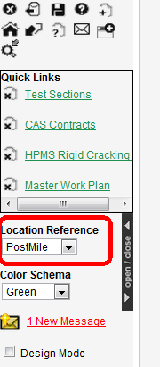

Below the icons and the Quick Links list is the Location Reference field. This field determines how locations are specified, the choices on this list in the PaveM system are:

* Basic LRS – This is the Route and Statewide Odometer (Route/ODM) and is the default method of specifying locations, and is always provided. With this type of referencing system, the system knows the location of assets in only one way, which is route and mile point. Note that for the Basic LRS alternate locations ("aliases") may be specified for principal locations in the Concurrent Location window.
* PostMile – In addition to the Basic LRS, Caltrans use one other ways to identify locations. The drop-down list will include this other way as PostMile in the selections from the drop-down list. This allows you to choose the method of identifying a location in the way that is most familiar and comfortable. A typical alternate LRS is street name and block number.

The contents of the drop-down list are configured in the Setup Reference Location Methods (LRMs) window. This window is described in the following section (3.4.4 Setup Reference Location Methods Window).

#### Defining an Alternate Reference System

When defining an alternate referencing system in the AgileAssets Pavement Analyst the user configures how the references will be listed. An alternate reference consists of two types of information:

1. Attribute values – these are one or more sets of fields that label the alternate reference, for example a county, a route designation or street name would be an alternate reference attribute. With each unique attribute label there are two fields one that is the label from the start point of an event and the other that is the label for the end of the event. As an example if the alternate reference uses county as a label there would be COUNTY\_FROM attribute and COUNTY\_TO attribute.
2. Measurements – There is always a pair of columns in the alternate referencing definition that defines a “from” and a “to” measurement for the linear reference, these could be milepoint, mile marker, street address, offsets, stations etc. These columns always are a pair. Point locations are identified by the “from” and “to” measures being equal.

This is best illustrated by example. In some agencies there is a statewide milepoint linear referencing system that identifies each route and the distance along the route from the start of the route within the state to the end of the route within the state. This measure is continuous across all boundaries within the state. The AgileAssets Pavement Analyst may utilize a statewide method as its “base” linear referencing system.

However in some agencies the pavement management office and other users of the system might normally work with a county milepoint based linear reference that resets the measure of distance along the route at each county boundary. In the Agile Assets system this would therefore be termed an alternate linear referencing method. To define the alternate linear referencing method we first need to identify the attributes needed to map the state milepoint based reference to the county milepoint based reference. Suppose we have a route (Route A) in the system that crosses 1 county boundary in the state from south to north. Say it passes from county 1 into county 2. In county 1 the route is 10 miles long and in county 2 the route is 5 miles long.

Given this example we can create a simple table to map all the state milepoints to the county milepoints:

|  |  |  |  |  |  |
| --- | --- | --- | --- | --- | --- |
| Route | State Begin | State End | County | County Begin | County End |
| A | 0 | 10 | 1 | 0 | 10 |
| A | 10 | 15 | 2 | 0 | 5 |

#### Proposed Base and Alternate Referencing Methods

The PaveM implementation will utilize two linear referencing methods to support the project as detailed in the table below. The base linear referencing method will utilize a Base Route identifier and a Statewide odometer (hereafter abbreviated ODM) measure along the base route. To properly handle the display of divided and undivided highways all the base routes will be divided into two directions indicated by “L” or “R” appended to the route name. Where the route is undivided the L or left side will be configured to be subordinate to the “R” or right side. The following table shows an example route 275 as summarized from the OTM\_TASAS\_HIGHWAYS information (for simplicity note that the Route Suffix, and both Post Mile Prefix and Suffix values are all blank for this route).

|  |  |  |  |  |  |  |  |
| --- | --- | --- | --- | --- | --- | --- | --- |
| County | Route Number | State Odometer Begin | State Odometer End | Alignment (L/R) | Highway Group (Divided Status) | PM Begin | PM End |
| YOL | 275 | 0 | 0.34 | R | D | 11.7 | 12.04 |
| YOL | 275 | 0 | 0.34 | L | D | 11.7 | 12.04 |
| YOL | 275 | 0.34 | 0.41 | R | D | 13.007 | 13.077 |
| YOL | 275 | 0.34 | 0.41 | L | D | 13.007 | 13.077 |
| SAC | 275 | 0.41 | 0.482 | R | D | 0 | 0.072 |
| SAC | 275 | 0.41 | 0.482 | L | D | 0 | 0.072 |
| SAC | 275 | 0.482 | 0.5 | R | U | 0.072 | 0.09 |
| SAC | 275 | 0.482 | 0.5 | L | U | 0.072 | 0.09 |
| SAC | 275 | 0.5 | 0.651 | R | D | 0.09 | 0.241 |
| SAC | 275 | 0.5 | 0.651 | L | D | 0.09 | 0.241 |
| SAC | 275 | 0.651 | 1.107 | R | D | 0.248 | 0.704 |
| SAC | 275 | 0.651 | 1.107 | L | D | 0.248 | 0.704 |

For Route 275 within PaveM there will be 2 base routes defined 275L and 275R both will have length 1.107 miles. Data on the majority of each of these base routes will be divided by its direction (N/E or S/W corresponding to R and L respectively) except for data in Sacramento County Post Miles between 0.072 and 0.09. This section is undivided and the 275L will be defined as subordinate to 275R in this range within the system. Additionally the system will be configured to allow bidirectional data in this area.Table 3‑1: Linear Referencing Methods Defined for the PaveM Project

|  |  |  |
| --- | --- | --- |
| **Linear Referencing Method** | **Type** | **Key Components** |
| **Route and Statewide Odometer (Route/ODM)** | Base LRM | Contains a unique identifier for each route and measure of the start distance and length along the route for each event recorded in the database.  The ODM measurements are the sum of odometer length from the CALTRANS GIS system from the beginning of each route to the start and end of each event. The network divided and undivided segments are defined in the table REFSEG\_REBUILD\_INCLUDEGRP.csv (embedded in this document in Appendix D). The following lists the columns used to store these key data elements   |  |  | | --- | --- | | Element | Table and column | | California Route Number and Route Suffix with L or R Designation (e.g. 275L or 168SL) | SETUP\_NETWORK\_LINES.ROUTE\_NAME | | ODM begin measure | SETUP\_LOC\_IDENT.OFFSET\_FROM | | ODM end measure | SETUP\_LOC\_IDENT.OFFSET\_TO | |
| **California Post Mile Designation** | Alternate LRM | This LRM will utilize the California Post Mile Linear referencing system including County, Route Number, Route Suffix, Post Mile Prefix and Suffix Identifiers and Begin and End Post Mile values. In all cases events stored within the system will have the same values of the County, Route Number, Route Suffix, Post Mile Prefix, and Post Mile Suffix codes for the full length of all data events.   |  |  | | --- | --- | | Element | Column in SETUP\_LOC\_IDENT | | Route Number | CA\_ROUTE\_FROM | | CA\_ROUTE\_TO | | County | CA\_COUNTY\_FROM | | CA\_COUNTY\_TO | | Post Mile Prefix | CA\_PM\_PREFIX\_FROM | | CA\_PM\_PREFIX\_TO | | Post Mile Suffix | CA\_PM\_SUFFIX\_FROM | | CA\_PM\_SUFFIX\_TO | | Route Suffix | CA\_RTE\_SUFFIX\_FROM | | CA\_RTE\_SUFFIX\_TO | | Post Mile Begin Value | CA\_POSTMILE\_BEG | | Post Mile End Value | CA\_POSTMILE\_END | |

**LRM Key Assumptions**

For the LRM methods proposed there are some key assumptions that apply to definition of the network. These are listed below:

1. The lengths used to define the base network will be the sum of the lengths as listed in the network table in appendix A along each alignment of each route and route suffix combination from beginning to end.
2. There will be 2 base routes defined for each valid combination of Route Number and Route Suffix the two base route names will be distinguished by a R or L suffix appended to the route name. The format of the base route name will be <Route Number><Route Suffix><L or R Designation>, for example 275L, 168SR, 086SL, and 005R are all valid base route names.
3. The specification of a given California County, Route Number, Route Suffix, Post Mile Prefix and Suffix and a Post Mile range with a direction always defines a unique location along the route. Data Events that span both sides of a divided highway must be split into two portions to cover the L and R base routes separately in areas where a route is undivided data that span both directions may be created on the “R” base route as the “L” base route will be subordinate in those locations.
4. All event data imported into the system that is based on the Post Mile reference will be mapped onto the corresponding base route and offsets for the begin and end events. The length of any event will then be calculated by subtracting the OFFSET\_FROM value from the OFFSET\_TO value in the BASE LRM.
5. The distance between the “begin” and “end” of an event must also be entirely dominant or entirely subordinate according the dominant/subordinate relationships defined for the network. This means that no events may be partially subordinate.
6. The majority of PaveM users will utilize the alternate referencing method on-screen for most data editing and viewing.

#### Configuring the Alternate Reference LRM

In the Agile system alternate referencing methods (LRM’s) are configured in the SETUP\_LOC\_REF and SETUP\_LOC\_REF\_COLUMN tables in the database. The SETUP\_LOC\_REF table contains the alternate referencing name and ID number for alternate reference defined. The SETUP\_LOC\_REF\_COLUMN table defines the ATTRIBUTE and MEASURE columns for the alternative linear referencing method. The configuration columns are:

1. LOC\_REF\_ID This is the identifier of the alternate referencing system, it is a unique system generated integer and it corresponds to the “XX” in the table LOC\_REF\_XX mentioned throughout this document.
2. COLUMN\_ID This is the defined location reference attribute column used for alternate referencing within the system for the beginning of each linear event. These column names will appear in the LOC\_REF\_XX table and as added columns to the SETUP\_LOC\_IDENT table (see the structure above).
3. COLUMN\_ID\_TO - This is the defined location reference attribute column used for alternate referencing within the system for the end of each linear event. These column names will appear in the LOC\_REF\_XX table and as added columns to the SETUP\_LOC\_IDENT table (see the structure above).
4. LOC\_REF\_COLUMN\_TYPE\_ID This may be one of two values:
   1. “1”indicates a location referencing attribute, which is a description of the location reference, for example a county number, street name, route name etc
   2. “2” indicates a location referencing measure, which is a measurement along a linear reference, for example a streets address number, milepoint, kilometer point etc.
5. SHOW\_TO\_FLAG – This column indicates if the COLUMN\_ID and COLUMN\_ID\_TO columns may contain different values.
   1. If this flag is 0 the system automatically hides the COLUMN\_ID\_TO value on screen an sets it value to be equal to the COLUMN\_ID value whenever the user edits a record in alternate referencing. This forces the "from" and "to" attribute values to be equal at all times.
   2. If this flag is 1 then the values contained in the COLUMN\_ID and COLUMN\_ID\_TO columns may be different and the TO value is shown on screen for user editing.

**Error! Reference source not found.** shows the definition of the alternate referencing for the PaveM project.

|  |  |  |  |  |  |
| --- | --- | --- | --- | --- | --- |
| LOC\_REF  \_ID | COLUMN\_ID | COLUMN\_ID\_TO | ORDER\_ID | LOC\_REF\_COLUMN  \_TYPE\_ID | SHOW\_TO  \_FLAG |
| 42 | CA\_ROUTE\_FROM | CA\_ROUTE\_TO | 1 | 1 | 0 |
| 42 | CA\_COUNTY\_FROM | CA\_COUNTY\_TO | 2 | 1 | 0 |
| 42 | CA\_PM\_PREFIX\_FROM | CA\_PM\_PREFIX\_TO | 3 | 1 | 1 |
| 42 | CA\_PM\_SUFFIX\_FROM | CA\_PM\_SUFFIX\_TO | 4 | 1 | 1 |
| 42 | CA\_RTE\_SUFFIX\_FROM | CA\_RTE\_SUFFIX\_TO | 5 | 1 | 0 |
| 42 | CA\_POSTMILE\_BEG | CA\_POSTMILE\_END | 6 | 2 | 1 |

### Mapping between Base and Alternate LRM’s

Once the alternate referencing is defined in the SETUP\_LOC\_REF\_COLUMNS table and the changes applied to the database, the columns configured they will appear in the SETUP\_LOC\_IDENT table (refer to Table 5). In order to support translation between the base LRM and the defined alternate LRM, the system requires a full map between them. The mapping between the base and alternate is provided by a special set of rows in the SETUP\_LOC\_IDENT table. These rows are always identified by the row filter:

SOURSE\_TABLE=’LOC\_REF\_XX’ (where XX is the ID number of alternate referencing system) (in this case 42)

This set of rows in SETUP\_LOC\_IDENT must always be a full map between all references in the alternate system mapped onto the base system. When editing and viewing data the system utilizes these records to calculate a base reference when given an alternate and vice versa.

### Setup Reference Location Methods Window

(System > LRS & GIS > Setup Location Reference Methods (LRMs))  
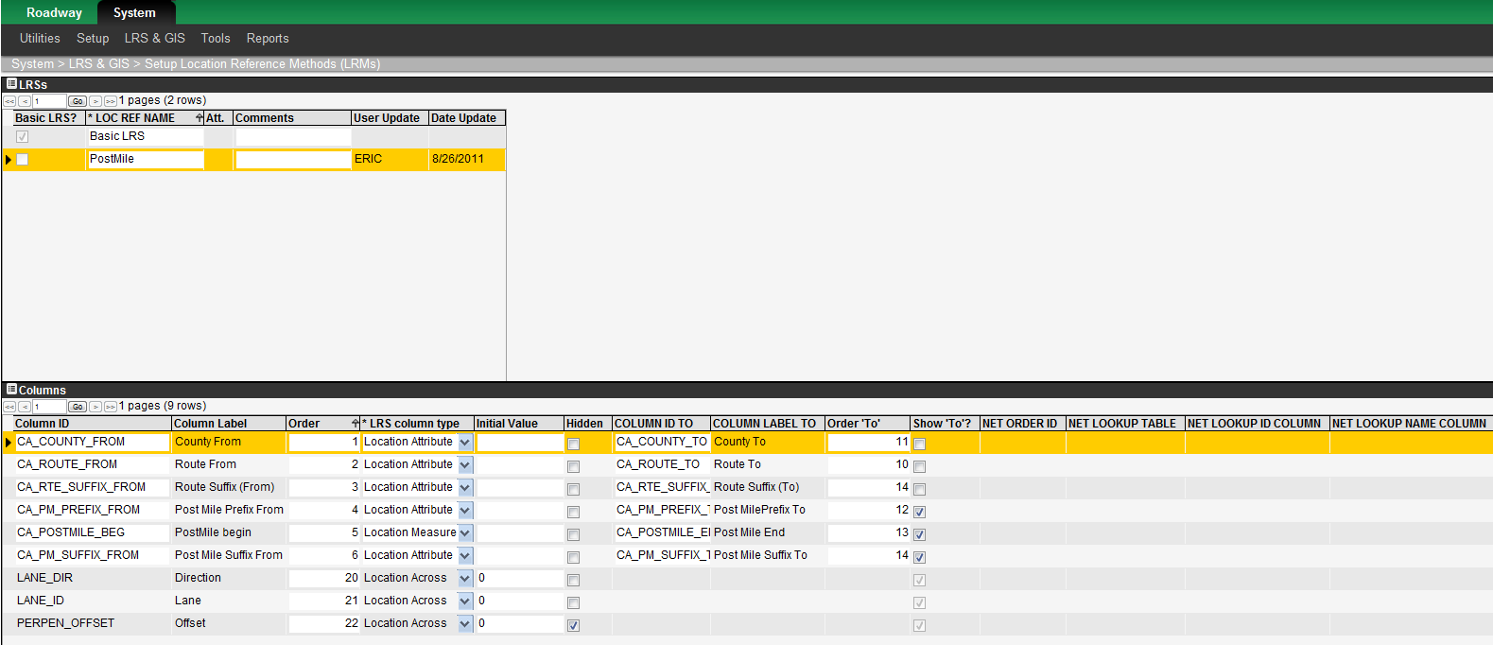

When your implementation of the application allows alternate location reference systems to be utilized, the Setup Reference Location Methods window is available. You use the Setup Reference Location Methods window to see the columns that define the base reference system (as denoted by a shadow check mark in the Basic LRS? column of the LRSs pane) and define the columns that constitute each alternate reference system (PostMile).

The Setup Reference Location Methods window contains two panes: the LRSs pane and the Columns pane.

#### The LRSs Pane

The LRSs pane shows the base reference system (as denoted by a shadow check mark in the Basic LRS? column) along with a record for each alternate reference system. The text entered in the Loc Ref Name column in the LRSs pane is what will appear in the drop-down list in the Location Reference field on the side of the browser window.

Each reference system is assigned a type in the LRS Type column, with the type being selected from a drop-down list. The list provides the following selections:

* Use Location Across – This selection means that for this reference system the identification of a position laterally (for example, across the road) will be done using the two columns Lane Direction and Lane Number. (These two columns are pre-defined in the system, and appear in various windows throughout the system as indicated in the table below.

Note: The base LRM is always set to "Use Location Across," thus providing the capability of lateral positioning, which can then be employed (if desired) for a particular system implementation.

* Ignore Location Across – This selection means that for this reference system the identification of a position laterally does not use the two pre-defined columns Lane Direction and Lane Number. See the table below for its affect in windows throughout the system.

|  |  |  |
| --- | --- | --- |
| Window Type/Situation | What Occurs When "Use Location Across" Is Selected for an Alternate LRM | What Occurs When "Ignore Location Across" Is Selected for an Alternate LRM |
| In the Alternate LRM Definition window. | The Lane Direction column is shown. | No lateral indication columns are shown. |
| In any location-referenced window when an alternate LRM is selected in the Location Reference field. | The Lane Direction and Lane Number columns are shown. | No lateral indication columns are shown. |
| In any location-referenced window when the base LRM is selected in the Location Reference field. | The Lane Direction and Lane Number columns are shown. | The Lane Direction and Lane Number columns are shown. (This is because the base LRM is always set to "Use Location Across.") |

When you point to an alternate reference system in the upper pane and right-click, the following special command is displayed in a shortcut menu:

* Make Window – This command displays a new window that shows the tree view of the menu items of the system. In the new window, click the parent menu item into which a menu item for the window that will show the cross-reference table between the Basic Reference System (BRS) and the alternate systems that you right-clicked. After selecting the parent menu item, click OK to close the window. Then log off and log back on, and the menu item will be in the designated place, with the name of the menu item being what is entered in the Loc Ref Name column. Open the new window to see the cross-reference table. The BRS is shown on the left and the alternate system is on the right.

#### The Columns Pane

Note: The values set in this pane for the base LRM should never be changed without first consulting AgileAssets.

The Columns pane shows the columns that define the reference system selected in the upper pane. The following columns appear in this pane:

* Column ID – This column shows the internal column ID used in the system.
* Column Label – This column shows the column heading label that appears for the column throughout the system.
* LRS Column Type – This column indicates whether the column is the "location measure" column. In defining an alternate reference system, one and only one column must be set as the "location measure"; all other columns must be set as "location attribute".
* Column ID "To" – This column shows the internal column ID used in the system. The contents of this field are not used if the Show "To" check box is clear.
* Column Label "To" – This column shows the column heading label that appears for this column throughout the system. The contents of this field are not used if the Show "To" check box is clear.
* Initial Value – If a value appears in this column, then the value will be automatically set to any record that is location- referenced when it is inserted into the system.
* Show "To"? – If the check box in this column is checked, then this LRM field will be shown twice in any location-referenced window when an alternate LRM is selected. It is shown once for the "from" point and then again for the "to" point. If unchecked, then the LRM field appears once and applies to both "from" and "to" points.–Note:–This column must be checked for the column designated "location measure."
* Order – This column indicates the order (left to right) in which the columns are seen in data windows throughout the system. Note: "To" columns are always situated to the right of "from" columns regardless of what is specified here.

#### Alternate LRM Windows

(System > LRS & GIS > Linear Network Tools > Location Reference > PostMile Alternate Ref System)

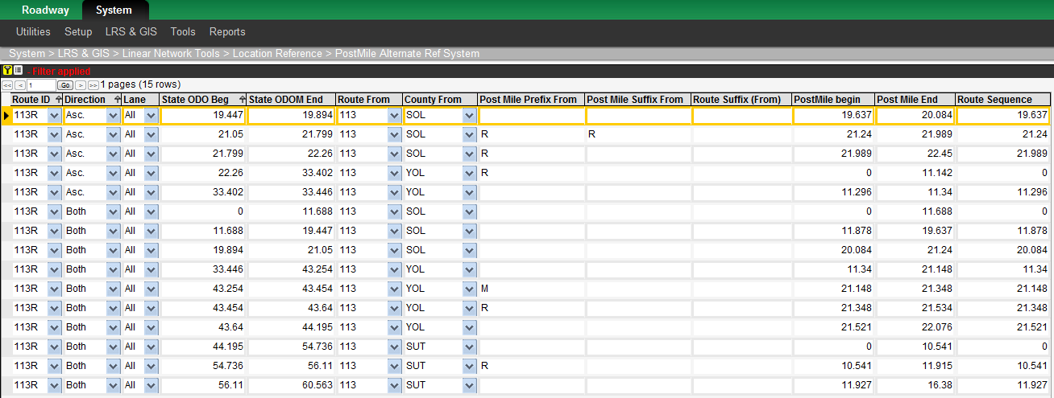

For each alternate reference system defined in the Setup Reference Location Methods window, the application creates a window that allows you to create and maintain the sectioning of your road network under the alternate reference system.

A row in this window describes a length of road in the alternate LRM and also cross-references that length of road to its base LRM description. This window contains two sets of columns:

* The set of columns that define location in the base LRM. This is the set of columns shown in the bottom pane of the Setup Location Referencing Methods window when the base LRM is selected in its top pane.
* The set of columns that define location in the alternate LRM (pertinent to this window). This is the set of columns shown in the bottom pane of the Setup Location Referencing Methods window when this alternate LRM is selected in the top pane.

Note that the Lane Direction column will only appear in this Alternate LRM window if the alternate LRM is configured with "use location across" in the top pane of the Setup Location Referencing Methods window.

#### How to Change Reference Systems

To change the method of identifying locations, navigate to the home window by clicking the Icon_Home icon. Then click the drop-down arrow in the Location Reference field to display the list of referencing systems. Finally, click the desired LRS in the drop-down list.

After you change the method of identifying locations, the change will be implemented the next time that a window with location data is displayed (or is refreshed). The change may result in additional columns being added to the view of the table in the window. See the example below for further information.

#### Example of Changing the Reference System

This example will show two traffic sections. The first reference system will identify locations by route and mile point. Then the LRS will be changed to an alternate referencing system where locations are identified by county post mile.

The traffic sections, in route and mile point reference, are both on route FL4040:

* The first section (marked "A") is between mile point 22.85 and 23.14.
* The second section (marked "B") is between mile point 23.14 and 23.14.

In the system, these sections look like this:

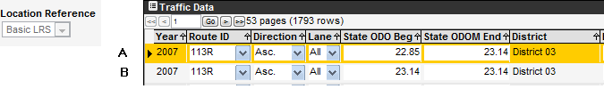

The LRS is now changed to the alternate referencing system. In this system, the traffic sections Route, County, PostMile identification, and they look like this:



The system deduces the alternate location reference of county and post mile from the basic reference of route and mile point because of the data provided in the alternate reference system window shown on the following page.

Using this information:

* Traffic section data can be entered by route and mile point -- and then the system knows the county post mile; or
* Traffic section data can be entered by county post mile, and then the system translates and stores the information as route and mile point. Then, upon next accessing this information, it can be viewed or edited utilizing either route and mile point or county post mile. 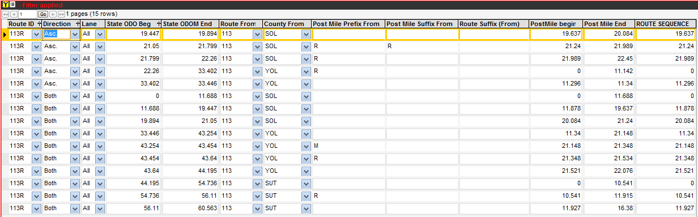

### Setup Network Lines

(System > LRS & GIS > Linear Network Tools > Geometry > Routes List)  
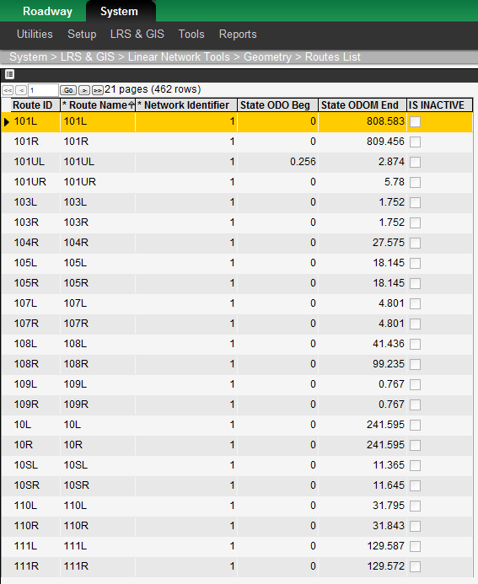

The Setup Network Lines window shows all of the routes (current and former) in your linear network along with the minimum and maximum mile points of each. Those routes that are no longer in use will have the Is Inactive check box selected. The measure points are editable. All other adjustments to the linear network (linear reference system [LRS]), such as add route, delete route, etc., are made by other means specific to your project’s implementation, including:

* Use of the linear network supplied within the third-party GIS map that is used in the system;
* Use of the GIS transactions window (if your agency does not an external interface to a linear referencing management system); or

### Concurrent Location

(System > LRS & GIS > Concurrent Location)  
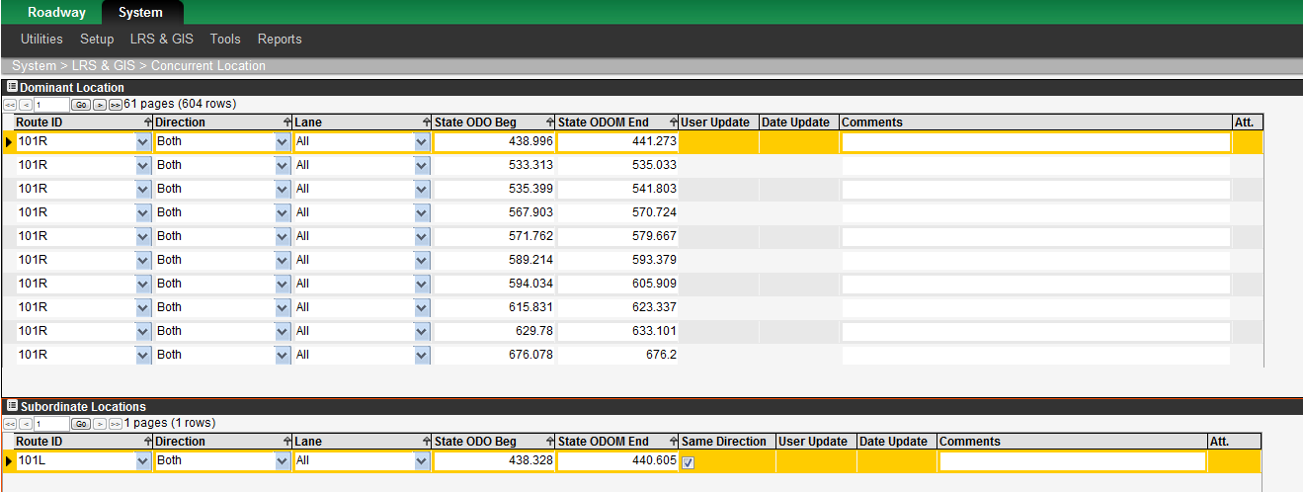

The Concurrent Location window allows you to associate alternate locations with a particular, principal location for the Basic LRS referencing system. The upper pane shows the principal location, while the lower pane shows the alternate locations ("aliases") that are associated with the principal location selected in the upper pane.

### Network Lanes

(System > LRS & GIS > Linear Network Tools > Geometry > Network Lanes)  
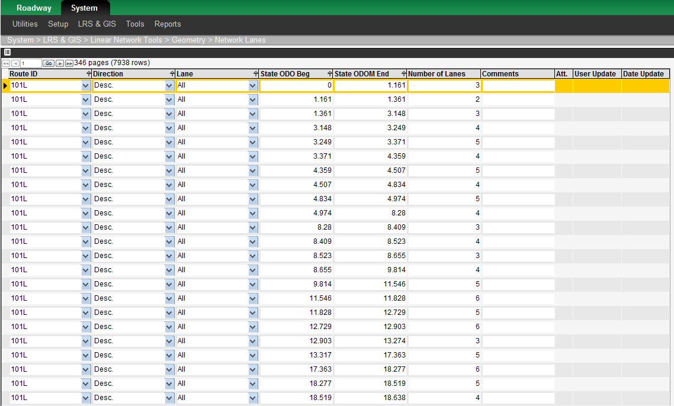

The Network Lanes window sets the number of lanes in each direction for your entire road network. Each record in this window indicates the number of lanes for a road section as identified by route, direction, start mile point, and end mile point. When entering data into this window, observe the following:

* For lane direction, never set the lane direction to "All."
* For lane ID#, always set the lane ID# to "All."

This "number of lanes" information is used for finest partition operations in:

* The Finest Partition window; and
* The System Jobs window, where it is used in the procedure to update the Finest Partition for the Pavement Structure Profile. (It updates the information needed for the Pavement Structure [Profile/Cross Section] window.)

### Manage GIS Data Sources

(System > LRS & GIS > Manage GIS Data Sources)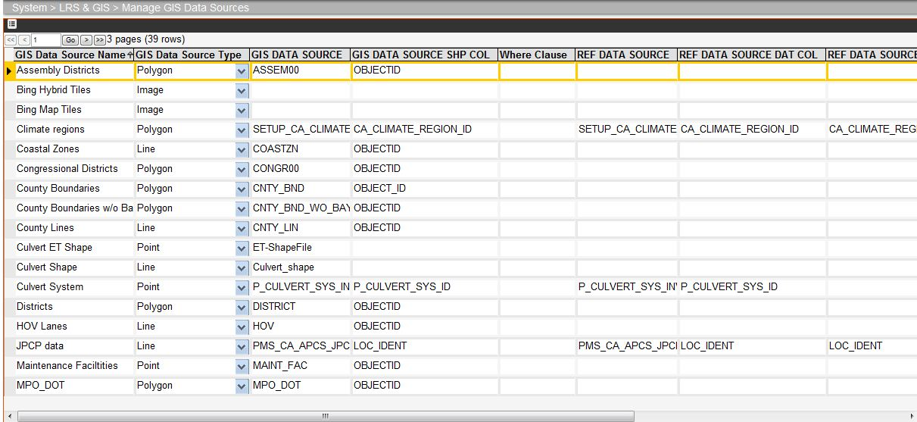  
The Manage GIS Data Sources window lists all sources of GIS data. You use the window to add and maintain the various sources that display data on a map. The sources configured here are used in the Floating Map window when adding layers to a map.

#### Description of the Manage GIS Data Sources Columns

The following table describes what data is entered in each column of the Manage GIS Data Sources window depending on the GIS data source type.

| Column Name | GIS Source | | | | |
| --- | --- | --- | --- | --- | --- |
| ArcGIS Online,  ArcGIS Online Tiles | Open Streets Tiles | Image | Shape | Oracle Spatial |
| GIS Data Source Name | This field shows the name of the GIS data source as displayed in the Map pane. | | | | |
| GIS Data Source Type | This field is a drop-down list that indicates the type of GIS layer (point, line, polygon, or image). | | | | |
| GIS Data Source | Path to desired layer in a semi-colon separated list (no ending semi-colon). | Table name of desired layer. | Name of the Image file. | Name of the Shape file. | Table name of desired layer. |
| GIS Data Source Shp Col | Leave blank. | Same as Shape. | Leave blank. | ID Column in GIS data source that identifies each feature to which data will be linked. If this column is null, features are given a dummy sequence by their record number. | |
| Where Clause | Leave blank. | SQL statement that limits the data that is retrieved. | Leave blank. | Leave blank. | SQL statement that limits the data that is retrieved. |
| Ref Data Source | Leave blank. | Same as Shape. | Leave blank. | The table within the AgileAssets schema that is a crosswalk between the GIS\_DATA\_SOURCE\_SHP\_COL and REF\_DATA\_SOURCE\_DAT\_COL columns. | |
| Ref Data Source Dat Col | Leave blank. | Same as Shape. | Leave blank. | A column within the REF\_DATA\_SOURCE table that matches data from within the AgileAssets schema. | |
| Ref Data Source Shp Col | Leave blank. | Same as Shape. | Leave blank. | The column within the REF\_DATA\_SOURCE table that matches the value in the GIS\_DATA\_SOURCE\_SHP\_COL column. | |
| Full Extent | This column Is used to limit the maximum extent shown for a map in AgileAssets software. It is a pair of xY coordinates, with all four numbers being space-delimited. | | | | |
| Coor. Ref. Sys. | This column contains a drop-down list that is comprised of the coordinate reference systems defined in the GIS Coor. Ref. Systems window (see page 44). You select the reference system that is to be associated with the layer and data source. | | | | |

#### Description of the Right-click Shortcut Menu

When you right-click a record in the Manage GIS Data Sources window, the system displays a shortcut menu. This menu contains the common commands along with the following special commands:

* Create New GIS Data Source — This command begins the process of adding a new GIS data source.
* Delete GIS Data Source — This command removes the selected record from the Manage GIS Data Source window.
* Recreate Window for Showing Attributes — This command enables the Show Attributes command found in right-click shortcut menus in GIS-related windows.
* Recreate Window for Editing Attributes — This command enables the pop-up windows to open from the Data from Map window.
* Preview — This command displays the Floating Map window (see below).

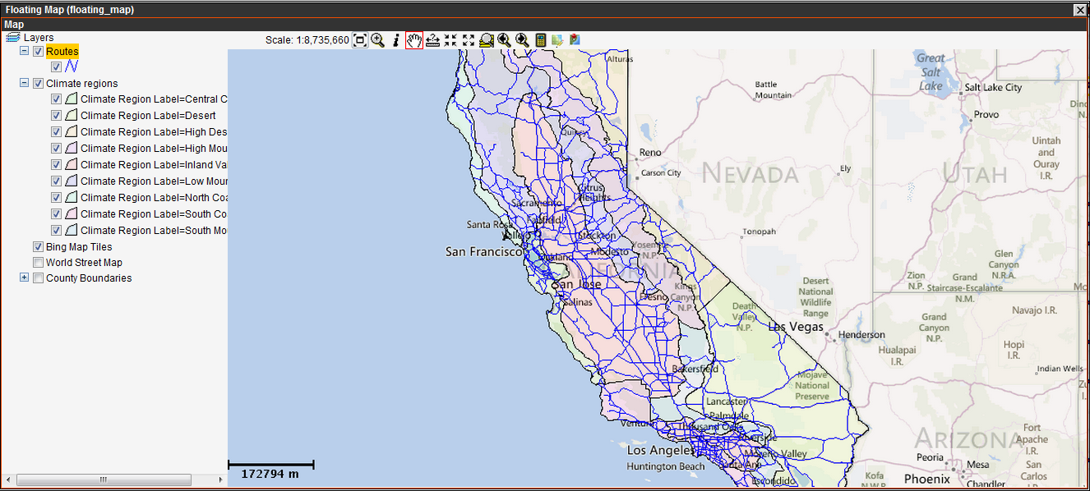

### Manage GIS Layers

(System > LRS & GIS > Manage GIS Layers)  
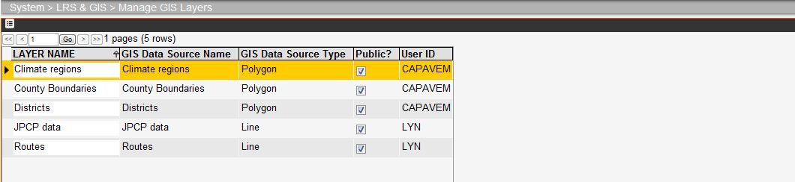

The Manage GIS Layers window lists all layers either created by you under the User ID you used when signing on or that are "public" layers. You use this window to review and manage your "library" of available layers. You can view how a layer appears (and begin the process of further customizing a layer) by using the Preview command, which displays the Floating Map window.

### GIS Images

(System > LRS & GIS > Gis Images)  
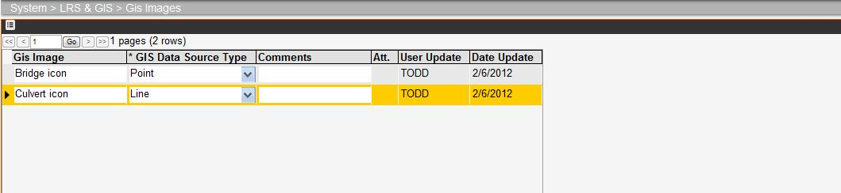

You use the GIS Images window to create a library of symbols that may be used in line and point theme styles in GIS maps. The symbols are image files that are associated with a record in this window via the Work with Attachments command.

**NOTE**

The image files are recommended to be PNG format.

### GIS Coordinate Reference System

(System > LRS & GIS > GIS Coor.Ref. Systems)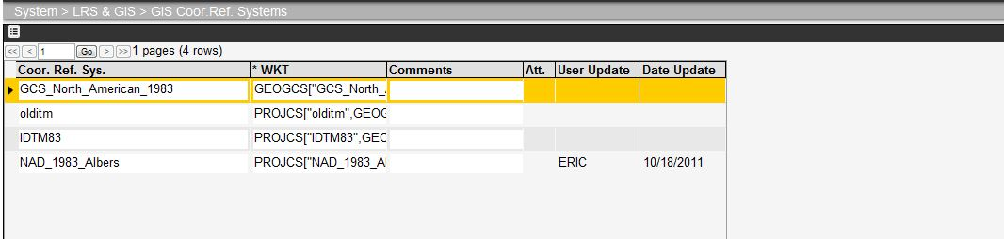

### Network Transactions

Note: You should only use this window if you do not have an interface to the AgileAssets Network Manager or your own agency’s linear referencing management system. Contact AgileAssets before making any changes to this window if you are unsure.

The purpose of the Network Transactions window is to perform all adjustments to the base location reference system for a linear network within the AgileAssets system. All route additions, deletions, or mile point adjustments are made through this window by entering transactions and then committing them. ("Committing" a transaction means that the results of the transaction are permanently applied throughout the database and GIS map.)

(System > LRS & GIS > Linear Network Tools > Geometry > Network Transactions)  
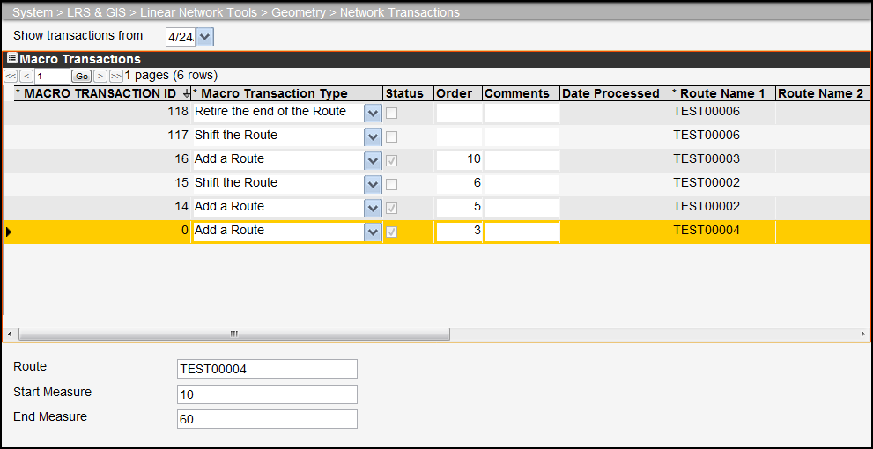

#### Network Transactions Window Description

This window contains the following elements:

* The Show Transactions From field — By entering a date at the top of the window (in the format MM/DD/YYYY) and clicking the  icon, all uncommitted transactions as well as those committed since the entered date will be displayed in the Macro Transactions pane. When no date is entered, only uncommitted transactions are retrieved.
* Macro Transactions pane. This pane is described in the following section.
* Transaction Input pane. This pane is described on the following page.

#### Macro Transactions Pane

When the Network Transactions window is first displayed, the Macro Transactions pane at the top of the window shows all uncommitted transactions. If a date is entered in the Show Transactions From field, then all committed transactions since the entered date are also shown (along with all uncommitted transactions). To see earlier committed transactions, change the date to a date earlier than the desired date of the committed transaction and then click the icon.

In the Macro Transactions pane, you enter and define new transactions. You may also edit uncommitted transactions. (An uncommitted transaction is one where the status field is not checked and consequently has no processed date.) After creating a new transaction or editing an uncommitted transaction, you may then commit the transaction, which applies the results of the transaction throughout the database and GIS map.

When you right-click a transaction in the table, a shortcut menu is displayed. This menu contains the following special commands along with the common commands:

* Decompose Macro Transaction — After selecting this command, the system displays a new window that shows the ordered series of basic transactions that compose the transaction you right-clicked. The transaction's input parameters are applied to these basic transactions as appropriate.

Note: Internally, the system operates using basic transactions. The Decompose Macro Transaction command is primarily used as a communications tool to convey how it operates internally. This is important, for example, during import routine development with a third-party system that controls the network. The eight basic transactions are described in the Interface Design document for the third-party system.

* Commit Transaction - This command commits the currently selected transaction, applying it throughout the database and the GIS map. Once a transaction is committed, the system places a check mark in the transaction's Status column and displays the processed date in the transaction's Date Processed column.

#### Transaction Input Pane

For the transaction and transaction type currently selected in the upper Macro Transactions pane, the Transaction Input pane at the bottom of the window displays the transaction inputs for the transaction type and allows you to enter the parameters for the transaction inputs. The transaction inputs vary depending upon transaction type. The table below identifies the inputs for each transaction type.

| Transaction Type | Inputs | | | | |
| --- | --- | --- | --- | --- | --- |
| First Route | Second Route | First Value | Second Value | Third Value |
| Add second route to start of route. | Main route. | Route to add. | New start measure. |  |  |
| Add second route to end of route. | Main route. | Second route. |  |  |  |
| Add lane inside. | Route name. |  | Start measure. | End measure. | Lane direction. |
| Add lane outside. | Route name. |  | Start measure. | End measure. | Lane direction. |
| Add a route. | Main route. |  | Start measure. | End measure. |  |
| Add asphalt to the end of a route. | Main route. |  | New pavement length. |  |  |
| Add asphalt to the start of a route. | Main route. |  | New pavement length. | New start measure. |  |
| Add new length. | Route name. |  | Start measure added. | End measure added. |  |
| Delete lane inside. | Route name. |  | Start measure. | End measure. | Lane direction. |
| Delete lane outside. | Route name. |  | Start measure. | End measure. | Lane direction. |
| Delete portion of the route. | Route name. |  | Start measure deleted. | End measure deleted. |  |
| Merge two routes. | Main route. | Route to add. |  |  |  |
| Realign portion of the route. | Route name. |  | Start measure. | Original end measure. | New end measure. |
| Realignment with renaming of old roadbed. | Route retained. | New name of original pavement portion. | Start realignment. | End realignment. | Length of new pavement. |
| Realignment with retirement. | Route to realign. |  | Start of realignment. | End of realignment. | Length of new pavement. |
| Rename a route. | Existing route name. | New route name. |  |  |  |
| Rename a portion of a route. | Route name. | New route name. | Start measure. | End measure. | Start measure of new route. |
| Retire a route. | Route name. |  |  |  |  |
| Retire a portion of a route. | Route name. |  | Start measure. | End measure. |  |
| Reverse a route's mile points. | Route name. |  |  |  |  |
| Shift a route's mile points. | Route name. |  | Miles to shift. |  |  |
| Split data on a route at mile point. | Route name. |  | Mile point for splitting. |  |  |
| Split a route and give a new name to the beginning of the route. | Route to split. | New name for beginning mileage. | Mile point for splitting. |  |  |
| Split a route and give a new name to the end of the route. | Route to split. | New name for ending mileage. | Mile point for splitting. |  |  |
| Trade dominance. | Subordinate route. |  | Start measure on subordinate route. | End measure on subordinate route. |  |

Several transactions not only adjust location reference but also work directly on attribute data records, splitting one record into two. This "split" capability is needed as it is the only way for data that spans a transaction mile point (that is, the attribute data's "from" point and "to" point are on either side of the transaction mile point) can be assigned to each of the two routes that are the result of the transaction. The transactions listed below use the "split" capability:

* Add lane inside.
* Delete lane inside.
* Delete portion of the route.
* Realign portion of the route.
* Realignment with rename of old roadbed (use "split" twice).
* Realignment with retirement (use "split" twice).
* Rename a portion of route (use "split" twice).
* Retire a portion of route (use "split" twice).
* Split data on a route at mile point (use "split" once).
* Split a route and give a new route name to the start (use "split" once).
* Split a route and give a new route name to the end (use "split" once).
* Trade dominance.

#### How to Run a Network Transaction

To run a Network transaction, follow these steps:

1. Open the Network Transaction window.
2. Right-click the table and then click Insert. The system adds a new record to the table.
3. In the Macro Transaction Type column of the new record, click the down arrow to display the list of macro transactions and then click the desired transaction. The system displays the fields for the information needed for the transaction in the lower pane.
4. In the lower, Transaction Input pane, complete the fields with the necessary information.
5. In the upper, Macro Transaction pane, right-click the new record and then click Commit Transaction. The system runs the transaction. After running the transaction, the system displays today's date in the Date Processed column as an indication that the transaction ran successfully.

Note: If you are running multiple transactions that require the result of one transaction for the next transaction, use the Order column to enter the order in which the transactions should be run. The transactions will still need to be manually run one at a time, but this will help you to run them in the proper order.

### Updating Network Geometries

When new transactions are committed in the Network Transactions window, the SETUP\_NETWORK\_LINES table should be updated to reflect changes in the network’s geometry. The SET\_NETWORK\_LINES table stores the geometry of each route of the network.

To update the Network geometries in the system your system administrator will first need to get the new shape file of the Caltrans network from the TSN GIS Division (e.g. TIGER\_ROUTES\_MODIFIED2009 Shape File): Perform the following steps to update the Network geometries) using the “Update Base LRS Geometries” import process in the System > Tools > Import Runner window:

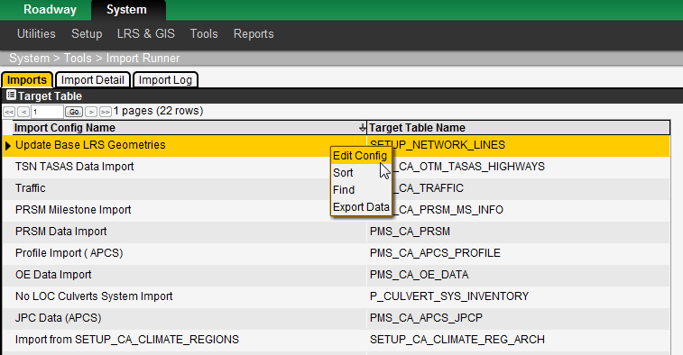

1. In the Import Runner window locate the record for importing the update geometries - “Update Base LRS Geometries”
2. Right-click on the record and select Edit Config from the command menu. A new popup window opens as show below

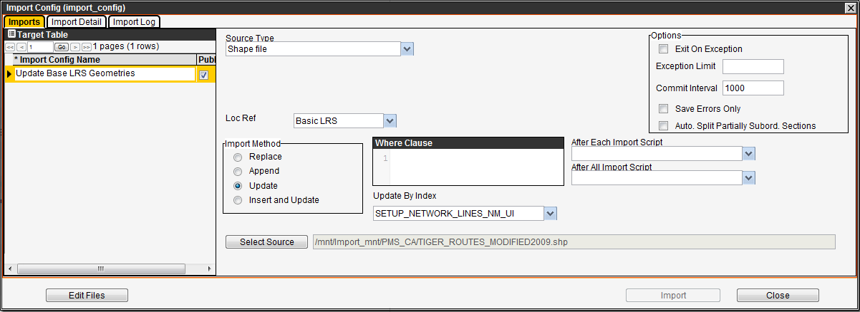

1. Click on the Edit Files button in the lower left hand corner of the window to upload the new Caltrans Network shape file. The following popup window opens:

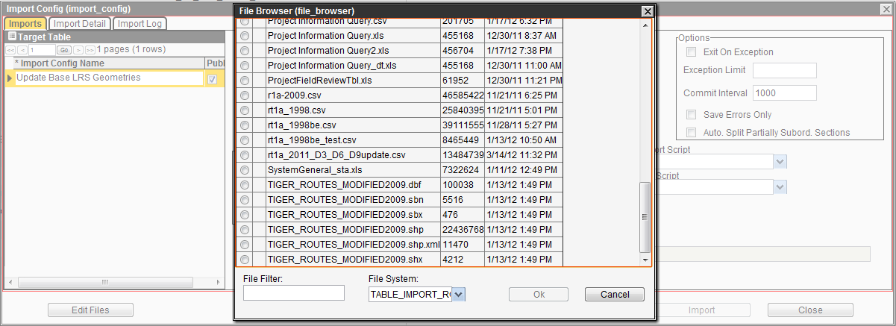

1. Delete the existing shape file by selecting the check box next to the record then right-click and select Delete selected from the command menu. Note the shape file may contain several files all with the same name but with all or some of the following extensions: \*.dbf, \*.prj, \*.sbn, \*.sbx, \*.shp, \*.shx). Delete each record.
2. Add/Upload the new shape file by uploading each of the files provided that makes up the shape file. To do this right-click and select Upload File from the command menu, then select the Choose File button from the Select File popup.

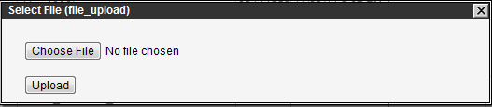

1. Select the file to be uploaded then click the Upload button in the Select File popup.

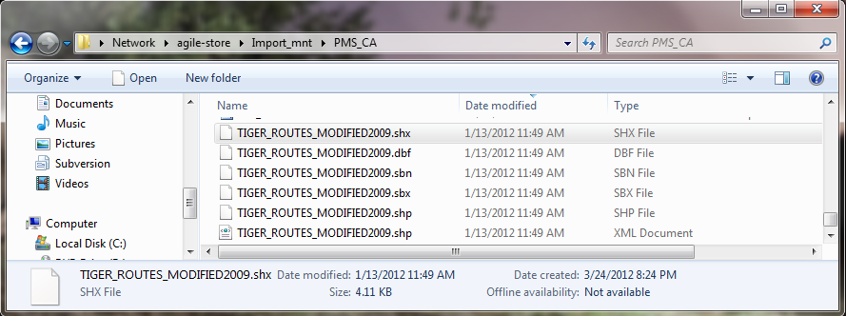

1. Repeat steps 5 and 6 for all the files that make up the shape file (note the name of this shape file will change in the future)
2. After loading all the files close the file browser window (shown in step 3) and click the import button in the Import Config window show below. Note, if the file name changed click on the Select Source button and navigate to select the new shape file (Select the file with the \*.shp extension)

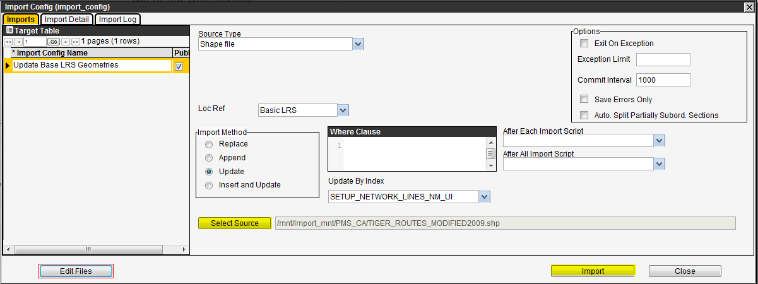

1. Click on the Import button to start the import/update process, the window shown below will appear. This process may take several minutes to run.

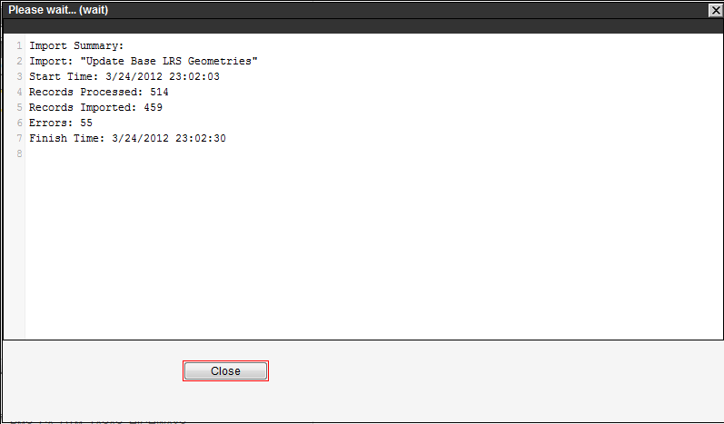

1. To verify that the Routes geometry was updated navigate to the Manage GIS Themes window (System > LRS & GIS > Manage GIS Data Sources window) and visually investigated the Routes theme.
2. Update the Alternative referencing system mapping in System > LRS & GIS > Linear Network Tools > Location Reference > PostMile Alternate Ref System window.
3. Run the ‘Update geometries in Location Table’ system job in the System > Tools > System Job > Schedules window. The Update geometries in Location Table system job resets the alt ref location for all location data in the system based on the mapping in step 11.  
   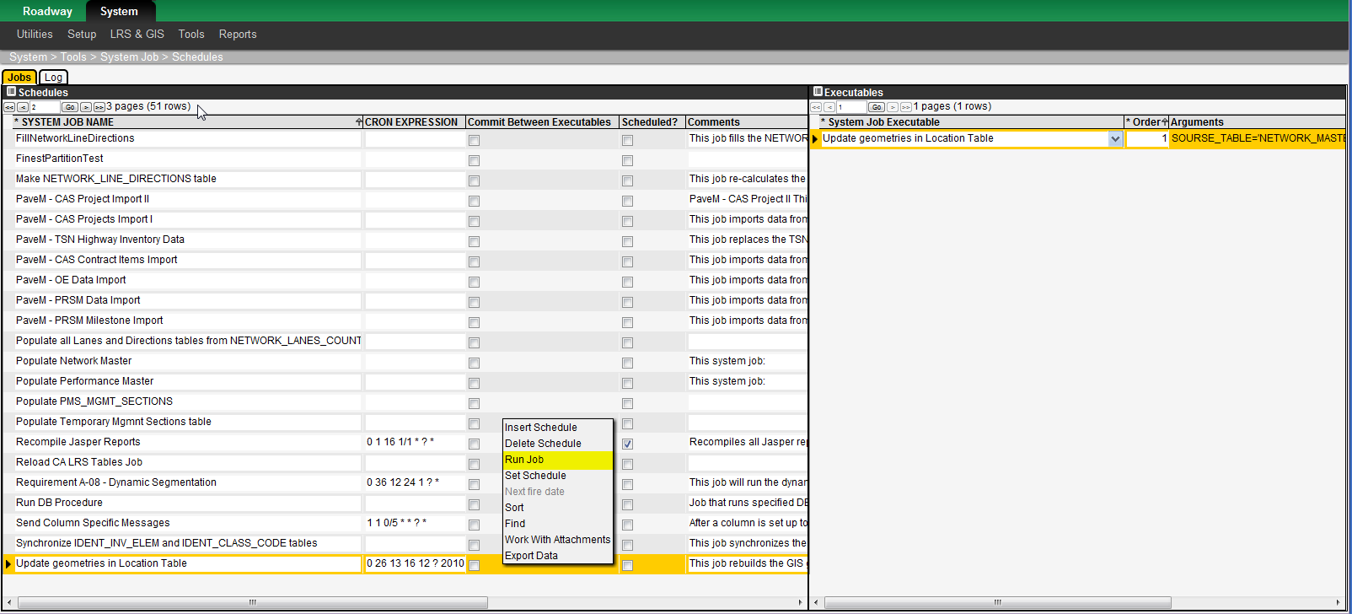

Several transactions not only adjust location reference but also work directly on attribute data records, splitting one record into two. This "split" capability is needed as it is the only way for data that spans a transaction mile point (that is, the attribute data's "from" point and "to" point are on either side of the transaction mile point) can be assigned to each of the two routes that are the result of the transaction. The transactions listed below use the "split" capability:

# Appearance Customization

AgileAssets applications are easily customized in appearance to suit your particular needs. You need to remember, however, that changing labels may cause the application to differ from the documentation provided.

## Windows That Control Appearance

The application provides several windows that may be used to modify the labels. The different windows are summarized below:

* To change menu labels, use the Menus window.
* To change column labels, use the Columns window.
* To change the name of commands, use the Actions Rights window.
* To change the title of a window launched from a menu, use the Setup Window Titles window. This window is found in the Utilities menu of the System module. (Alternatively, you could also use the User Control Properties dialog box if you have design privileges.
* To change the title of a “pop-up” window launched from a command or hyperlink, use the Setup Popup Window Titles window. This window is found in the Utilities menu of the System module.
* To change the text messages displayed by the system, use the Text Resources window. This window is found in the Utilities menu of the System module. (You may alter a message to better suit the situation in which it appears, but remember that a message may appear in more than one situation. Therefore, avoid making the message so specific that it is unlikely to work in multiple situations.)

Note: Variables in a message are preceded by a percent sign (%).

## Menu Hierarchy

(System Module > Utilities > Menus)

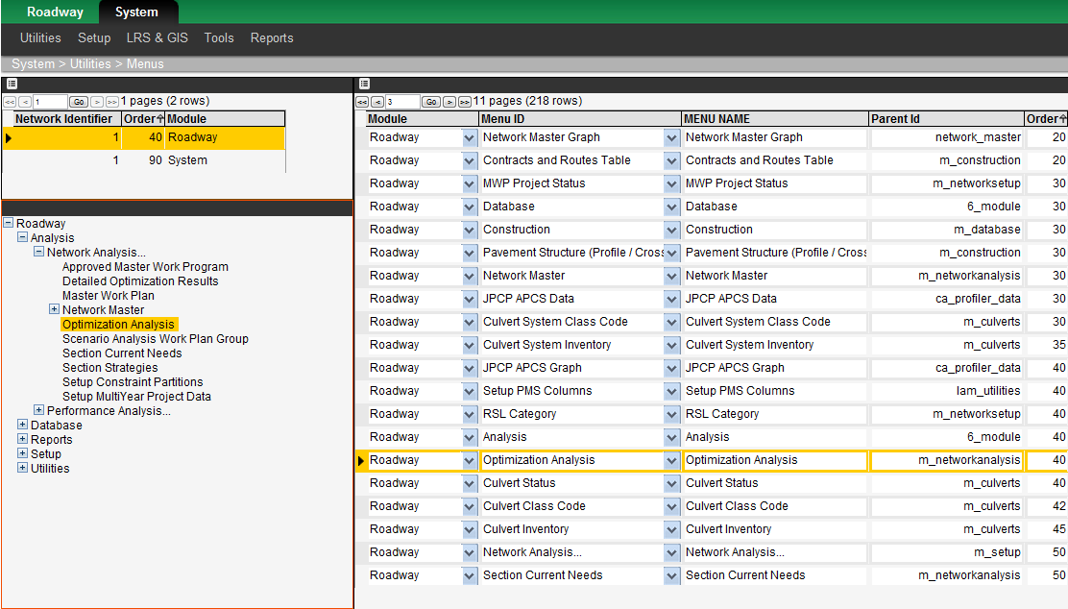

The Menus window configures the structure and labels of the menu hierarchy of the system. The upper left pane shows the module and the pane beneath it shows the menu hierarchy for that module. The table on the right provides records for each node of the menu hierarchy. You use the table to adjust such things as the label for the menu item and the order in which the menu items appear. You may also move a menu item from one menu to another (within the module) by changing the Parent ID of the menu item.

You use the Menus window to maintain the labels for each of the menu commands in the main menu structure of the asset management application. You may also use this window to re-arrange the order of the items in the menus.

To change the label for a menu item, follow these steps:

1. Display the Menus window (System > Utilities > Menus)
2. In the upper left pane, if necessary use the page forward button to display the module in which the menu appears
3. In the lower left pane, expand the hierarchy to locate the menu item to be modified and then click the desired menu item. The menu item is highlighted in the hierarchy and in the table in the right pane.
4. In the right pane, modify the text shown in the Menu Name column
5. Click Icon_Save to save the new label

To alter the order in which items appear in a menu, locate the item to be moved and note the value assigned to it in the Order column. (The order is from the top down.) Change the value in the Order column to be the proper location, and re-number the intervening menu items so the menu items are in the proper order. Click Icon_Save when you are finished. To see the new order, check the menu or close and re-open the Menus window.

## Setup Window Titles

**The Setup Window Titles window (System > Utilities > Setup Window Titles) is used to maintain labels for the windows and panes** throughout the application. It contains the following panes:

* Modules (and module's menu hierarchy) -- The left pane shows the available modules, with the selected module highlighted. Below the table that shows the various modules of the application is the hierarchy of menu items for the selected module.
* Windows -- The upper right pane shows the windows associated with the menu item selected in the hierarchy in the lower left pane. You may edit the title of a window by highlighting the existing text in the Window Name column and typing the new title.
* Window Objects -- The lower right pane shows all components of the window selected in the upper Windows pane. You may edit the label applied to a component by highlighting the existing text in the Object Title column and typing the new label.

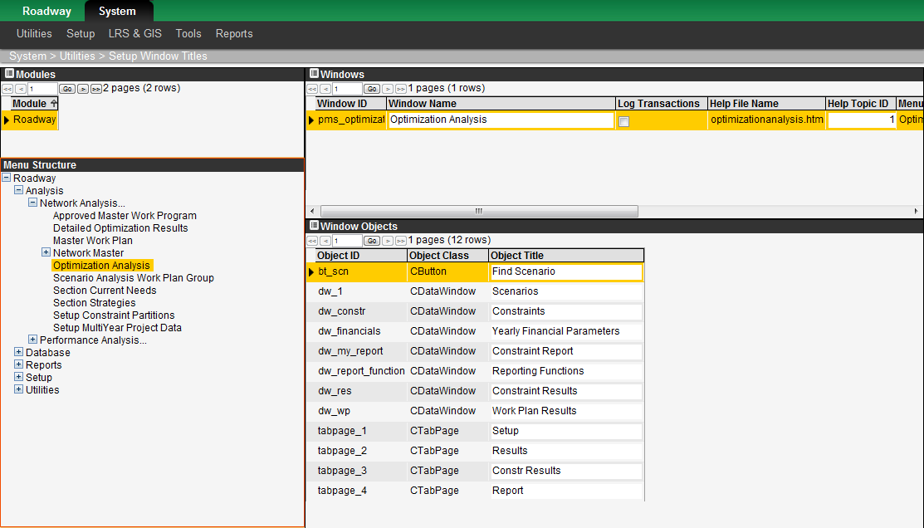

## Setup Popup Window Titles

**The Setup Popup Window Titles window (System > Utilities > Setup PopUp Window Titles)** is used to maintain labels for popup windows that appear throughout the application (and the objects that appear in them). It contains the following panes:

* Windows -- The upper pane shows the available popup windows. You may edit the title of a popup window by highlighting the existing text in the Window Name column and typing the new title.
* Window Objects -- The lower pane shows all components of the popup window selected in the upper pane. You may edit the label applied to a component by highlighting the existing text in the Object Title column and typing the new label.

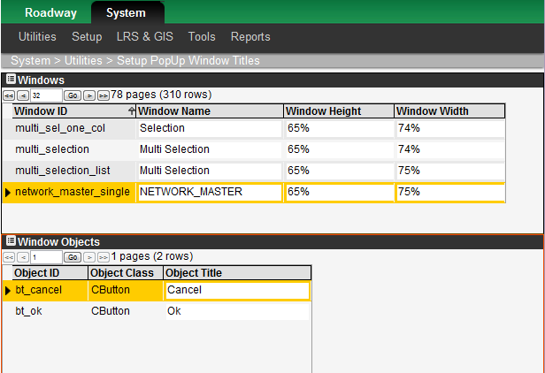

## Text Resources descriptions

**Note: Consult with an AgileAssets staff member before changing any text messages.**

This window is found in the Utilities menu of the System module. You may alter a message to better suit the situation in which it appears, but remember that a message may appear in more than one situation. Therefore, avoid making the message so specific that it is unlikely to work in multiple situations.

The Text Resources window (System > Utilities > Text Resources) lists all text messages that may be generated by the application. Variables in a message are preceded by a percent sign (%). You may alter a message to better suit the situation in which it appears, but remember that a message may appear in more than one situation. Therefore, avoid making the message so specific that it is unlikely to work in multiple situations.

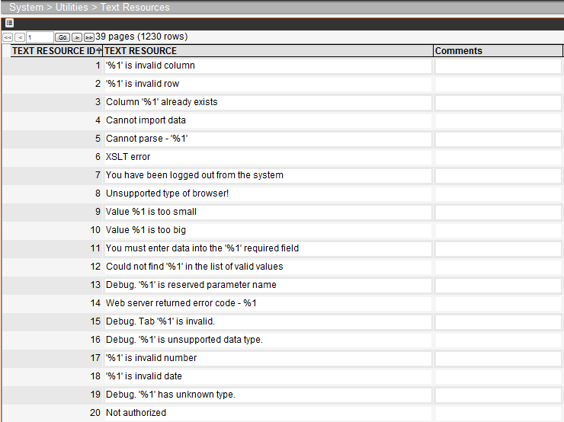

## Design Mode

Design mode is a fully functional mode of the application that also allows a user to adjust the layout of individual windows (the height and width of panes [including panes with tabs], the location of a window variable, and column widths). The changes apply to all users, but only for the window that is modified. (For example, adjusting the column width of the County column [which appears in multiple windows] will not increase the width of the column in all windows; rather, it will only adjust the width of the column in the one window where the adjustment was made.) Only those users that have a check mark in the Is Admin? check box of the User Names and Access window are allowed to enable Design mode.

Note: Any user, not just one with design privileges, can adjust the width of columns in a window while the window is open. However, for any user other than the one with design privileges, the column width will revert to the default width when the window is closed and re-opened.

When a user with Design mode privileges logs on, he or she will see a check box in the left gutter that is labeled Design Mode. When the user selects this check box by clicking it, the application is placed in Design mode. A check mark in the check box denotes that Design mode is enabled. This mode will remain enabled until the user again clicks the Design Mode check box or logs off.

To modify the layout of a window, follow these steps:

1. Log on to the application.
2. Click the Design Mode check box on the left side of the browser window.

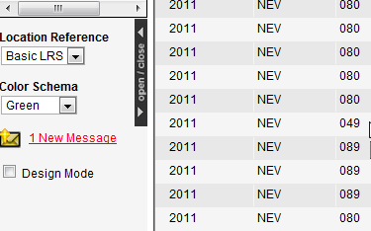

1. Open the window to be adjusted.
2. Make the desired modifications. Note that the right-click command Change Control Properties becomes available in Design Mode to modify the title of the pane and adjust the pane's size and position. See page 58 for more information.
3. Once the window is modified as desired, open another window.
4. The application displays a dialog box asking if you want to save the modifications. Click OK to keep the modifications or click Cancel to discard the modifications and return to the former layout.
5. Modify another window or, if finished, clear the Design Mode check box by clicking it.

## User Control Properties Dialog Box

The User Control Properties dialog box is a powerful tool that is available to users with design privileges. It is displayed by placing the application in Design Mode (by checking the Design Mode check box in the left application gutter) and then displaying the window which you wish to modify. You then right-click the desired pane of the window and click the Change Control Properties command that appears at the bottom of the shortcut menu.

### Description of the User Control Properties Dialog Box

This command displays the Control Properties dialog box, which contains three tabs.

The first tab is the General Properties tab. An example of this tab is shown below.

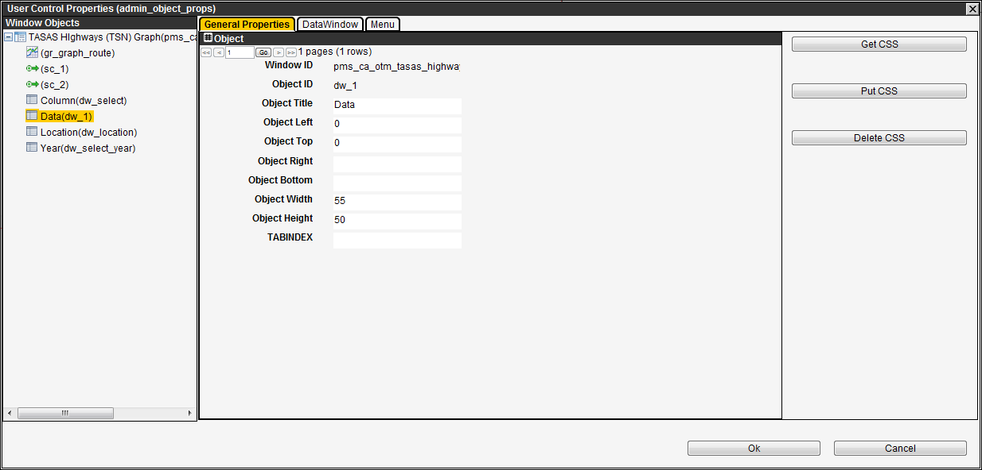

This tab specifies the title of the pane or window as well as its placement. These may be adjusted to re-name the pane or re-position it in the window. The fields are described below:

* Window ID: This field displays the ID of the window chosen
* Object ID: This field displays the object ID information of in the window
* Object Title – This field shows the word or phrase that appears in the blue bar above the pane.
* Object X, Object Y – These two fields set the position of the upper left corner of the pane within the window.
* Object Width – This field shows the width of the pane in pixels.
* Object Height – This field shows the height of the pane in pixels.
* TabIndex – This field sets the order in which the "focus" in the window moves from pane to pane. It is recommended that this be used only by AgileAssets personnel.

Typically, these fields are not edited directly. Instead, the size of the pane is adjusted by dragging the edges of the pane to the desired size.

When the User Control Properties dialog box is launched when record view is active (that is a window that shows only a single record and the columns appear as fields), command buttons are added to the General Properties tab for CSS file manipulation. These command buttons are shown and described below:

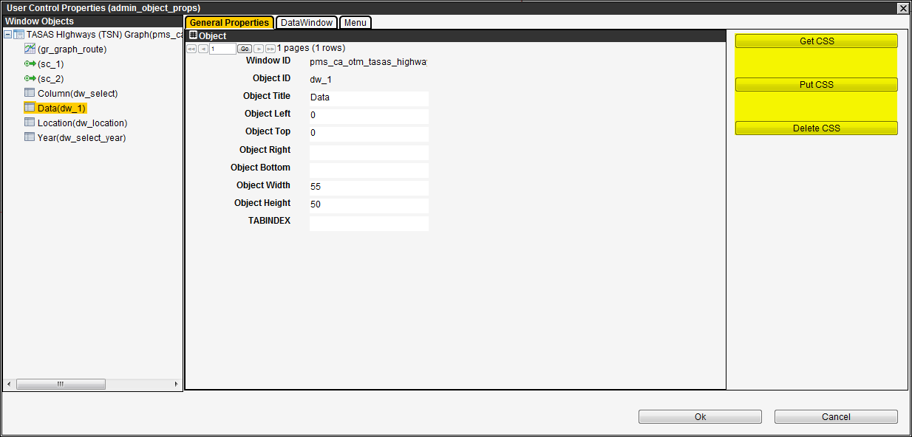

* Get CSS – This command button sends the default format to a Cascading Style Sheet (CSS) file in a folder selected by you. This allows you to modify this CSS file (using third-party software) supplying the desired format.
* Put CSS – This command button allows you to identify the CSS file (that now contains the desired formatting) that the application acquires and uses to format the pane.
* Delete CSS – This command button removes the user-created CSS file that is formatting the pane and returns the pane to the default record view formatting.

The second tab is the Data Window tab. An example of this tab is shown below.

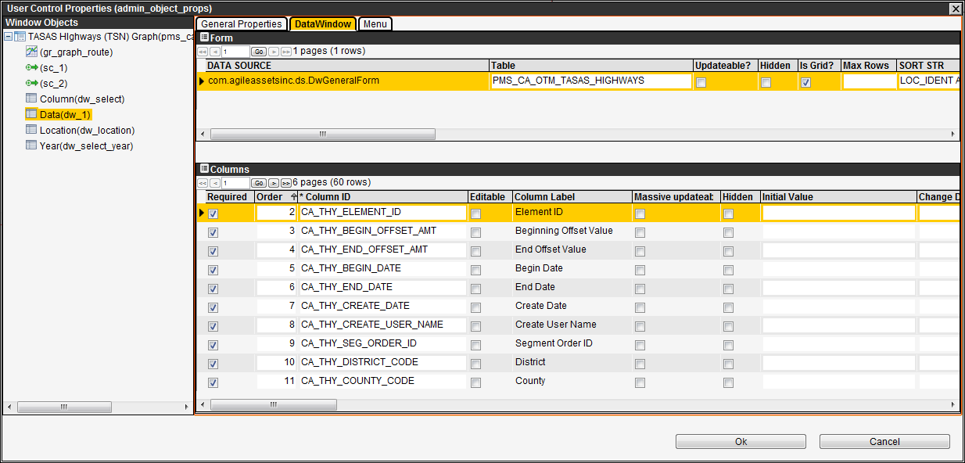

The Data Window tab sets what columns appear in the pane that you right-clicked. The tab provides two panes: Forms and Columns.

##### Form Pane

The upper, Form pane shows the following information:

* Data Source – This column shows the name of the Java (if lowercase) or Oracle (if uppercase – DW\_\*) object which selects and presents the data shown in the pane.
* Update Table – This column shows the name of the table from which the data in the pane is drawn.
* Updateable? – When this check box is selected, data in the pane may be modified.
* Is Grid? – When this check box is selected, the form is a grid. When it is clear, the form is free-form. (A "grid" form type shows multiple records in a table-like display; a "free-form" form type shows a single record at a time.)
* Max Rows – This column shows the maximum number of records that may appear in the pane. Note: If the value is null, the maximum number of records is 10,000. If the value is zero, all records from the table are shown in the pane.
* Sort Str – This column configures how the columns in the Filter window are ordered. It is an “SQL order” clause.
* Retrieval Args – This column provides the retrieval arguments (column IDs separated by semicolons) pertinent to the table selected in the Tables pane. It is only applicable when the form is used for a linked pop-up window.
* Where Clause – This column is used to filter the records shown in the pane. It is an “SQL where” clause for the selected table in the Tables pane.
* Filterable? – When this check box is selected, the columns in the table may be filtered via the Filter command in the right-click shortcut menus.
* Access-regulated? – When this check box is selected, the data in the table is automatically filtered to only those records where an "owner" column is the administrative unit you selected when you logged on.
* Bookmark Column – This column specifies the internal column name by which bookmarks are set.
* Default Column Width – This column specifies the default width for the data pane’s columns in pixels.
* Can reorder columns? – When this field is checked, windows with Java based Data Sources permit the user to drag and drop columns to reorder them while in design mode.
* BeforeSave Script – This column provides a script that executes after the icon_save icon is clicked, but before the actual save operation (and after basic required-field and data-type checks). These scripts are usually used to verify changed rows prior to committing the data to the database. In technical terms the data is saved to the database but not committed before this script is run. This allows you to create Groovy scripts that can query across any tables for validation purposes.
* AfterInsert Script – This column provides a script that executes after a new row is inserted into the Data pane. Typically, these scripts will set some default values in the row based on the user ID, the user’s login administrative unit, or current date or time.
* Custom HTML – This column contains HTML code that customizes the appearance of the pane when in free form (single record) view (provided the pane is formatted via a CSS file). This code is activated dynamically. Note: To display the results of newly added HTML code, display the General Properties tab, click the Get CSS button, and then immediately click the Put CSS button. Then close the Change Control Properties dialog box, close the window, and re-open the window. The effect of the HTML code should be shown in the pane.

When you point to a record in this pane and right-click, a shortcut menu is displayed. This menu contains the following special commands:

* Switch to Form – This command is for AgileAssets staff use only.
* Create/Edit Script – This command displays a new window in which you enter a Groovy script or modify an existing script. These scripts are for server-side event handlers (mostly data checking routines) for BeforeSave and AfterSave events. After entering the script and closing the window, the new (or modified) script is available in the drop-down lists found in the BeforeSave Script and AfterSave Script columns. Note: This command only becomes available when the cursor is in a script field.
* Add Record History Link – This command adds a Record History column to the table (and to the Columns pane in the Data Window tab). This column contains a hyperlink that opens a new window that shows changes that were made to the selected record. Note: This command is not available if the column already exists in the table.
* Add Maintenance History Link – This command adds a Maintenance History column to the table (and to the Columns pane in the Data Window tab). This column contains a hyperlink that opens a new window that provides a log of maintenance that was performed on the inventory item (Table Name = “\*\_INVENTORY e.g. CULVERT\_P\_INVENTORY). Note: This command is not available if the column already exists in the table.

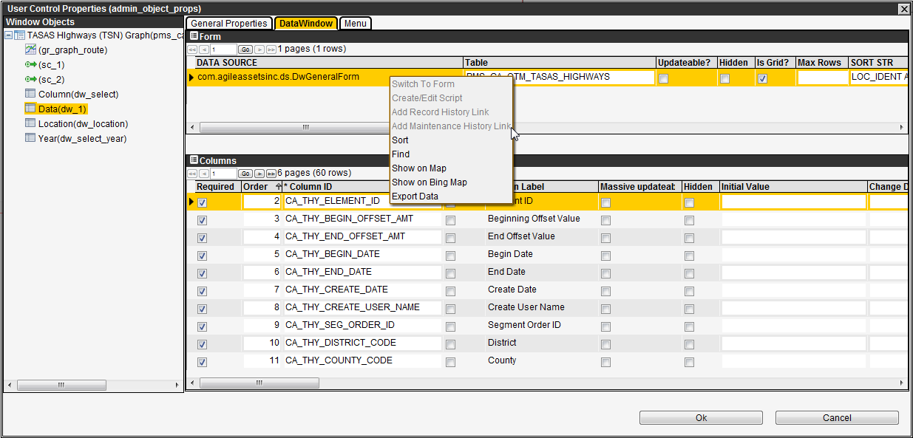

##### Columns Pane

The lower, Columns pane shows the columns that appear in the pane that you right-clicked. By default, this pane lists all columns that are in the table shown in the Forms pane. You may add or remove columns from this pane by utilizing the right-click Select Columns command. This in turn determines what columns are shown in the pane that you right-clicked to launch the User Control Properties dialog box.

Note: If the pane contains a column or columns that provide location information, see the following section for more information.

When you point to a record in this pane and right-click, a shortcut menu is displayed. This menu contains the following special command:

* Select Columns – This command displays a new window in which appear all columns for the table shown in the Forms pane as defined in the Tables window. Select or de-select any set of column names by using the appropriate right-click selection commands. When you close the window, the set of columns in the Columns pane is adjusted accordingly.

Note: If the column is a list column, then all columns in the list column table are also available for selection and are shown as children in the list of all columns.

Note: Be careful in using the Select All command as it selects all columns including all child columns. Instead, the Select Visible Items command is generally used because it ignores these child columns.

Note: If you wish to include a column that is not in the table, use the Insert command. This command adds a new, blank record into which you may type the name of the column you wish to include.

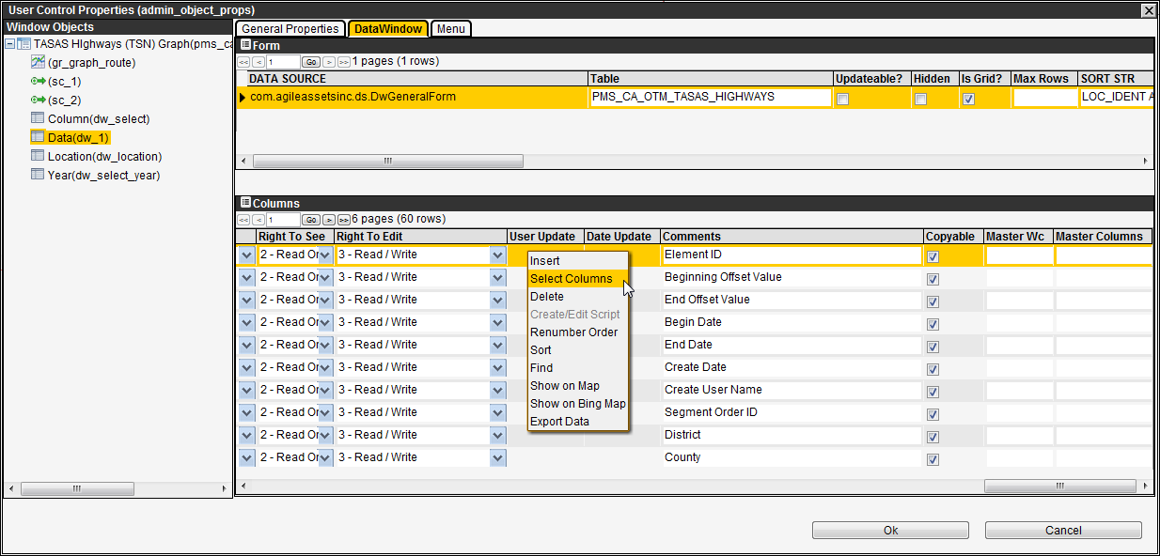

* Create/Edit Script – This command displays a new window in which you enter a Groovy script or modify an existing script. These scripts are for server-side event handlers (mostly data checking routines) for ItemChanged events. After entering the script and closing the window, the new (or modified) script is available in the drop-down list found in the OnItemChange Script column.

The columns that are of particular importance are the following:

* Order – This column sets the order of the columns within the pane (from left to right). If the table is created by a DW\_ proc, this column is read-only.
* Column ID – This column is the database column identification.
* Column Label – This column is the literal description of the column that is used in the column heading of the window pane.
* Required – When this check box is selected, data must be entered in the column. If data is not entered in the column, then when you try to save an error message will appear and the save will be disallowed.
* Editable – When this check box is selected, data in the column may be modified (provided your security profile allows you to edit the data). When it is clear, the data is read-only. (Note: All calculated columns should have this check box clear.)
* Hidden – When this check box is selected, the column is not displayed. (While removing the column from the pane accomplishes the same thing, hiding the column allows you to easily re-display the column if you need to.)
* Initial Value – Placing a value in this column is optional. When a value is placed in this column, it is used to fill the column as each record is inserted.
* Change DDDW – This column is applicable only when the column contains a drop-down list and is used to filter the entries in the drop-down list. The Change DDDW column shows the “SQL where” clause that filters the drop-down list to just the desired items. (Note: To limit the number of entries in the drop-down list, use the Max Rows column.)
* Dropdown Filterable – This check box determines whether the items in the drop-down list in the column may be filtered. When selected, the items are filtered as the column is filtered. When clear, the list is not filtered (even if the column is filtered).
* Column Width – This column sets the width of the column (in pixels).
* Select Str – This column provides the SELECT statement calculation that defines this column’s value. If the table is created by a DW\_ proc, this column is read-only.
* Max Rows – If the column is a drop-down list, this column determines the number of entries in the list. If the value is null, the maximum number of entries is 10,000. If the value is zero, it is the actual number of entries (which may be greater than 10,000). Note: If the value in this column is smaller than the number of candidates for inclusion in the list, then the selection of candidates for inclusion is random (not predictable).
* Is Link – When this check box is selected, each value in the column is a hyperlink and displays a popup window or URL when clicked. To define the hyperlink, you use the following columns:
* Target Window ID – This column contains the WINDOW\_ID of the pop-up window or the URL of the website that will be displayed when the hyperlink is clicked. (If the WINDOW\_ID is not known, use the Setup Window Titles window in the System module, which shows the WINDOW\_IDs for windows.)
* Retrieval Args – This column provides the retrieval arguments (column IDs separated by semicolons) that are passed to the pop-up window and determine what is displayed in the window. These arguments may also be input parameters for the URL, with <1> indicating the first parameter, <2> indicating the second, and so forth.
* OnItemChange Script – This column provides a Groovy script that may be used to validate data and/or determine the value of other column(s) based on what is entered in a column. More information on this type of Groovy script is provided in the following section.

Note: The script is triggered at the point of entry, not upon save. This means that if, for example, a column's value is determined from the values in two other columns and one of these values is null, the script needs to be written so that the third column's value is not generated until values exist in both of the other columns.

Note: Exercise care in creating scripts. This is a powerful feature and utilizing a large number of scripts will degrade performance.

* On Link Click Script – This column provides a Groovy script that may be used to initiate an action when the hyperlinked field is clicked (As setup using the Is Link and Link Target fields). These types of Groovy scripts are usually used to perform actions outside of the FMS – such as opening an external webpage.
* Right to See – This column determines the security level for viewing the column. If this column is set to Null, then the security level for the window is used.
* Right to Edit – This column determines the security level needed to modify data in the column. If this column is set to Null, then the security level for the window is used.
* Master Columns/Master Wc – The list in a drop-down field may be configured to have different entries depending on the record selected. The **Master Columns** column contains the name of the column that is used to constrain what is shown in the drop-down list. Additionally, the **Master Wc** column supplies the where clause that sets what is displayed in the drop-down list.

The third tab in the User Control Properties Dialog Box is the Menu tab. An example of this tab is shown below. You use this tab to set the order in which right-click commands appear in the shortcut menu as well as the Right-to-See security level for each command.

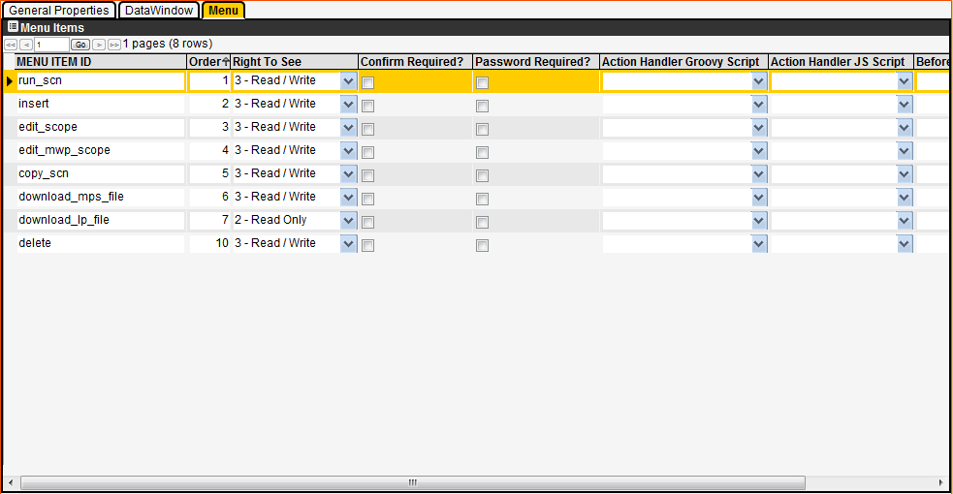

### OnItemChanged Script Information

The OnItemChange Script column contains a drop-down list of existing OnItemChange Groovy scripts that are available within the database. You may also right-click this column and then click the Create/Edit Script command to either edit the currently assigned script or create a new one. Scripts configured here are typically used for validating data as it is entered by a user. These scripts run whenever a user has edited the value in a column and the user moves the cursor off of the field by tabbing or saves data.

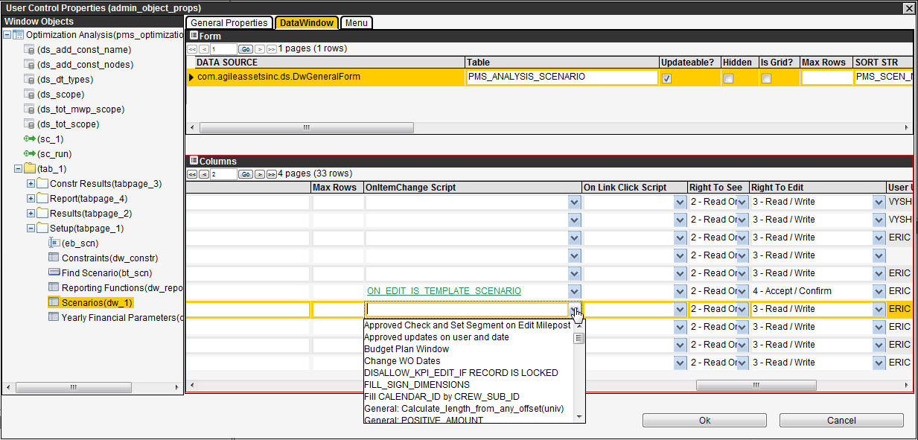

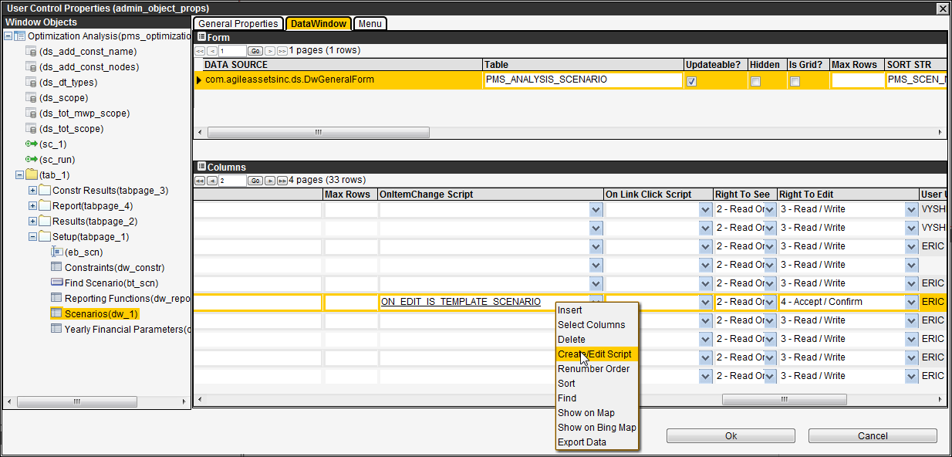

# System Tools

The application provides the following features for the maintenance of the application:

* System jobs, including scheduled imports/interfaces.
* System log.
* System notifications.
* System messages.
* Help topic mapping.
* Groovy scripts.

These features are described in the following sections.

## System Job Executables

(System Module > Tools > System Job > Executables)

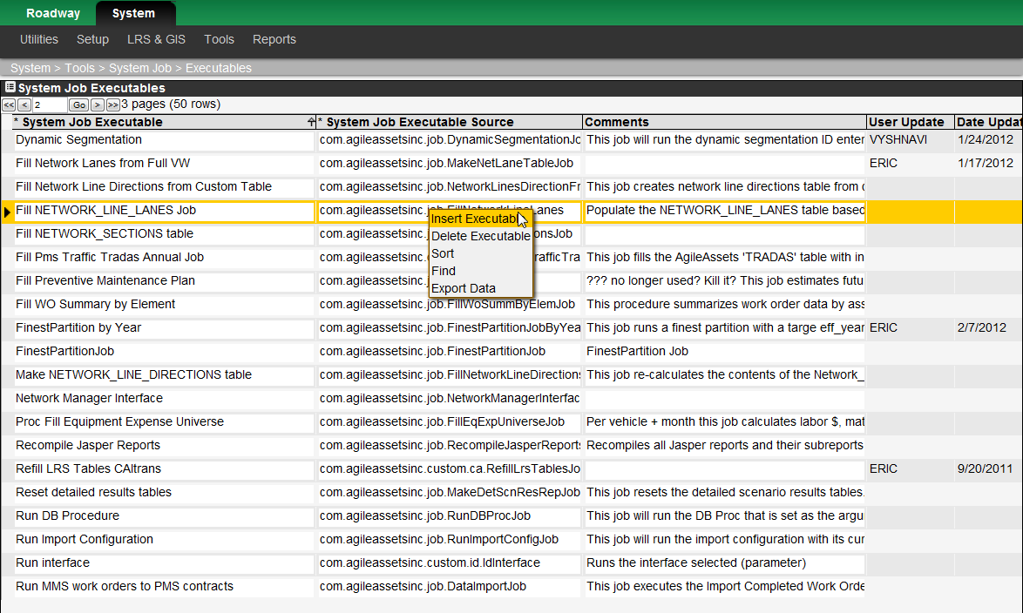

### Description of the System Jobs Executables Window

System jobs must be setup in the System Job Executables window (System Module > Tools > System Job > Executables) before they can be run or scheduled in the System Job Schedules window. The jobs are added to this window (via the Insert command) then the job is named in the System Job Executable field and the system job’s Java object is declared in the System Job Executable Source field. This task is usually performed by a database script during system updates.

## System Job Schedules

(System Module > Tools > System Job > Schedules)

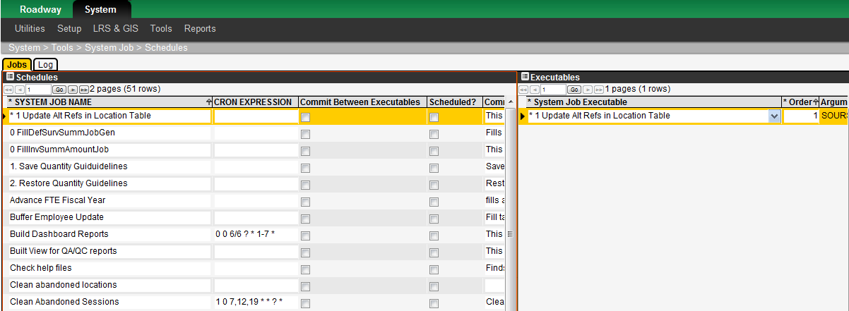

### Description of the Systems Jobs Schedules Window

Note: Scheduled jobs will only run if a user called SYSTEM is in the User Names and Access window.

System jobs are generally those computer processes that help to maintain data within the application and also move data through interfaces to systems external to the application. The jobs may be run “on demand” (via the Run Job command) or periodically as configured with the Edit CRON Expression command.

The Jobs tab lists the available system jobs. For a particular job, after execution the Log tab shows the run history of the job — provided the Log check box in the Jobs tab is selected.

The following table shows the system jobs currently configured for the PaveM application along with a description of what the job does.

| Name of System Job | Description |
| --- | --- |
| Build Dashboard Reports | This job refreshes all user dashboard reports. |
| Check help files | Finds out where there are HTM files set in HELP\_FILE\_NAME of SETUP\_WINDOWS filling HELP\_TOPIC\_ID with 1 if file exists in help, 0 if file does not exist in help, NULL if there is no file name in the HELP\_FILE\_NAME column |
| Clean Abandoned Sessions | Cleans abandoned Oracle sessions. This is just an Oracle clean-up activity that your Oracle DBA may want run periodically. |
| Clean Import Config Log | Clean Import Config Log of records older than N months, always keeping the latest |
| Clean Loc Idents | This job updates the SETUP\_LOC\_IDENT\_USER table by clearing user session location records |
| Expand Milepoints of PRL segments | Run this job after importing APCS data. It takes the beginning and ending DS segment lengths of the PRL segment and add 1.2 the length to the end of the PRL and subtracts 1.2the beging ds length from the beginning. Should recalculate Alternative reference milepoints when done. |
| Fill Network Line Directions from Custom Table | This job creates network line directions table from custom view. |
| FillNetworkLineDirections | This job fills the NETWORK\_LINES\_DIRECTIONS target table from other source(s). It will change per client. This one's source is NET\_Q\_LANES. The target table is required for any finest partition + dynamic aggregation |
| Make NETWORK\_LINE\_DIRECTIONS table | This job re-calculates the contents of the Network\_line\_direction table. It should only be run at the direction of AgileAssets. |
| **PaveM - CAS Projects Import I** | This job imports data from a view of the Caltans CAS Contracts data – Location not imported |
| **PaveM - CAS Project II** | This job imports data from a view of the Caltans CAS Contracts data – Updates location only. Should run after PaveM - CAS Projects Import I |
| **PaveM - TSN Highway Inventory Data** | This job replaces the TSN Highway Inventory Data in PaveM with OTM\_TASAS\_HIGHWAYS data from from a View of the TSN TASAS Highway Log. |
| **PaveM - CAS Contract Items Import** | This job imports data from a view of the Caltans CAS Contract Items data |
| **PaveM - OE Data Import** | This job imports data from a view of the Caltrans Office Engineers Data |
| **PaveM - PRSM Data Import** | This job imports data from a view of the PRSM Projects Data |
| **PaveM - PRSM Milestone Import** | This job imports data from a view of the PRSM Project Milestone Data. Should run after PaveM - PRSM Data Import. |
| Populate Network Master | This system job:   * Fill the NMF with list of pavement management sections from the Pavement Management Sections table. * Updates all the calculated columns in the table (NETWORK\_MASTER) |
| Populate Performance Master | This system job:   * Fill the PMF with list of pavement management sections from the Pavement Management Sections table with a user defined year. * Updates all the calculated columns in the table (PERFORMANCE\_MASTER) |
| Populate PMS\_MGMT\_SECTIONS | This job will run the dynamic segmentation ID entered as a job parameter. |
| Recompile Jasper Reports | Recompiles all Jasper reports and their subreports. |
| Reload CA LRS Tables Job | This job refills the CA LRS from the GIS Data in TIGER\_REFERENCE\_ACT\_OTM view (tiger\_refsec\_highway\_group provided by GIS group). |
| Run DB Procedure | Job that runs specified Database Procedure |
| Send Column Specific Messages | After a column is set up to send a message, then this job must be run for it to actually work |
| Synchronize IDENT\_INV\_ELEM and IDENT\_CLASS\_CODE tables | This job synchronizes the IDENT\_INV\_ELEM (universal inventory element) and IDENT\_CLASS\_CODE (universal class code) tables. |
| Update Alt Refs in Location Table | This job resets the alt ref columns in SETUP\_LOC\_IDENT (strictly for insurance).It may also be used to set these columns for existing SETUP\_LOC\_IDENT rows when the alt loc ref system is initially defined or modified although this is probably all done automatically. |
| Update geometries in Location Table | This job rebuilds the GIS geometry in the GEOM column for locations in SETUP\_LOC\_IDENT |
| Update Oracle geometry meta data | This job updates data in a target table as defined in the Update from Geometry window using the geometry in the defined source table. |
| Update PMS\_PVMNT\_FINEST\_PART | This job must to run to update the calculated data (table) used in the Construction Profile window |
| Update sequences | Updates all sequences with the highest value in data. If no data then sets the sequence to 1. |
| Update Target Table | Runs the Update Target Table against the defined target Table (parameter) for all the updatable columns in this table and for the whole table. |

Note1: Import/Interfaces are in **Bold** font

Note2: To create a new system job, consult with an AgileAssets technical staff member.

### Example of Scheduling a System Job

The following is an example of scheduling a system job to run every Friday at 10:23 pm:

1. Display the System Job Schedules window (System > Tools > System Job > Schedules).
2. In the Schedules pane, point to the job to be scheduled (see the Job Name and Comment fields for a description of what each job does), then click it to select and highlight it.
3. In the Executables pane, right-click on the system job executable, then click Define Argument(s) to set the arguments to be used when the job is run. The system displays a new Define Arguments window which allows you to set the arguments to be used when the job is run.
4. Click OK in the Define Arguments window once the argument(s) have been set.
5. Click icon_save to save the new arguments.
6. In the Schedules pane, right-click on the job to be scheduled, and then click Edit CRON Expression. The system displays a new window that allows you to set when the job is to be run.

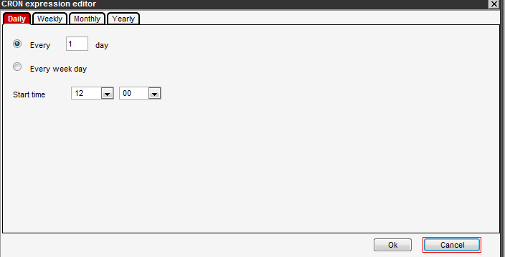

1. Click on the Weekly tab in the CRON expression editor window which opened.
2. Click in the select box next to Friday to select it.
3. Use the drop-downs next to the Start time text to select: ‘22’; ‘23’ (22:23 or 10:23 pm).
4. Type ‘1’ in the Every ‘ ’ week(s) field.
5. Click OK to save the new schedule and close the window for entering the scheduled time.
6. In the row showing the system job, if you would like a log to be kept of this job, click the check box shown in the Log column. (The log will appear in the Log tab of this window.)
7. Click in the job’s Scheduled? field to select the checkbox and schedule the job to run.
8. Click icon_save to save the new schedule.

Note: To create a new system job, consult with an AgileAssets technical staff member.

Note: Use the Edit CRON Expression command wisely. For example, setting an automatic schedule for procedures with input parameters may result in "process" problems. If it is scheduled, the procedure will run automatically using its default parameter value set as identified in the window. This may lead to negative results. Consequently, the user is responsible for making the correct decision whether to schedule jobs that have input parameters.

## Notifications

(System Module > Tools > Notifications)

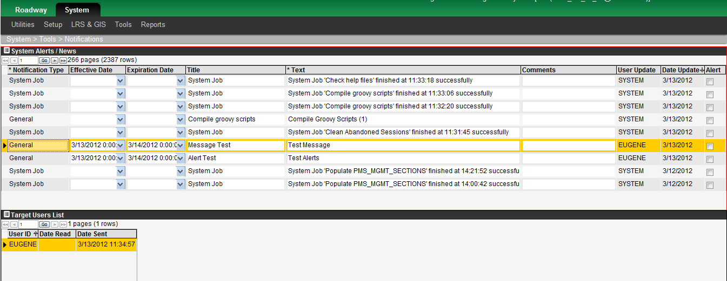

The PaveM application supports general system notifications. General notifications are displayed to a user whenever the date and time set in the Effective Date column is reached. Once a user views a notification and sets it as Read then closes the notification messages window, he or she will not see the notification again.

A notification is configured by using the Insert command found by right-clicking in the System Alerts / News pane of the Notifications window (System Module > Tools > Notifications). This inserts a new record in the table, and you may then add the necessary information to the record for the notification. When you save the new record, the notification is activated and will be triggered at the specified date and time set in the Effective Date column. It will remain in effect until the date and time set in the Expiration Date column. You should also enter a header for your notification in the Title field, and the detailed notification in the Text field.

Note: Double-clicking in either of the date fields will display a calendar that shows not only dates but time as well. When using this calendar, set the time first and then click the desired date because clicking a date closes the calendar window.

## Notification Types

(System Module > Tools > Notification Types)  
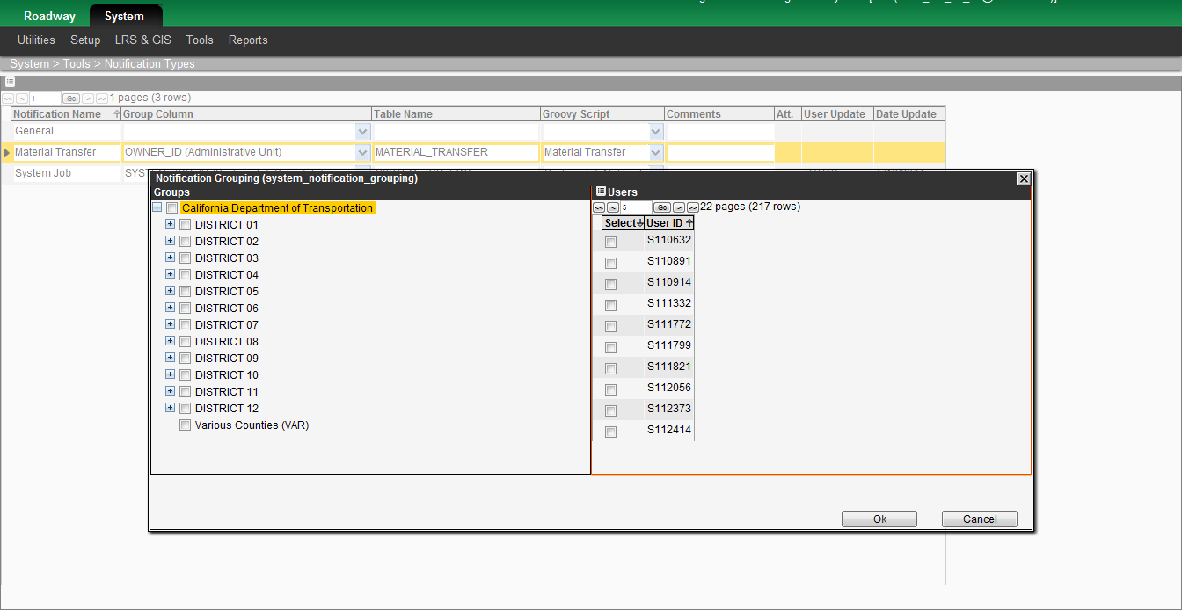

|  |  |  |  |  |  |  |  |  |
| --- | --- | --- | --- | --- | --- | --- | --- | --- |
| You use the Notification Types window to configure messages that are sent when a certain action occurs. (You may also configure messages that are sent at a certain time; this type of message [called a General message] is configured in the [Notifications](http://vega:8080/ams_tx_06_06_limited/Help/notifications.htm) window.)  The different types of notifications vary depending on the needs of the agency using the AgileAssets system. Two examples of typical types utilized by several agencies (Note, none of these are applicable to the Caltrans PaveM) are described below.   |  | | --- | | * Material Transfer – This type generates messages when a material transfer occurs, that is when a request for stock transfer is made and when the stock to be transferred is “fulfilled” (sent from the warehouse that had the stock originally). | | * Service Request – This type sends a message to the user(s) who will be doing the work described in the service request when the service request is inserted or the owner assigned is changed. |   The following columns are found in this window:   |  | | --- | | * Notification Name – This column shows the label for the notification type. |   Note: The General type is by default always present. However, it has no function in this window and so the fields for this type are left empty. Its use is in the [Notifications](http://vega:8080/ams_tx_06_06_limited/Help/notifications.htm) window.   |  | | --- | | * Group Column – This column shows the group of users to whom the message will be sent. You may modify the message's recipients by using the Edit Grouping command, which is found on the shortcut menu that is displayed by right-clicking the record. | | * Table Name – This column shows the name of the table in which a data change will cause the message to be sent (based upon the criteria in the Groovy script). | | * Groovy Script – This column contains the name of the Groovy script that determines when the message will be sent and also what the message will contain. The Groovy script is selected from a drop-down list, the contents of which are all Groovy scripts of the AfterChange Notification Trigger type. |   When you right-click a record, the system displays a shortcut menu. This menu contains the common commands along with the following commands:   |  | | --- | | * Create/Edit Script – This command is only available when the Groovy Script field is active. When enabled, this command displays the Groovy Script dialog box. | | * Edit Grouping – When you select this command, the system displays a dialog box showing the users who are part of each group (and will thus receive the notification for that group). You may then edit who belongs to each group and save the new data. |   Note:  Some versions of the AgileAssets system allow a user to designate an alternate user to receive his or her messages. This is configured in the [Set Substitutes for Notifications](http://vega:8080/ams_tx_06_06_limited/Help/notification_substitutes.htm) window (System Module > Utilities > [Set Substitutes for Notifications](http://vega:8080/ams_tx_06_06_limited/Help/notification_substitutes.htm)). |

## System Logs

(System Module > Tools > Logs)

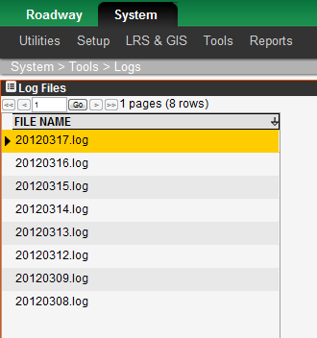

The purpose of the System Logs window is to capture error statements that are transmitted by the system. These logs are then sent to AgileAssets support staff to aid in their debugging efforts.

When you report a problem to AgileAssets you may be instructed to “turn on the log" and then send the results to AgileAssets. This is accomplished by setting the Logging Level parameter in the System Parameters window to a value other than None. The application will then log all errors that occur in the system. The logs are then listed in this window, the System Logs window.

You open a particular log by first downloading a log to your computer by using the Download File right-click command. Then, once the log file is downloaded, you can open it using a tool such as Notepad or send it to AgileAssets as instructed.

## Groovy Scripts

Caution: The Groovy Scripting feature provides considerable flexibility to the software. Due to the power of this feature, it should only be used by people trained in Java and its use within this application. Used improperly, this feature can cause serious problems.

The Groovy Scripts window (System > Tools > Groovy Scripts) is where Groovy scripts are developed and maintained. An example of this window is shown on the following page. Groovy scripts provide the ability to add features to the application by writing and applying appropriate Java code. For example, this feature is often used to add data-checking capabilities for data entry. The scripts configured in this window are then available in the appropriate drop-down lists found in other parts of the application.

There are many types of Groovy scripts, with several Groovy scripts per type – each of which adjust or check data in a different way. The following table shows eight different types of Groovy script along with information on purpose, when invoked and where configured, the table in 5.6.3 Groovy Script Types and Parameters contains the full list of groovy script types available in the system.

| Type | Purpose | When Invoked | Where Configured |
| --- | --- | --- | --- |
| AfterImport | Adjusting the data imported into the target table at the end of the import routine. | At the end of an import routine. | The Imports tab of the Import Data window. |
| AfterInsert | Setting initial values of columns for the record just inserted. | Immediately after the Insert command executes. | When in Design Mode, in the Form (top) pane of the Data Window tab of the Change Control Properties dialog box. |
| BeforeSave | Data-checking during data entry. | When you click the Save icon prior to the actual data save. | When in Design Mode, in the Form (top) pane of the Data Window tab of the Change Control Properties dialog box. |
| ChangeWithTime | Adjusting data from year to year within network analysis. For example, increasing the pavement age each year. | During analysis in each year just after normal performance model deterioration is applied. | In the PMS Columns in Analysis window. |
| ConditionImprovement | Adjusting the value of a PI (performance index) column after application of a treatment. | During analysis just after treatment is selected for a given year. | In the bottom two panes of the Treatments window. |
| ImportMapping | Adjusting the data imported into the target table on a column-by-column basis during the transfer of data. | When data is transferred from the source to the target table. | The Import Detail tab of the Import Data window. |
| OnItemChange | Data-checking during data entry. | When you leave the data cell. | When in Design Mode, in the Column (bottom) pane of the Data Window tab of the Change Control Properties dialog box. |
| PIThresholdForRSL | Expression to compute the end of life threshold with respect to each PI (performance index). | During analysis in each year just after treatment selection (including “no” selection) has been decided and improvement has occurred. | In the top right pane of the Performance Models window |

### Groovy Scripts Window

(System Module > Tools > Groovy Scripts)

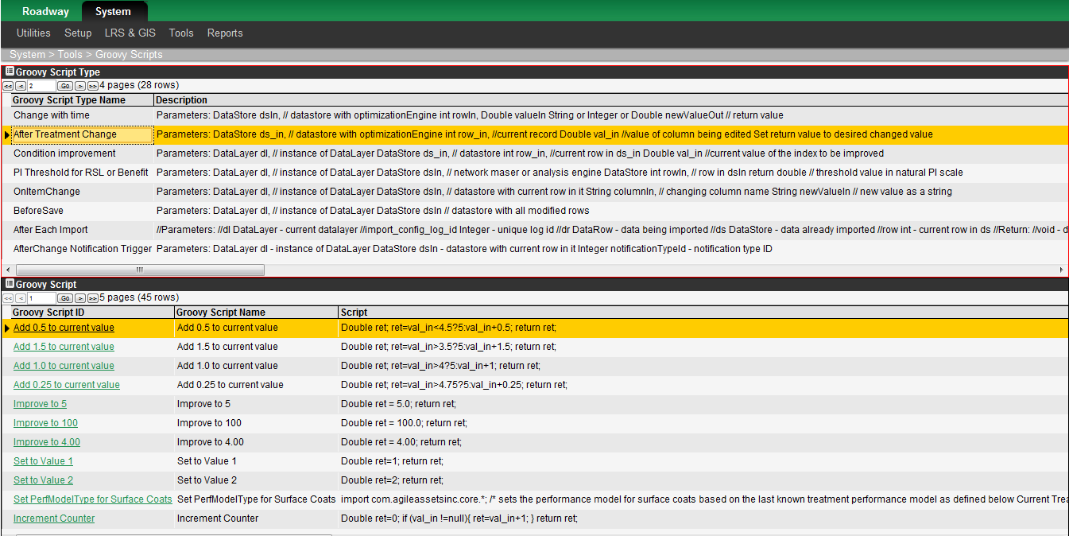

The top pane of the Groovy Scripts window shows the different types of Groovy scripts that are available.

For the type selected in the upper pane, the lower pane shows the Groovy scripts that have been created for this type. The lower pane also provides the following command in addition to the common commands:

* Edit Groovy Script – This command displays the Groovy Script dialog box, in which you may modify the selected Groovy script. This dialog box is described in the following section.

### The Groovy Script Dialog Box

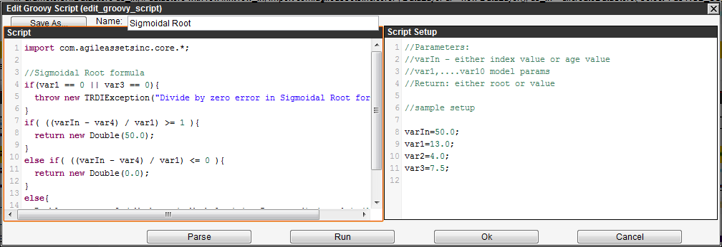

The Groovy Script dialog box is displayed after selecting the Insert or Edit Groovy Script command from the Groovy Scripts window. This dialog box allows you to create or modify Groovy scripts.

The left pane shows the actual Groovy script. (The displayed name for the script is shown in the Name field.) The right pane shows the allowed parameters for this type of script and serves as a reference when creating or modifying scripts.

The following buttons are also available:

* Save As – This button allows you to copy the current Groovy script as a basis for creating a new Groovy script. You can assign a new name to the script and adjust the script as desired.
* Parse – This button checks the Groovy script’s syntax and displays what is found.
* Run – This button runs the Groovy script and shows the output. This button will only work for those types that have no input parameters; otherwise an error will occur (saying the script needs input).
* OK – This button saves the Groovy script and closes the Groovy Script dialog box.
* Cancel – This button discards any changes made in the Groovy Script dialog box and closes it.

### Groovy Script Types and Parameters

There are many types of Groovy scripts as can be seen in the Groovy Scripts window (System Module > Tools > Groovy Scripts), six of the most used types of Groovy scripts are listed in the table below. Each Groovy script uses particular parameters (and only these parameters). The following table lists the input parameters for each the six most used type of Groovy Script.

| Type | Parameters | Description |
| --- | --- | --- |
| Activity | DataLayer dl | Instance of DataLayer. |
| DataStore dsIn | Datastore with all modified rows in it. |
| AfterTreatmentChange | DataStore dsIn | Datastore with optimization engine. |
| int rowIn | Current record. |
| double val\_in | Value of column being edited. |
| Return | Desired changed value. |
| AfterChange Notification Trigger |  |  |
| AfterImport | Varies | May contain various parameters. |
| AfterInsert | DataLayer dl | Instance of DataLayer. |
| DataStore dsIn | Datastore with inserted row in it. |
| BeforeOpenMenu |  |  |
| BeforeSave | DataLayer dl | Instance of DataLayer. |
| DataStore dsIn | Datastore with all modified rows in it. |
| CalcColumnsinAnalysis |  |  |
| ChangeWithTime | DataStore ds\_run | Datastore with optimization engine. |
| int rowIn | The current row within the optimization engine. |
| Double valueIn | The value of the column that is being changed (within rowIn). |
| newValueOut | Return value (string or integer or double). |
| ConditionImprovement | DataStore ds\_run | Datastore with optimization engine. |
| int rowIn | The current row within the optimization engine. |
| Double valueIn | The value of the column that is being changed (within rowIn). |
| newValueOut | Return value (string or integer or double). |
| ImportMapping | Varies | May contain various parameters. |
| MMS Models | DataStore dsIn | Datastore with current data in it. |
| int rowIn | Current row of dsIn. |
| currentScore | Current score. |
| targetScore | Target score. |
| currentBudget | Current budget. |
| Return double | The future budget. |
| MMS Util Function | DataStore dsIn | Datastore with current data in it. |
| int rowIn | Current row of dsIn. |
| currentScore | Current score. |
| Return double | The utility value for the given score. |
| OnItemChange | DataLayer dl | Instance of DataLayer. |
| DataStore dsIn | Datastore with current row in it. |
| String columnIn | The column name in which the change occurs. |
| String newValueIn | The new value as a string. |
| OnLinkClick | DataLayer dl | Instance of DataLayer. |
| DataStore dsIn | Datastore with current row in it. |
| Return string | URL of the link. |
| PIThresholdForRSL | DataLayer dl | Instance of DataLayer. |
| DataStore dsIn | Network master or analysis engine DataStore. |
| int rowIn | Row in dsIn. |
| return double | Threshold value in natural PI scale. |
| System Job Notification |  |  |
| Treatment | DataLayer dl | Instance of DataLayer. |
| DataStore dsIn | Datastore with all modified rows in it. |

# Database Management

This section describes various aspects of database management such as creating tables, windows, and menu items.

## Columns

(System Module > Utilities > Columns)

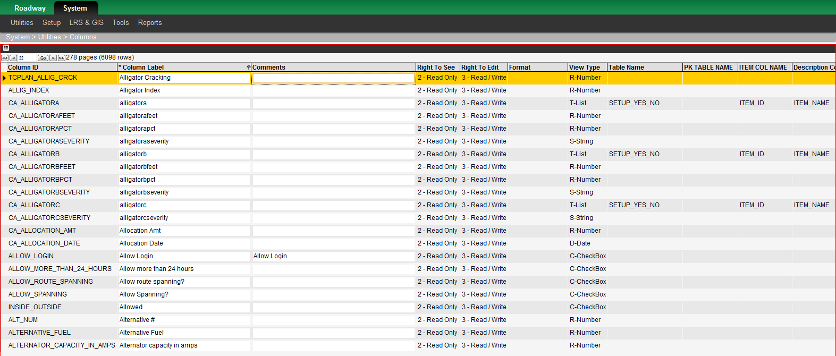

Columns are configured and maintained in the Columns window (System Module > Utilities > Columns) As discussed previously in the section on security, this window is utilized to set access to data in the column. Additionally, you may use this window to set the attributes of a column.

The Columns window contains the following columns:

* Column Label – This is the name of the column as seen by a user. (The Column ID column shows the name of the column within the system.)
* Right to See – This is the minimum access level setting in a user's profile (for the window) to allow the user to see the column within that window.
* Right to Edit – This is the minimum access level setting in a user's profile (for the window) to allow the user to edit the column within that window.
* Use for Weighted Average – A check mark indicates that the column may be used to create weighted-average aggregations in tabular reports.
* Format – This column configures how the data in the column is formatted. Dates and times are formatted automatically as set in the System Parameters window. Monetary values are formatted by putting [Currency] in the column, with the currency format being that which is configured in the System Parameters window. Finally, numbers may be formatted using Java formatting techniques; see this website for more information: http://java.sun.com/j2se/1.4.2/docs/api/java/text/DecimalFormat.html

Note: You cannot edit the Format column directly. Instead, right-click the record for the column and then click Edit. The application displays a dialog box. Click Next to view the second page of the dialog box and, provided the View Type is R-Number, the field for setting the format is at the bottom of the dialog box.

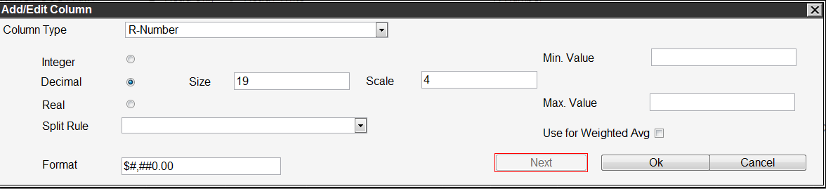

* View Type – This column only affects the display of data when used and filtered in standard reports. This allows an Application Administrator to create new columns for reporting and choose how the columns will be configured for the user in filtering and displaying the data in reports. The permitted variables for View Type are as follows:
  + B – Color.
  + C – Check box (a variable that has two values displayed as a check box).
  + D – Date.
  + R – Number (real).
  + S – String (character).
  + T – If the Table\_Name and Parent\_Col\_Name columns are completed, this indicates a tree-type list. If the columns are not completed, this indicates a simple list.

When the View Type variable is Tree, the following additional variables may be used:

* + DB Tables and Views – This is the name of the lookup table that contains the list of legal values (codes) and a description of each.
  + ID Column – This is the name of the column in the lookup table that is the code. This is the actual data value stored in the database. (This field does not display until a table is selected in the DB Tables and Views field.)
  + Label Name – This is the name of the column in the lookup table that is the literal description of the code. This is what the user will see on the screen when reporting or filtering data based on this column. (This field does not display until a table is selected in the DB Tables and Views field.)
  + Where Clause – This is the Oracle "**where**" statement to apply to the Oracle lookup table in order to get only the set of values that apply to this column ID. (This field does not display until a table is selected in the DB Tables and Views field.)
  + PK Tables – If you pick a view in the DB Tables and Views field, this field supplies the underlying table needed for the foreign key that is required for future automatic processing.
* Rule for Finest Partition Data Split – When the Master Work Plan is included in network analysis; the system performs a finest-partition operation between it and the Network Master file. The type of finest partition operation is selected from the drop-down list in this column.

Note that not all of these columns can be edited directly in the window itself. Instead, you use the Insert and Edit commands, which have special functionality for column-attribute manipulation:

* Insert – This command inserts a new column into the system. Once a column is defined in this window, other windows (that build or adjust data table structures) can assign it to one or more data tables. When you select this command, a new window appears. The user supplies the column ID, descriptive label, and other column attributes. See the Edit command description for details on column attributes.

Note: The following rules must be observed when naming new columns:

* + The column name must begin with a letter.
  + The column name cannot be longer than 30 characters.
  + The column name must be made up of alphanumeric characters or the following special characters: $, \_, and #. If the column name uses any other characters, it must be enclosed in double quotation marks.
  + The column name cannot be an Oracle "reserved word." (See the following site for reserved words: <http://docs.oracle.com/cd/B19306_01/em.102/b40103/app_oracle_reserved_words.htm>)
* Edit – This command provides edit capability for the attributes of an existing column. When you select this command, a new window appears that is identical to the window displayed with the Insert command – except that the column ID is already present and cannot be changed. Three column attributes are editable here: column label, right to see, and right to edit. To edit the remaining column attributes, click the Next button. The information available and editable in the subsequent pane varies depending upon the column type selected as shown at the top of the pane:
  + When the T-List column type is selected, then you select the table from which the data for the T-List column will originate. Then you select the column in that table that uniquely identifies the data. Next, you select the column in that table that will be displayed when the T-List is used as a drop-down list. Finally, you set the "where clause" if you want only a portion of the data selected to be shown for the T-List.
  + When the String column type is selected, then the size of the column (how many characters) must be provided.
  + When the Color, Date, or Checkbox column type is selected, then the rest of the pane is blank.
  + When the R-Number column type is selected, then the following information must be provided:
    - The Numeric Type. Select the type by clicking the appropriate radio button: Integer, Decimal, or Real. If Decimal is selected, then additionally provide the size (number of digits on both sides of the decimal point).and scale (number of digits to the right of the decimal point).
    - The minimum value and maximum value used for data validation.
    - Whether the values in the column may be used for weighted-average aggregations.
    - The Split Rule if your agency has implemented either the AgileAssets Pavement Management System or Road Network Manager product. When one of these products is implemented, you need to specify the Split Rule because that rule is needed in the Finest Partition operation; it determines how the numeric value will be adjusted when road section limits are more finely partitioned.

The following are the available Split Rules (null uses Don’t Split rule):

* + - Split along and across – Any value that varies as road section area varies normally would be split along and across. An example would be cost to maintain a road section.
    - Split along – Any value that varies as road section length varies, but is not affected by road section width changing, normally would be split along. An example would be roadway length.
    - Split across – Any value that varies as road section width varies, but is not affected by road section length changing, normally would be split across. An example would be pavement width pertinent to this record.
    - Don't split – Any value that varies as road section width varies, but is not affected by road section length changing, normally would be split across. An example would be average elevation of this road section.

Note: When editing, in the first popup window that is displayed, you may change any of the fields. However, for the second popup window that is displayed by clicking Next, do not change any fields without first consulting AgileAssets.

In addition to the Edit and Insert commands, a Delete command is also available. However, this should not be used without first consulting with AgileAssets. Unpredictable operation may occur if you delete a column that is in use.

## Tables

(System Module > Utilities > Tables)

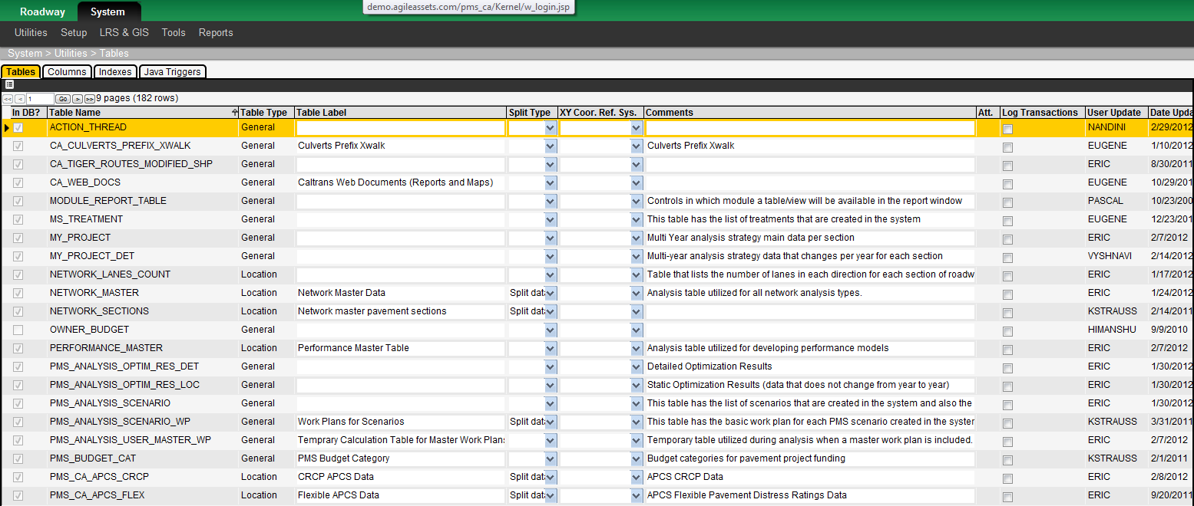

Four types of tables are supported: inventory, location, setup, and general. The Tables window is the primary means of creating and maintaining location, setup, and general tables in the database – along with the windows and menu items needed to display the data in the table. Inventory tables are created in the Setup Asset Type window, with the menu items and windows created in the Tables window. This section first describes this window and then provides instructions to create tables as well as the menu items and windows to display the table data.

### Description of the Tables Window

The Tables window contains the following tabs:

* The Tables tab lists all tables created via this window as well as all inventory and class code tables created from the Asset Type window.
* For the table selected in the Tables tab, the Columns tab lists all columns in the table.
* For the table selected in the Tables tab, the Indexes tab lists the indexes and primary keys for the table.

##### Tables Tab

The Tables tab lists each table created using the Tables window. It also shows any inventory and class-codes tables created via the Asset Type window. The Table Name column shows the name of the table as it exists in the database; it is set by the user during the Insert process.  
(System > Utilities > Tables > Tables Tab)  
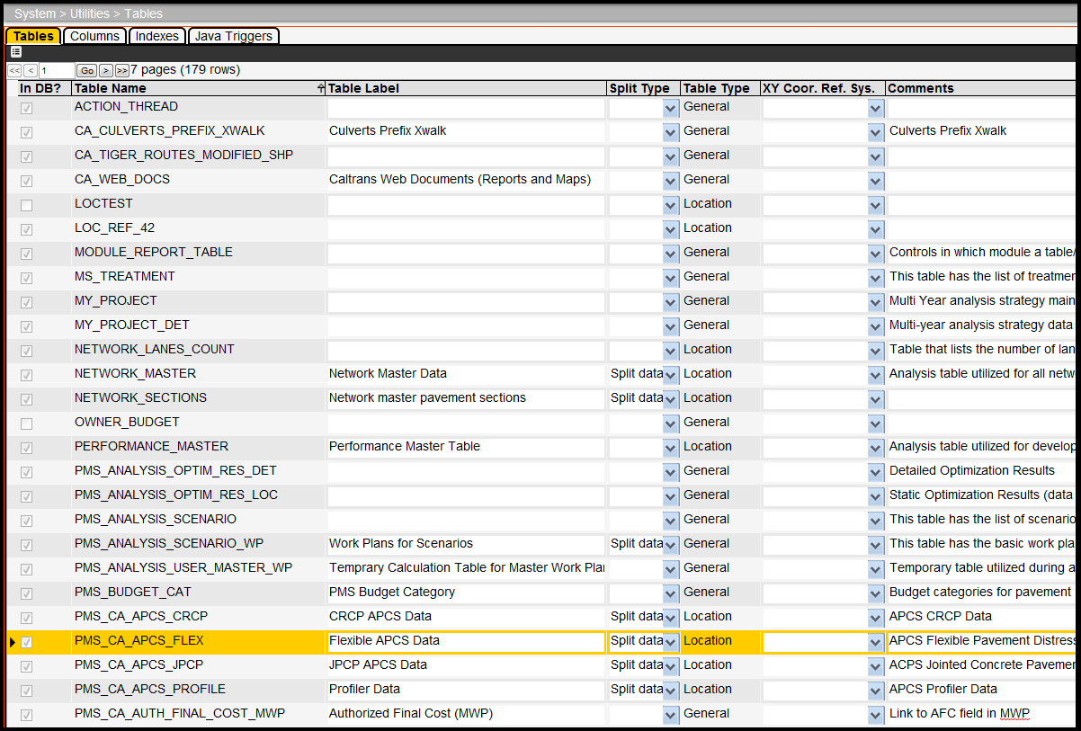

##### Columns Tab

The Columns tab shows the columns in the table selected in the Tables tab. When the Apply Changes right-click command in the Tables tab is executed, it updates the table structure using the column definitions from this tab.

(System > Utilities > Tables > Columns Tab)  
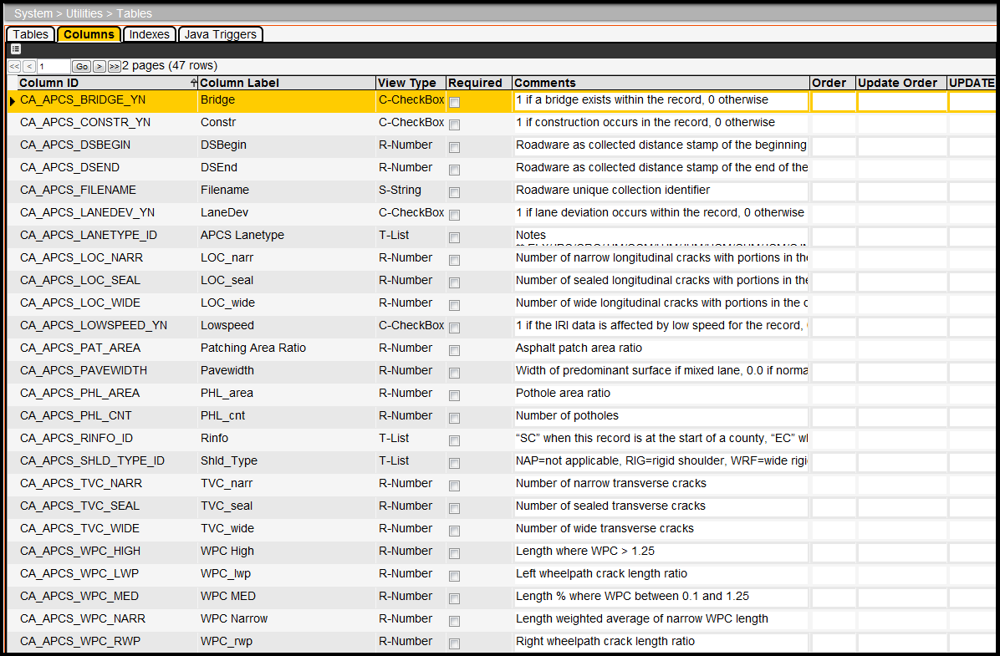

The columns in this tab provide the following information:

* Column ID – This is the internal name that identifies the column.
* Column Label – This is the name of the column as seen in the application.
* View Type – This column identifies the type of column. This value controls how the column is configured in the Oracle table as well as how it is displayed in data windows. Valid values are: B - Color; C - Check Box; D - Date; R - Number; S - String; and T - List.
* Required – When the check box in this column is checked, data must appear in the column. The system will also prefix the column name with an asterisk (\*) to denote that it is required.
* Audit – When the check box in this column is checked, a change history for the data in the associated column is kept and is available by clicking the Audit Link column's value in the appropriate data entry window. Note: Auditing only works on tables that have a single-column unique index.
* Update Order – This field configures the order in which calculated columns are calculated. This order is important whenever one calculated column is based upon the results of a second; in this case, the first column’s Update Order must be larger than the second’s. This field is ignored whenever the Update Source field is blank.
* Update Source – This field, when filled, indicates that this row in the Columns pane is a calculated column and is the SELECT SQL statement that performs that calculation.
* Where Clause – This field, when filled, is the WHERE clause portion of the SELECT SQL provided in the Update Source field. This field is ignored whenever the Update Source field is blank.

##### Indexes Tab

The Indexes pane in the upper part of the tab lists the indexes for the table. The Available Columns and Index Columns panes in the lower part of the window are used to see and/or adjust the column components of the currently selected index.

(System > Utilities > Tables > Indexes Tab)  
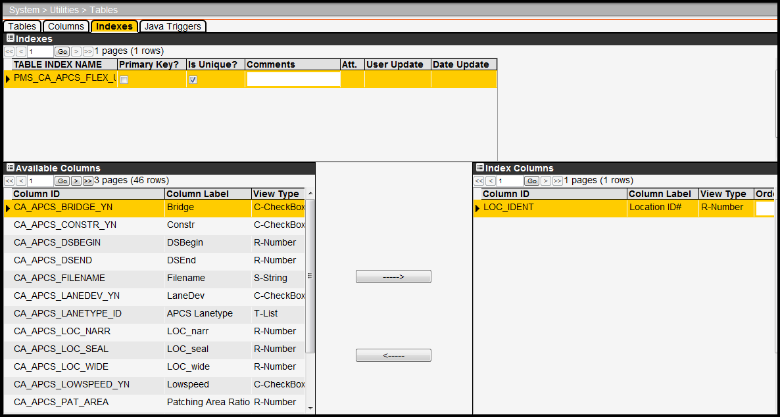

The Indexes tab shows the indexes pertinent to the table identified in the Tables tab. When the Apply Changes right-click command in the Tables tab is executed, it updates the indexes definitions from this tab.

The Indexes tab contains three panes:

* Indexes pane – This pane lists all indexes for the table selected in the Tables tab.
* Available Columns pane – This pane lists all columns for the table selected in the Tables tab and is used to select columns to be put into the current index.
* Index Columns pane – This pane lists all columns in the index currently selected in the Indexes pane.

The index tab also contains two buttons with arrows to add and remove columns from the index. The upper arrow key adds the column selected in the Available Columns pane to the Indexes pane. The lower arrow key removes the column selected in the Indexes pane and places it in the Available Columns pane.

The columns in this tab provide the following information:

* The Primary Key? column in the Indexes pane sets the index to be the primary key. Only one index (per table) can be the primary key.
* The Is Unique? column in the Indexes pane sets the index to be unique.
* The Order column in the Index Columns pane sets the order of the columns in the index.

##### Java Triggers Tab

The Java Triggers tab shows Java scripts that trigger changes in the table selected in the Tables tab. It also lists AfterChange type Groovy scripts that affect the table. When the Apply Changes right-click command in the Tables tab is executed, it updates the AfterChange Groovey script defined in this tab.

(System > Utilities > Tables > Java Triggers Tab)

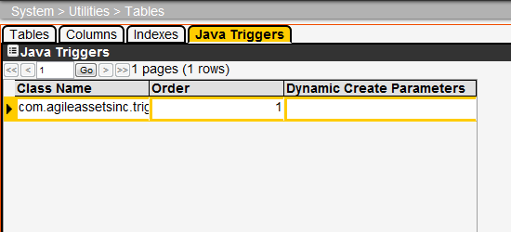

Since Groovy scripts cannot run in an Oracle environment as such, each is given a Java "wrapper" that enables the Groovy script to run. The name of this wrapper is the same for all AfterChange Groovy scripts: com.agileassetsinc.trigger.GroovyScriptTrigger. The particular AfterChange Groovy script is given in the Dynamic Create Parameters column, which shows the ID number of the Groovy script.

When you right-click a record that shows com.agileassetsinc.trigger.GroovyScriptTrigger in the Class Name column, the Edit Groovy Script command becomes available, which opens the dialog box used to create the Groovy script.

If you wish to use an existing AfterChange Groovy script rather than create a new one, do not use this command. Instead insert a new record in the Java Triggers tab and in the:

* Class Name column enter “com.agileassetsinc.trigger.GroovyScriptTrigger”
* Dynamic Create Parameters column enter the ID number of the existing Groovy script.
* Order column enter the order of execution if more than one record exist

### How to Create a Table with Location Data

The majority of the tables in a Pavement Management System contain location data. Follow these steps to create a new table that contains location data with the Tables window:

1. Open the Tables window.
2. In the Tables tab, right-click and then click Insert. The application displays a dialog box.  
   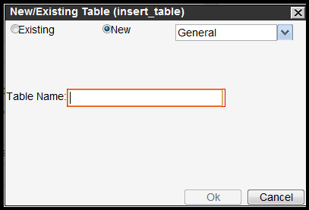
3. For the purposes of this example, assume that the table does not yet exist in the database. Therefore, in the Insert dialog box click the radio button beside New.
4. Click the arrow for the drop-down list and then click Location.  
   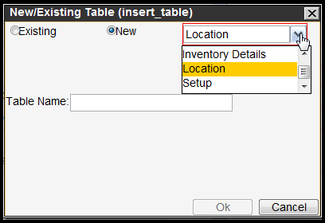
5. Enter the internal name of the new table in the text field in the lower part of the dialog box.  
   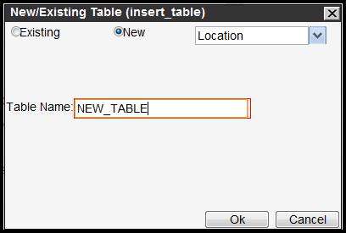
6. Click OK. The application closes the dialog box and adds a new record to the table. (The table is not actually created in the database at this point.)
7. In the new record, enter the name of the new table in the Table Label column and, optionally, any additional information in the Comments column.  
   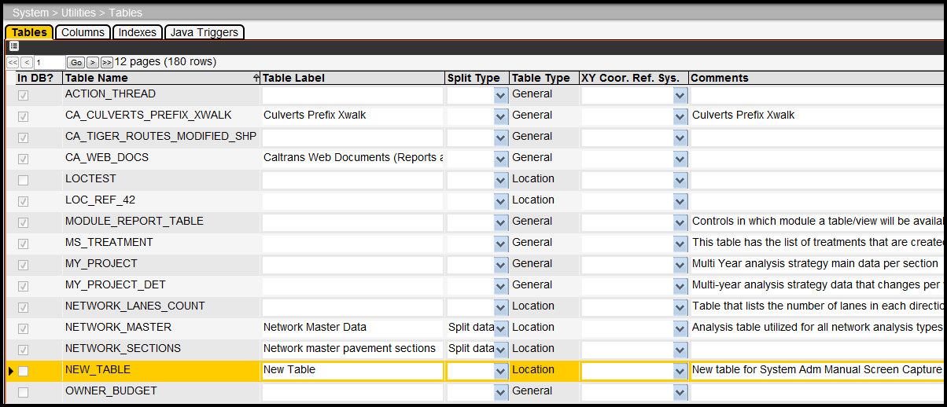
8. Click the Columns tab. This tab shows the default columns for any table (comments, user ID, and user update date). The LOC\_IDENT column is one of the default columns for a Location table.  
   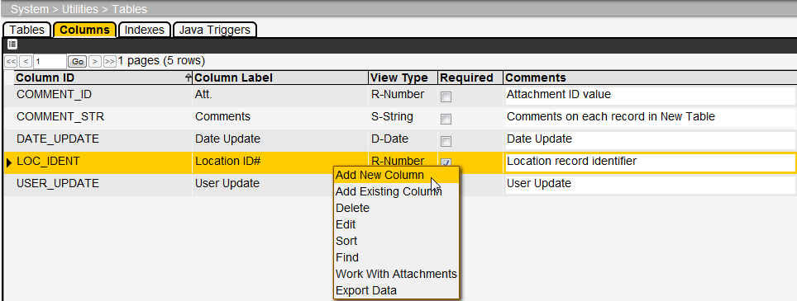
9. Right-click in the Columns tab and then select the appropriate command: either Add New Column if the column does not exist in the database or Add Existing Column if the column does exist. See page 101 for more information on adding a column.
10. Repeat step 9 for each column.
11. If desired, click the Index tab and create an index for the table. See page 102 for more information on creating an index. A unique index on the LOC\_IDENT column is automatically added to all Location tables.
12. Click the Tables tab.
13. Right-click the record for the new table and then click Apply Changes. The application now creates the table in the database with the columns specified in the Columns tab.
14. Click the **icon_save** icon.

The table is now created. Next you will need to create the window for the display of data from the table. Three general types of windows may be created: one that displays data in a tabular format (a data window); one that displays data graphically along a route, provided location information is in the database table (a graph window); and a popup window that is launched via hyperlinks in a column (a popup window). Procedures to create these three types of windows are described in the following sections.

### How to Make a Data or List Window

To create the window that will display the data in a table, follow these steps:

1. Display the Tables window (System > Utilities > Tables).
2. Locate the table for which you will create a window. Right-click the record showing the table and then click Make Window. The application displays a new window. The default selection in the dialog box is to create a data window, which is the goal of this example.  
   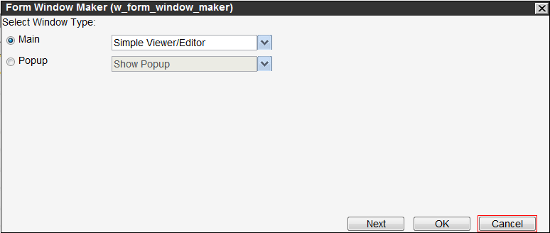
3. Keep the default options (Main radio button - Simple Viewer/Editor), just click Next. The application displays a second new window.
4. In the second new window, check that the Window Title is what you want. If necessary, modify the title as desired.  
   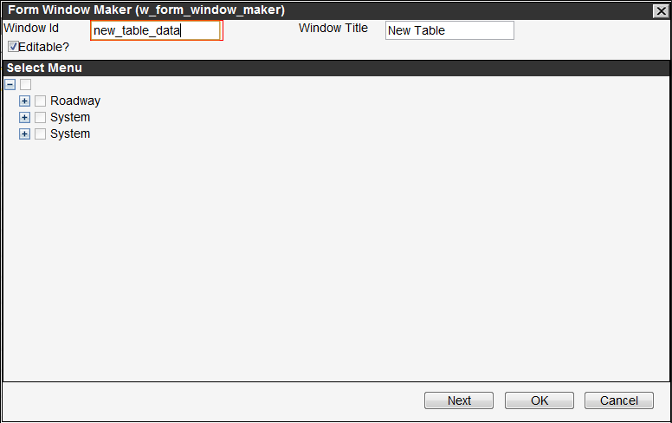
5. If the data in the window may be modified, click the Editable? check box to select it.
6. In the lower part of the dialog box, expand the menu hierarchy to locate the parent menu item under which the menu item to display the window will be placed.
7. Right-click the parent menu item and then click Add Branch. The application displays a new dialog box so you may enter the name of the menu item.  
   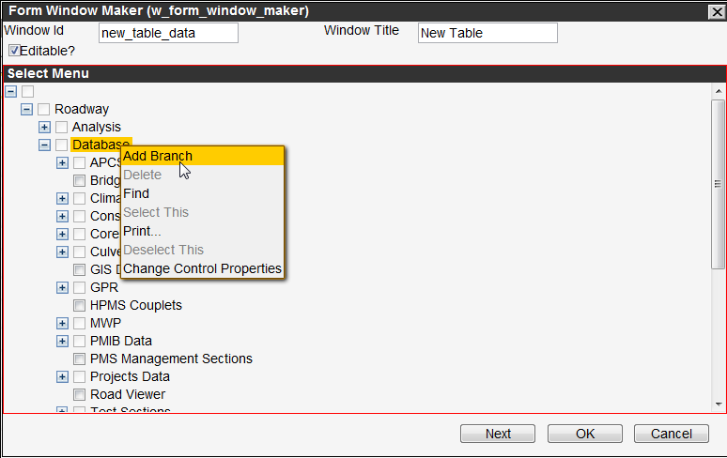
8. In the dialog box, in the New Menu ID field enter the internal ID for the menu item that will open the window. (This ID should be lower case and not contain spaces.) Also, in the New Menu Name field, enter the name of the menu item that will open the window.  
   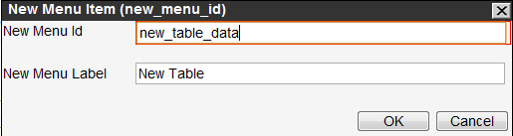
9. Click OK to close the dialog box. A new node is added subordinate to the parent menu item and the check box next to it is automatically selected.
10. Click OK to make the window.

### How to Make a Popup Window

You may elect to display data from a table in a window that "pops-up" when you click a hyperlink in a column. This is accomplished as follows:

1. Display the Tables window (System > Utilities > Tables).
2. Locate the table for which you will create a popup window. Right-click the record showing the table and then Make Window. The application displays a new window. The default selection in the dialog box is to create a data window, not a popup window.
3. Click the radio button for the second option (Popup).  
   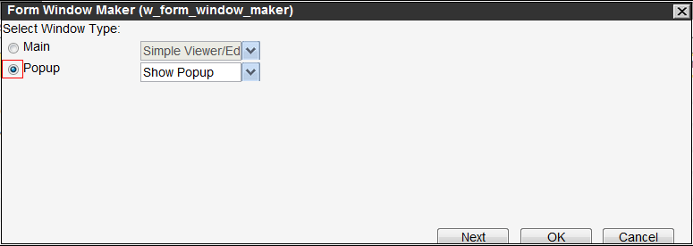
4. Click Next. The application displays a second window.
5. In the second window, check that the Window Title is what you want. If necessary, modify the title as desired. Also, write down the popup window ID as this will be needed when configuring the hyperlink.  
   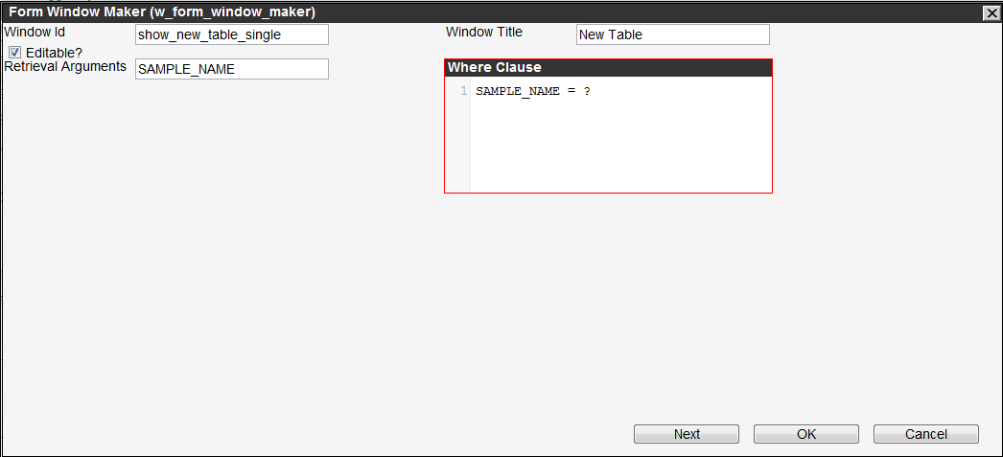
6. If the data in the window may be modified, click the Editable? check box to select it.
7. Enter the retrieval argument and, if necessary, the Where Clause that determines what data appears in the popup window.
8. Click OK to make the window.

Once the popup window is available, you need to configure the column that contains the hyperlink that will display the popup window. This is accomplished as follows:

1. Place the application in Design Mode by clicking the Design Mode checkbox in the left gutter.
2. Display the window that contains the column that will have the hyperlink.
3. Right-click the pane containing the column and then click Change Control Properties. The application displays the User Control Properties dialog box.
4. Click the Data Window tab.
5. In the lower pane of the tab, locate the column that will contain the hyperlink.

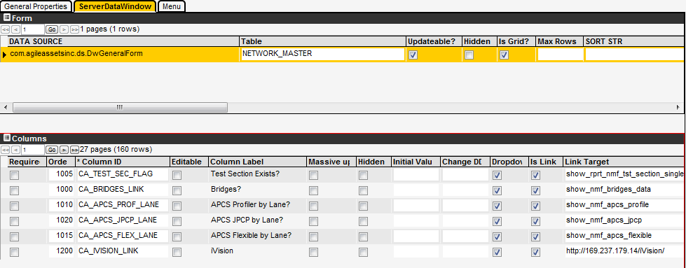

1. In the record showing the column, click the Is Link check box.
2. In the Target Window ID column, enter the popup window ID that you wrote down in the previous set of instructions.
3. In the Retrieval Args column, enter the argument for the data to be retrieved and passed to the popup window.
4. Click OK to close the dialog box.
5. Click the **icon_save** icon. The application asks if you wish to save the new layout.
6. Click OK to save the new layout.
7. Exit Design Mode by clicking the Design Mode check box in the left gutter.

### How to Make a Graph Window

Rather than create a window that displays data in a tabular format, you may also display data as a graph along a route (provided the underlying table in the database contains location information). This is accomplished as follows:

1. Display the Tables window (System > Utilities > Tables).
2. Locate the table for which you will create a window. Right-click the record showing the table and then Make Window. The application displays a new window. The default selection in the new window is to create a data window, not a graph window.
3. For the first option (Main), click the down arrow to display the list of types of windows and then click the Graph Along the Route Window entry.
4. Click Next. The application displays a second new window.
5. In the second dialog box, check that the window title is what you want. If necessary, modify the title as desired.
6. If the data in the window may be modified, click the Editable? check box to select it.
7. In the lower part of the dialog box, expand the menu hierarchy to locate the parent menu item under which the menu item to display the window will be placed.
8. Right-click the parent menu item and then click Add Branch. The application displays a new dialog box so you may enter the name of the menu item.
9. In the dialog box, in the New Menu ID field enter the internal ID for the menu item that will open the window. (This ID should be lower case and not contain spaces.) Also, in the New Menu Name field, enter the name of the menu item that will open the window.
10. Click OK to close the dialog box. A new node is added subordinate to the parent menu item.
11. Right-click the new node and then click Select This. The square beside the menu name is colored yellow to denote that it is selected.
12. Click OK to make the window.

### How to Create a List Table

Follow these steps to create a new table that contains data that will be used in a drop-down list:

1. Open the Tables window.
2. In the Tables tab, right-click and then click Insert. The application displays a dialog box.
3. For the purposes of this example, assume that the table does not yet exist in the database. Therefore, in the Insert dialog box click the radio button beside New.
4. Click the arrow for the drop-down list and then click Setup.
5. Enter the internal name of the new table in the text field in the lower part of the dialog box.  
   *Note: All list table names start with ‘SETUP\_\*. The system automatically enters this portion of the table name.*  
   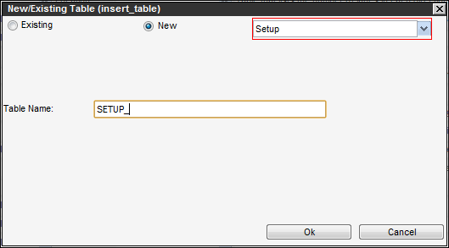
6. Click OK. The application closes the dialog box and adds a new record to the table. (The table is not actually created in the database at this point.)
7. In the new record, enter the displayed name of the new table in the Table Label column and, optionally, any additional information in the Comments column.
8. Click the Columns tab. This tab shows the default columns for any table (comments, user ID, and user update date).
9. Right-click the table in the Columns tab and then select the appropriate command: either Add New Column if the column does not exist in the database or Add Existing Column if the column does exist.
10. Repeat step 9 for each column.
11. If desired, click the Index tab and create an index for the table. See page 102 for more information on creating an index.
12. Click the Tables tab.
13. Right-click the record for the new table and then click Apply Changes. The application now creates the table in the database with the columns specified in the Columns tab.
14. Click the **icon_save** icon.

The table is now created. Next you will need to create the window for the display of data from the table.

### How to Create an Inventory Table

A table that contains inventory information for a particular asset type is handled differently than other types of tables. An inventory table is created in the Asset Types window. (The application also automatically creates a class codes table to categorize the items in inventory when the inventory table is created.)

*Note: Inventory tables are normally featured in the Maintenance Management System, however inventory tables were configured for the Caltrans culverts data in the PaveM system.*

Once this is accomplished, the names of the inventory and class codes tables will appear in the Tables window. You may then create windows to display the data from these tables along with supporting status and PM windows if desired.

The following steps describe how to create an inventory and other supporting windows:

1. Display the Asset Type window (System > Setup > Asset Type).
2. Find the record for the asset type corresponding to the inventory table to be created and enter the name of the inventory table in the Inventory Table Name field. Remember that the table name cannot exceed 30 characters and must end in \_INVENTORY.



1. Click the **icon_save** icon. The system creates records in the Tables window for the inventory and class codes tables. (The class codes table has the same prefix as the inventory table name and ends with \_CLASS\_CODE.)
2. Open the Tables window (System > Utilities > Tables).
3. In the Tables tab, locate the record for the **class codes table** for the asset type. Right-click this record and then click Apply Changes. The class codes table now exists in the database.
4. In the Tables tab, locate the record for the **inventory table** for the asset type. Right-click this record and then click Apply Changes. The inventory table now exists in the database.
5. Right-click the record for the inventory table and then click Make Window. The application displays a new window. The default selection in the dialog box is to create an inventory window.

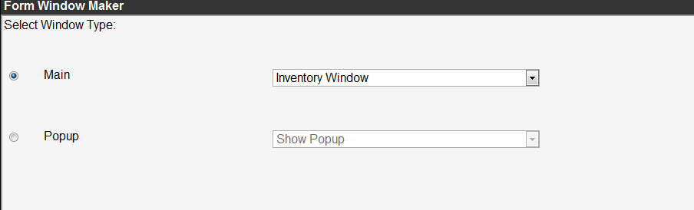

1. Since the inventory table option is already selected, just click Next. The application displays a second new window.
2. In the second new window, check that the window title is what you want. If necessary, modify the title as desired. (The Editable? check box is already selected as is appropriate.)  
   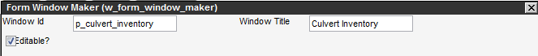
3. In the lower part of the dialog box, expand the menu hierarchy to locate the parent menu item under which a new menu item for all windows (inventory, class codes, status, etc.) associated with the asset type will be placed.
4. Right-click the parent menu item and then click Add Branch. The application displays a new dialog box so you may enter the name of the menu item.
5. In the dialog box, in the New Menu ID field enter the internal ID for the menu item under which the menu items to open all the windows associated with the asset type will appear. (This ID should be lower case and not contain spaces.) Also, in the New Menu Name field, enter the name of the menu item that will be displayed in the menu hierarchy.
6. Click OK to close the dialog box. A new node is added subordinate to the parent menu item you right-clicked in step 11. Note: The application automatically selects this node, so you will need to de-select it to continue.
7. Click the yellow square beside the name of the new menu item to de-select it.
8. Right-click the new menu item created in step 10 and then click Add Branch. The application displays a new dialog box so you may enter the name of the menu item that will display the inventory window for the asset type.

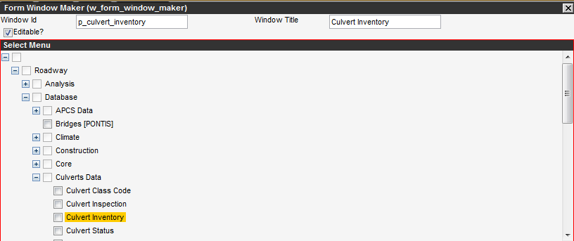

1. In the dialog box, in the New Menu ID field enter the internal ID for the menu item that will open the inventory window. (This ID should be lower case and not contain spaces.) Also, in the New Menu Name field, enter the name of the menu item that will be displayed in the menu hierarchy.
2. Click OK to close the dialog box. A new node is added subordinate to the menu item you right-clicked in step 14. This node is automatically selected, which is appropriate this time.
3. Click OK. The window and menu item for the display of the asset type's inventory is now created.
4. Now create a status window to categorize the items in inventory. To start, right-click the record for the inventory table and then click Make Window. The application displays a new window.
5. The Main radio button is already selected as required, so click the down arrow to display the list and then click Status Window.
6. Click the Next button. The application displays a second new window.
7. In the second new window, check that the window title is what you want. If necessary, modify the title as desired. (The Editable? check box is already selected as is appropriate.)
8. In the lower part of the dialog box, expand the menu hierarchy to locate the menu item created in step 12 under which all windows associated with the asset type will be placed.
9. Repeat steps 14 through 17. The Status window and menu item are now created.
10. If you would like to perform PM activities on items in inventory, you may create a PM by Inventory window and menu item as described in the following steps:
    1. Right-click the record for the inventory table and then click Make Window. The application displays a new window.
    2. The Main radio button is already selected as required, so click the down arrow to display the list and then click PM by Inventory.
    3. Click the Next button. The application displays a second new window.
    4. In the second new window, check that the window title is what you want. If necessary, modify the title as desired. (The Editable? check box is already selected as is appropriate.)
    5. In the lower part of the dialog box, expand the menu hierarchy to locate the menu item created in step 12 under which all windows associated with the asset type will be placed.
    6. Repeat steps 14 through 17. The PM by Inventory window and menu item are now created.
11. In various windows of the application, you may select a portion of a map and display information for items of a selected asset type that fall within the selected area. If you would like to have this capability for this particular asset type, perform the following steps:
    1. Right-click the record for the inventory table and then click Make Window. The application displays a new window.
    2. Click the Popup radio button. The Popup list field is activated.
    3. Click the down arrow to display the list and then click Inventory Popup.
    4. Click the Next button. The application displays a second new window.
    5. In the second new window, check that the displayed information is correct. Modify or add any information that is needed.
    6. Click OK to complete the process.
12. You now need to create the window and menu item to display the information in the class codes table that is associated with this asset type's inventory. Locate the record for the class codes table, right-click this record, and then click Make Window. The application displays a new window. The default selection in the dialog box is to create a class codes window.
13. Since the class codes table option is already selected, just click Next. The application displays a second new window.
14. In the second new window, check that the window title is what you want. If necessary, modify the title as desired. (The Editable? check box is already selected as is appropriate.)
15. In the lower part of the dialog box, expand the menu hierarchy to locate the menu item created in step 12 under which all windows associated with the asset type will be placed.
16. Right-click the menu item and then click Add Branch. The application displays a new dialog box so you may enter the name of the menu item that will display the class codes window.
17. In the dialog box, in the New Menu ID field enter the internal ID for the menu item that will open the class codes window. (This ID should be lower case and not contain spaces.) Also, in the New Menu Name field, enter the name of the menu item that will be displayed in the menu hierarchy.
18. Click OK to close the dialog box. A new node is added subordinate to the menu item you right-clicked. This node is automatically selected, which is appropriate.
19. Click OK. The window and menu item for the display of the asset type's class codes is now created.
20. If you would like to perform PM activities on items in inventory by utilizing class codes, you may create a PM by Class Codes window and menu item as described in the following steps:
    1. Right-click the record for the class codes table and then click Make Window. The application displays a new window.
    2. The Main radio button is already selected as required, so click the down arrow to display the list and then click PM by Class Code.
    3. Click the Next button. The application displays a second new window.
    4. Repeat steps 28 through 33. The PM by Class Code window and menu item are now created.

The process for creating inventory and associated windows and menu items is now complete.

### How to Create a Generic Table

A generic table is not a table with location data, nor is it a table that contains a list used for setup, nor does it contain inventory data. To create this type of table, follow these steps:

1. Open the Tables window.
2. In the Tables tab, right-click and then click Insert. The application displays a dialog box.
3. For the purposes of this example, assume that the table does not yet exist in the database. Therefore, in the Insert dialog box click the radio button beside New.
4. Click the arrow for the drop-down list and then click General.
5. Enter the internal name of the new table in the text field in the lower part of the dialog box.
6. Click OK. The application closes the dialog box and adds a new record to the table. (The table is not actually created in the database at this point.)
7. In the new record, enter the displayed name of the new table in the Table Label column and, optionally, any additional information in the Comments column.
8. Click the Columns tab. This tab shows the default columns for any table (comments, user ID, and user update date).
9. Right-click the table in the Columns tab and then select the appropriate command: either Add New Column if the column does not exist in the database or Add Existing Column if the column does exist. See the following two sections for more information on adding columns.
10. Repeat step 9 for each column.
11. If desired, click the Index tab and create an index for the table. See page 102 for more information on creating an index.
12. Click the Tables tab.
13. Right-click the record for the new table and then click Apply Changes. The application now creates the table in the database with the columns specified in the Columns tab.
14. Click the **icon_save** icon.

The table is now created. Next you will need to create the window for the display of data from the table.

### How to Add a New Column to a Table

During the creation of a new table, or the modification of an existing table, you may add a new column as follows:

1. Open the Tables window.
2. In the Tables tab, click the record for the table into which the column will be added to select it.
3. Click the Columns tab.
4. In the Columns tab, right-click and then click Add New Column. The system displays the first of two dialog boxes to create the new column.
5. Complete the fields of the first dialog box as appropriate. Remember that the convention for the column ID is that it is in upper case and ends in \_ID.
6. Click OK. The system displays the second dialog box.
7. Complete the fields of the second dialog box to configure the column as desired.
8. Click OK. The system checks whether the ID exists. If it does exist, an error message will appear. If it does not exist, then a new record will be inserted into this pane.
9. Click the Tables tab.
10. In the Tables tab, right-click the selected table and then click Apply Changes. The system adds the column to the table.
11. Click the **icon_save** icon.

### How to Add an Existing Column to a Table

During the creation of a new table, or the modification of an existing table, you may add an existing column as follows:

1. Open the Tables window.
2. In the Tables tab, click the record for the table into which the column will be added to select it.
3. Click the Columns tab.
4. In the Columns tab, right-click and then click Add Existing Column. The system displays a dialog box to enter the ID of the column.

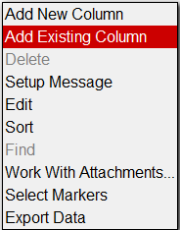

1. In the dialog box, type the column's ID. You need to know the exact spelling of the ID and must match its case (see the Columns window for the list of existing columns and what type of column each is). Note that the column may be a drop-down list created in the Manage List Columns window.
2. Click OK. The system checks whether the ID exists. If it does not, an error message will appear. If it does exist, then a new record will be inserted into this pane.
3. Click the Tables tab.
4. In the Tables tab, right-click the selected table and then click Apply Changes. The system adds the column to the table.
5. Click the **icon_save** icon.

### How to Create an Index for the Table

Follow these steps to create an index for a table created with the Tables window:

1. Open the Tables window.
2. In the Tables tab, select the desired table by clicking the record for the table.
3. Click the Indexes tab.
4. In the Indexes pane, right-click and then click Insert. The application displays a dialog box.
5. In the dialog box, enter the name of the new index and then click OK. The application closes the dialog box and adds a new record to the pane.
6. In the Available Columns pane, select the column to be used for indexing by clicking the record showing the column.
7. Click the right-pointing arrow between the two lower panes to move the selected column to the Index Columns pane.
8. Repeat steps 6 and 7 for any additional columns to be used for indexing.
9. When all desired columns are shown in the Index Columns pane, complete the Order column to indicate the relationship of the index columns to each other.
10. Click the Tables tab.
11. Right-click the record selected in step 2 and then click Apply Changes. The new index columns are now in force.

### How to Modify Column Definitions

A column can be modified in either the Columns window (System > Utilities > Columns) or the Tables window (System > Utilities > Tables). The example below describes how to modify the column definition in the Tables window:

1. Open the Tables window.
2. In the Tables tab, click the record for the table for which the columns need to be modified.
3. Click the Columns tab.
4. In the Columns tab, right-click the record for the column and then click Edit. The application displays a dialog box where the column name and right to see/edit can be updated. Click Next to view/edit the second page of the dialog box where the column type can be updated as described in 6.1 Columns.
5. Open the window that shows the data from the table.
6. In the Tables tab, Right-click the record for the table and then click Apply Changes. The system updates the table with any changes to the column definition.
7. Click the icon_save icon.

### How to Change the Order of Columns

Note: If a table is created from a DW\_ procedure, the order of the columns cannot be modified. Also, the order of the constituent columns of the LOC\_IDENT column are set in the LRM window (System > LRS & GIS > Setup Location Reference Methods (LRMs)).

The columns in the data window for a data table appear in the order specified in the Order column of the Data Window tab of the User Control Properties dialog box. Number 1 signifies the leftmost column and then increments to the right. To change the order in which the columns appear in a window, follow these steps:

1. Place the application in Design Mode by clicking the Design Mode checkbox in the left gutter.
2. Display the Tables window.
3. Right-click the record for the table that contains the columns to be re-ordered and then click Change Control Properties. The application displays the User Control Properties dialog box.
4. Click the Data Window tab.
5. In the lower pane of the tab, modify the values in the Order column to indicate the desired order.
6. Click OK to close the dialog box.
7. Click the icon_save icon. The application asks if you wish to save the new layout.
8. Click OK to save the new layout.
9. Exit Design Mode by clicking the Design Mode check box in the left gutter.

### How to Modify Update Source for Calculated Columns

To modify the SQL statement or any other information in a column, follow these steps below (which show how the update source SQL is updated):

1. Open the Tables window.
2. In the Tables pane, click the record for the table for which the columns need to be modified.
3. Click the Columns tab.
4. In the Columns tab, make the desired modifications to the calculation SQL in the UPDATE SOURCE column.
5. Click the icon_save icon.
6. Open the window that shows the data from the table.
7. Right-click and then click Update Target Table. The system then re-calculates any calculated columns using the new column definitions.

### How to Update When Source Data Changes

If the source data changes (for example, if survey data for a section data table is re-imported), the re-calculation of the values based on this data (for example, the indices based on the survey data) is not performed automatically. Instead, you must perform the re-calculation manually as described below:

1. Navigate to the window that shows the data from the data section table.
2. Right-click and then click Update Target Table. The system displays a dialog box so you may select what calculated columns you wish to update.

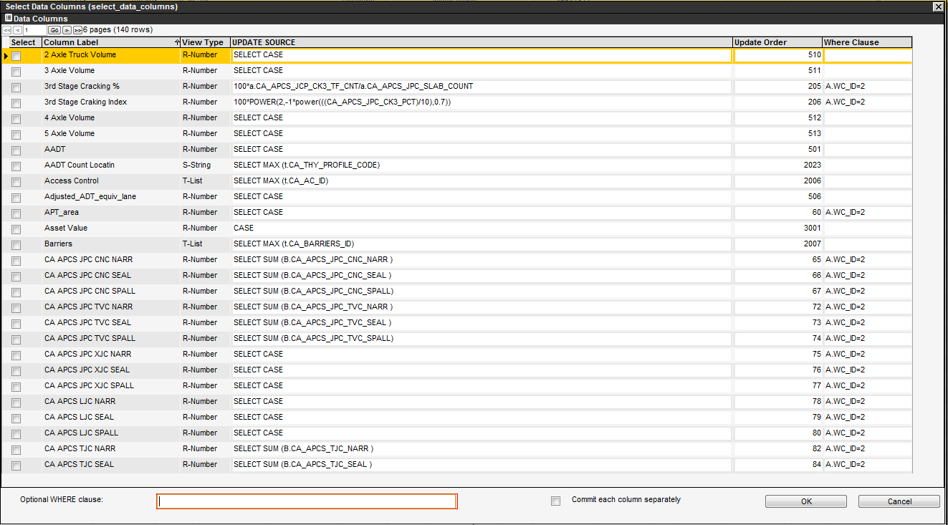

1. Click the check box for each calculated column you wish to re-calculate and then click OK. The system re-calculates the values of the specified columns.

Note: Use the Update Target Table command wisely. When this command is executed, it updates all the records for the selected column(s) in the table based on the conditions specified in the Update Source.

## Create the Import Procedure

Perform the following steps to setup the import:

1. Display the Tables window (*System > Utilities > Tables*)
2. Right-click on the identified target table. In this example the target table is PMS\_CA\_CORE, and click on Import Table Data.

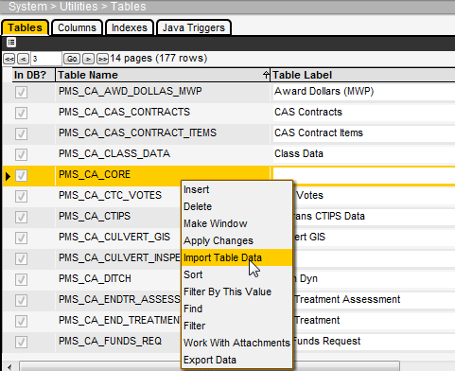

1. In the import config pop-up window, right-click on the Target Table pane (left pane) and select Insert.

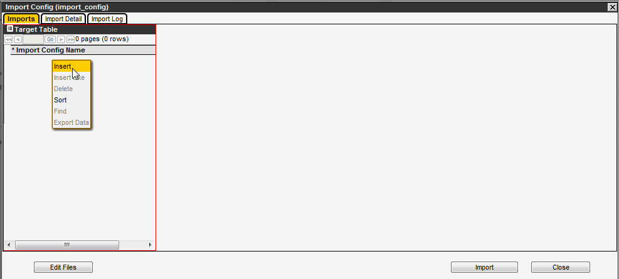

1. Specify the Import Config name as ‘import for test table’ in the newly create record (left pane)
2. Click on the Edit Files button on the bottom left corner of the pop-up window. This will open a pop-up window called File Browser.

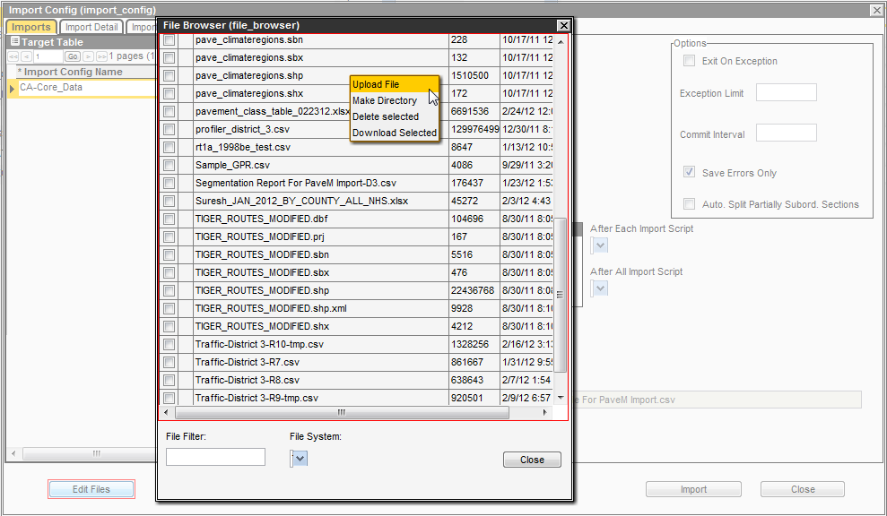

1. Upload the previously created “Big Core File for PaveM inport” file (.csv) in the share drive by doing a right-click and selecting Upload File in the right-click menu after the correct target folder being selected. Follow the steps on the screen to upload the file created in the previous section.
2. Once completed, click on the button Close to close the File Browser pop-up. This step is necessary to make the file available in the next step.
3. In the Import Config pop-up window, in the right pane, specify the following:
   1. Source Type: Comma Separated
   2. Check the Has Header check-box.

(This is important because the source file used in this example has a header row. Note: if the source file(s) does not contain any header row and the data starts from the first row in the source file, then the Has Header check-box will be left unchecked)

* 1. Select the Save Errors Only check box so that only records with errors will be in the “Import Log csv file.
  2. Select the Import Method as Replace. See screenshot below.

Note 1: The Import Method ‘Replace’ will first delete all the existing data in the target table and then import the data from the source file. And, the Import Method ‘Update’ is used if the purpose of the import is to edit (modify/change) the already existing records in the target table.

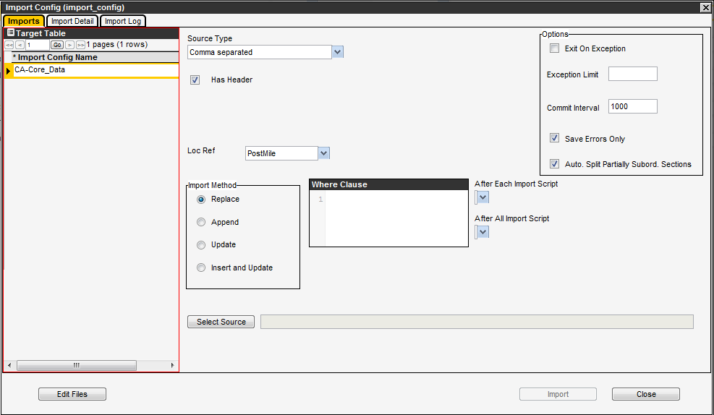

1. Click on the Select Source button in the right pane, then navigate to and select the file you uploaded in the share drive.

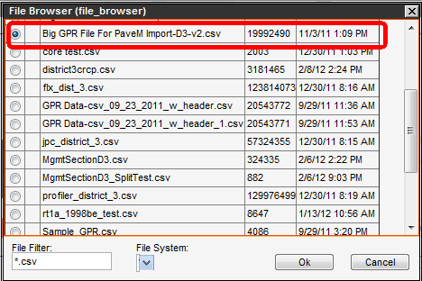

Then click OK on the File Browser pop-up box

Note 1: only the files of the type \*.csv will appear in the File Browser pop-up window, because this file type was selected in Step 8.a.

1. Click on the Import Detail tab in the Import Config pop-up window.

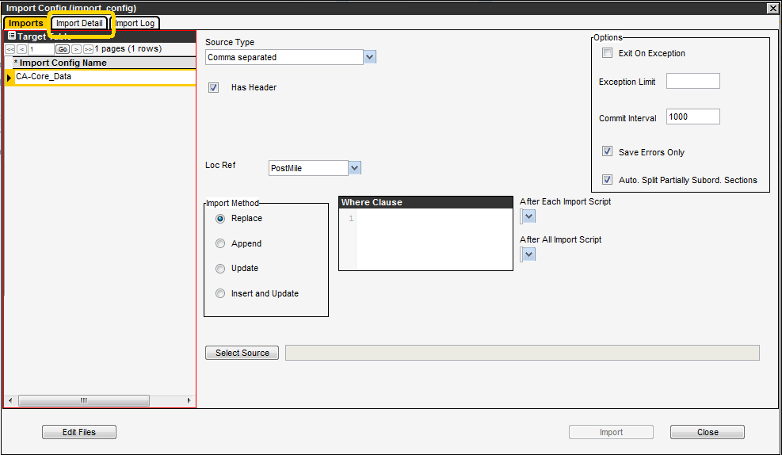

It is worth understanding at this point why the import mappings are necessary. In a source file, all the data is stored in string format. When this data is imported in the AgileAssets application, it needs to be converted into the correct format prior to the import. Because of this it is very important that proper import mapping is done between the source and target columns.

The columns from the source file are used as arguments in the mapping procedure. The AgileAssets application processes this argument and converts it into the correct readable format. This correct value (after conversion) is then placed in the respective field (also specified in the mapping process and referred to as target column) of the target table.

Various argument types are: (a) Source Column (b) Format (example: MM/dd/yy) and (c) A value (specified in the import mapping; no source column is used in this case)

The next five steps describe import mapping for the fields that will be used in the example under consideration.

1. Set import mapping for CA\_CORE\_FILENAME (Target Table).
   1. This mapping is done so that a valid CA\_CORE\_FILENAME is imported in the system. The mapping type used here checks sets the value in the source to the value in the target since no formatting change is needed.
   2. In the Import Detail tab, in the right-pane (Import Column Mapping) click in the Import Mapping Arg List column on the row where Target Column is CA\_CORE\_FILENAME. This will open the Argument List pop-up window.

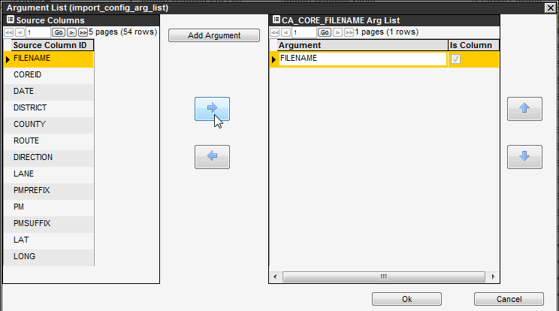

In the pop-up, highlight the FILENAME Source column in the left pane and move it to the Argument list in the right-pane using the arrows in the middle. (See image above). Then click OK.

* 1. This will close the Argument List pop-up window, and fill the Import Mapping Arg List field.
  2. Now select ‘General: set to column value’ as Import Mapping Script from the drop-down. See image below.

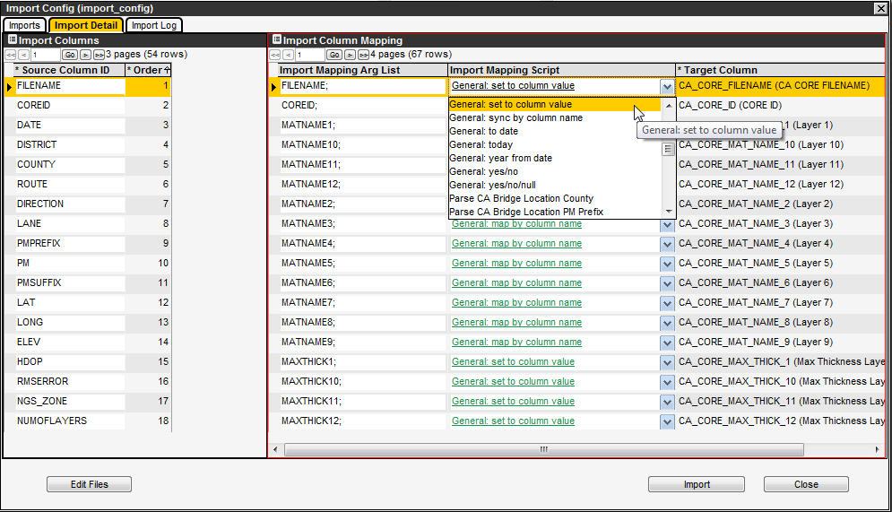

* 1. The import mapping for CA\_CORE\_FILENAME column is done.

1. Set Import Mapping Script for the other columns as shown in the table below.

| **Import Mapping Arg List** | **Import Mapping Script** | **Target Column** |
| --- | --- | --- |
| FILENAME; | General: set to column value | CA\_CORE\_FILENAME (CA CORE FILENAME) |
| COREID; | General: set to column value | CA\_CORE\_ID (CORE ID) |
| MATNAME1; | General: map by column name | CA\_CORE\_MAT\_NAME\_1 (Layer 1) |
| MATNAME10; | General: map by column name | CA\_CORE\_MAT\_NAME\_10 (Layer 10) |
| MATNAME11; | General: map by column name | CA\_CORE\_MAT\_NAME\_11 (Layer 11) |
| MATNAME12; | General: map by column name | CA\_CORE\_MAT\_NAME\_12 (Layer 12) |
| MATNAME2; | General: map by column name | CA\_CORE\_MAT\_NAME\_2 (Layer 2) |
| MATNAME3; | General: map by column name | CA\_CORE\_MAT\_NAME\_3 (Layer 3) |
| MATNAME4; | General: map by column name | CA\_CORE\_MAT\_NAME\_4 (Layer 4) |
| MATNAME5; | General: map by column name | CA\_CORE\_MAT\_NAME\_5 (Layer 5) |
| MATNAME6; | General: map by column name | CA\_CORE\_MAT\_NAME\_6 (Layer 6) |
| MATNAME7; | General: map by column name | CA\_CORE\_MAT\_NAME\_7 (Layer 7) |
| MATNAME8; | General: map by column name | CA\_CORE\_MAT\_NAME\_8 (Layer 8) |
| MATNAME9; | General: map by column name | CA\_CORE\_MAT\_NAME\_9 (Layer 9) |
| MAXTHICK1; | General: set to column value | CA\_CORE\_MAX\_THICK\_1 (Max Thickness Layer 1) |
| MAXTHICK10; | General: set to column value | CA\_CORE\_MAX\_THICK\_10 (Max Thickness Layer 10) |
| MAXTHICK11; | General: set to column value | CA\_CORE\_MAX\_THICK\_11 (Max Thickness Layer 11) |
| MAXTHICK12; | General: set to column value | CA\_CORE\_MAX\_THICK\_12 (Max Thickness Layer 12) |
| MAXTHICK2; | General: set to column value | CA\_CORE\_MAX\_THICK\_2 (Max Thickness Layer 2) |
| MAXTHICK3; | General: set to column value | CA\_CORE\_MAX\_THICK\_3 (Max Thickness Layer 3) |
| MAXTHICK4; | General: set to column value | CA\_CORE\_MAX\_THICK\_4 (Max Thickness Layer 4) |
| MAXTHICK5; | General: set to column value | CA\_CORE\_MAX\_THICK\_5 (Max Thickness Layer 5) |
| MAXTHICK6; | General: set to column value | CA\_CORE\_MAX\_THICK\_6 (Max Thickness Layer 6) |
| MAXTHICK7; | General: set to column value | CA\_CORE\_MAX\_THICK\_7 (Max Thickness Layer 7) |
| MAXTHICK8; | General: set to column value | CA\_CORE\_MAX\_THICK\_8 (Max Thickness Layer 8) |
| MAXTHICK9; | General: set to column value | CA\_CORE\_MAX\_THICK\_9 (Max Thickness Layer 9) |
| MINTHCK1; | General: set to column value | CA\_CORE\_MIN\_THICK\_1 (Min. Thickness Layer 1) |
| MINTHCK10; | General: set to column value | CA\_CORE\_MIN\_THICK\_10 (Min. Thickness Layer 10) |
| MINTHCK11; | General: set to column value | CA\_CORE\_MIN\_THICK\_11 (Min. Thickness Layer 11) |
| MINTHCK12; | General: set to column value | CA\_CORE\_MIN\_THICK\_12 (Min. Thickness Layer 12) |
| MINTHCK3; | General: set to column value | CA\_CORE\_MIN\_THICK\_2 (Min. Thickness Layer 2) |
| MINTHCK3; | General: set to column value | CA\_CORE\_MIN\_THICK\_3 (Min. Thickness Layer 3) |
| MINTHCK4; | General: set to column value | CA\_CORE\_MIN\_THICK\_4 (Min. Thickness Layer 4) |
| MINTHCK5; | General: set to column value | CA\_CORE\_MIN\_THICK\_5 (Min. Thickness Layer 5) |
| MINTHCK6; | General: set to column value | CA\_CORE\_MIN\_THICK\_6 (Min. Thickness Layer 6) |
| MINTHCK7; | General: set to column value | CA\_CORE\_MIN\_THICK\_7 (Min. Thickness Layer 7) |
| MINTHCK8; | General: set to column value | CA\_CORE\_MIN\_THICK\_8 (Min. Thickness Layer 8) |
| MINTHCK9; | General: set to column value | CA\_CORE\_MIN\_THICK\_9 (Min. Thickness Layer 9) |
| NUMOFLAYERS; | General: set to column value | CA\_CORE\_NUM\_LAYERS (NUM LAYERS) |
| RMSERROR; | General: set to column value | CA\_CORE\_RMS\_ERROR (RMS ERROR) |
| SETUP\_CA\_COUNTY;CA\_COUNTY\_ID;COUNTY;CA\_COUNTY\_ABBREV; | General: map by multiple | CA\_COUNTY\_FROM (County From) |
| SETUP\_CA\_COUNTY;CA\_COUNTY\_ID;COUNTY;CA\_COUNTY\_ABBREV; | General: map by multiple | CA\_COUNTY\_TO (County To) |
| DISTRICT; | General: set to column value | CA\_DISTRICT\_ID (District) |
| HDOP; | General: set to column value | CA\_HDOP (CA HDOP) |
| NGS\_ZONE; | General: set to column value | CA\_NGS\_ZONE (NGS ZONE) |
| PMPREFIX; | General: set to column value | CA\_PM\_PREFIX\_FROM (Post Mile Prefix From) |
| PMPREFIX; | General: set to column value | CA\_PM\_PREFIX\_TO (Post MilePrefix To) |
| PMSUFFIX; | General: set to column value | CA\_PM\_SUFFIX\_FROM (Post Mile Suffix From) |
| PMSUFFIX; | General: set to column value | CA\_PM\_SUFFIX\_TO (Post Mile Suffix To) |
| PM; | General: set to column value | CA\_POSTMILE\_BEG (PostMile begin) |
| PM; | General: set to column value | CA\_POSTMILE\_END (Post Mile End) |
| ROUTE; | Parse Ca Route and Rte Suffix | CA\_ROUTE\_FROM (Route From) |
| ROUTE; | Parse Ca Route and Rte Suffix | CA\_ROUTE\_TO (Route To) |
| ROUTE; | Parse Ca Route and Rte Suffix | CA\_RTE\_SUFFIX\_FROM (Route Suffix (From)) |
| ROUTE; | Parse Ca Route and Rte Suffix | CA\_RTE\_SUFFIX\_TO (Route Suffix (To)) |
|  |  | COMMENT\_ID (Att.) |
|  |  | COMMENT\_STR (Comments) |
|  |  | DATE\_UPDATE (Date Update) |
| DATE;MM/dd/yyyy; | General: to date | EFF\_DATE (Effective Date) |
| ELEV; | General: set to column value | ELEVATION (Elevation) |
| DIRECTION;"N";1;"E";1;"S";2;"W";2;1; | General: case statement | LANE\_DIR (Direction) |
| LANE; | General: set to column value | LANE\_ID (Lane) |
| LAT; | General: set to column value | LATITUDE (Latitude) |
| 1; | General: max loc\_ident | LOC\_IDENT (Location ID#) |
| LONG; | General: set to column value | LONGITUDE (Longitude) |
| 0; |  | PERPEN\_OFFSET (Offset) |

Note: The there are four arguments for the “General: map by multiple” Import Mapping Script 1) Table Name in the system with the data to be mapped to the target, 2) The column name to mapped to the target column, the field in the source to be used for the mapping and 4) the column in the table (1st argument) to which the source column (3rd argument) must match to return the value (2nd arg) that will be placed in the Target table column.

1. The import mapping for the core data table is done.
2. Now click on the Close button on the bottom right corner.
3. This will close the Import Config pop-up window.

### Test the import in Import Log

The import can be viewed in the Import Log. To test the import just created, do the following:

1. Go to the Table PMS\_CA\_CORE in the PaveM system. Right click and select **Import Table Data**
2. Then go to the Import Log tab.

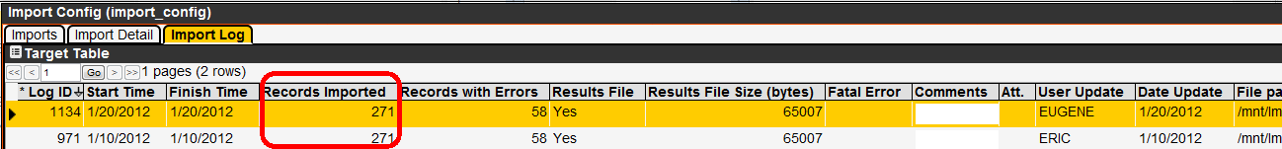

1. Now do a right-click in the Import Log tab and check for **Records Imported** and **Record with Errors**. If there are 0 errors then the data is imported successfully. If there are any errors present, those would be listed. If there are any errors, right-click and select Download File 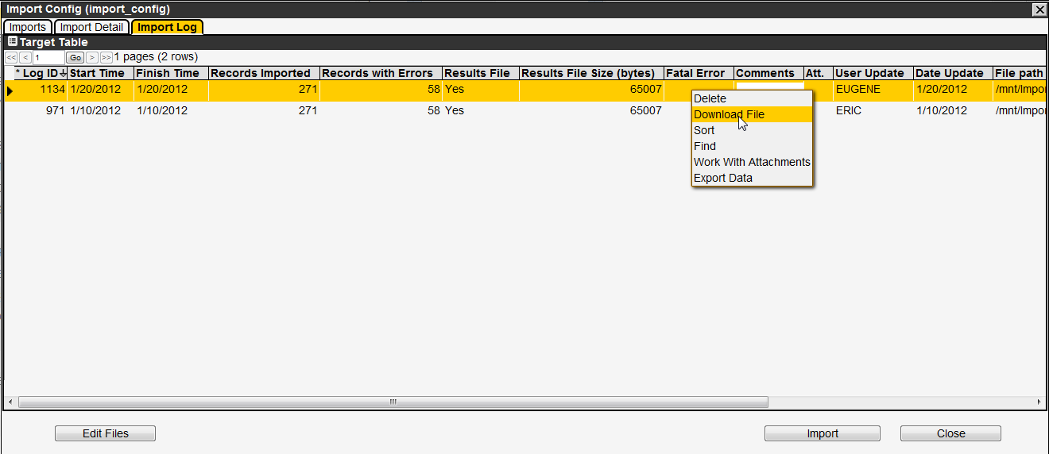
2. You can view the reason of the records which were not imported.

## Views

(System Module > Utilities > Views)

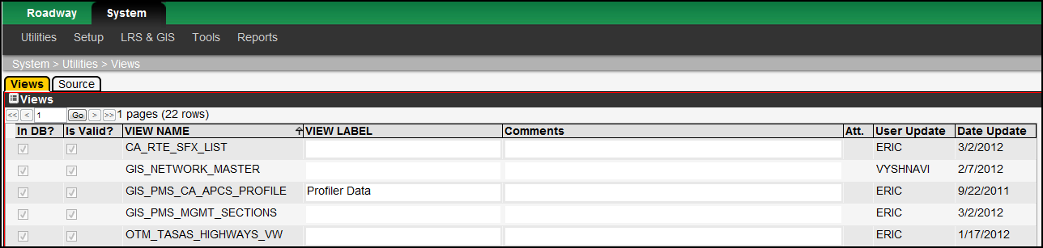

The Views window allows you to create and modify views, including editing the SQL used to create a view, and create windows to display a view's data. The Views window contains two tabs: Views and Source.

##### The Views Tab

The Views tab lists all views created in the application. A check mark in the In DB? column indicates that the view is part of the underlying database (which means the Apply Changes command has been executed at least once). A check mark in the Is Valid? column indicates that the SQL is valid. These check boxes cannot be updated manually and, instead, are automatically updated after the Apply Changes command is executed.

This tab also provides a right-click shortcut menu. This menu contains the common commands along with the Make Window command. The Make Window command creates a window that displays the view's data.

Note: The menu item that allows you to display the window for the view must be created (in the Menus window of the System module) before selecting the Make Window command.

##### The Source Tab

For the view selected in the Views tab, this tab provides the SQL that generates the view.

This tab also provides a right-click shortcut menu with one command: Apply Changes. After modifying the SQL, this command applies the changes to the database.

### How to Create a View

To create a view, follow these steps:

1. Display the Views window (System > Utilities > Views).
2. In the Views tab, right-click and then click Insert. The application displays a dialog box so you may enter the internal name of the view.
3. Type the name of the view in the dialog box. The convention for names is all upper case, no spaces.
4. Click OK. The application closes the dialog box and inserts a new record in the Views tab.
5. In the new record, optionally enter a display name for the view and any comments.
6. Click the Source tab.
7. In the Source tab, enter the SQL that will produce the view.
8. Right-click the tab and then click Apply Changes. The application checks the SQL and, if valid, adds the view to the database. The view is now created.

### How to Make a View Window

The first task in creating a window to display data from a view is to create the menu item that a user will select to display the window. This is accomplished as follows:

1. Display the Menus window (System > Utilities > Menus).
2. In the upper left pane, find the record for the module in which the menu item will appear and then click the record to select it. After selecting the module, the application displays the menu hierarchy for the module in the lower left pane.
3. In the lower left pane, if necessary expand the hierarchy to display the parent menu item under which the new menu item will be placed.
4. Right-click the parent menu item and then click Add Branch in the shortcut menu that is displayed. The application displays a dialog box so you may enter the name of the new menu item.
5. In the dialog box, type the name of the new menu item.
6. Click OK. The application closes the dialog box and adds a new node under the parent menu item as well as a new record in the table in the right pane.
7. Click the icon_save icon to save the new menu item.

The menu item that will display the window now exists. You may now create the window that will display the data in a view as described in the following steps:

1. Display the Views window (System > Utilities > Views).
2. Locate the view for which you will create a window. Right-click the record showing the view and then Make Window. The application displays a dialog box. The default selection in the dialog box is to create a data window, which is the goal of this example.
3. Since the data table option is already selected, just click Next. The application displays a second dialog box.
4. In the second dialog box, check that the window title is what you want. If necessary, modify the title as desired.
5. If the data in the window may be modified, click the Editable? check box to select it.
6. In the lower part of the dialog box, expand the menu hierarchy to locate the menu item that a user will select to display the window. Click the check box beside the name of the menu item to select it.
7. Click OK to make the window.

### Configuring Views for Generating Reports

Once views exist in the database, you may specify what views serve as the basis for reports. (Tables may also be similarly configured.) This is accomplished in the Module Reports Table window (System > Setup > Reporting Tables and Views), which is found in the Utilities menu of the System module. An example of this window is shown on the following page.

In this window, you insert a record by right-clicking and then clicking Insert. In the new record, select the module from the drop-down list and then select the view from the second drop-down list. Click the icon_save icon to save the new information. The configured view will then appear in the Selection tab of the reports window in the designated module where the name is “New Report from <View Name>.”

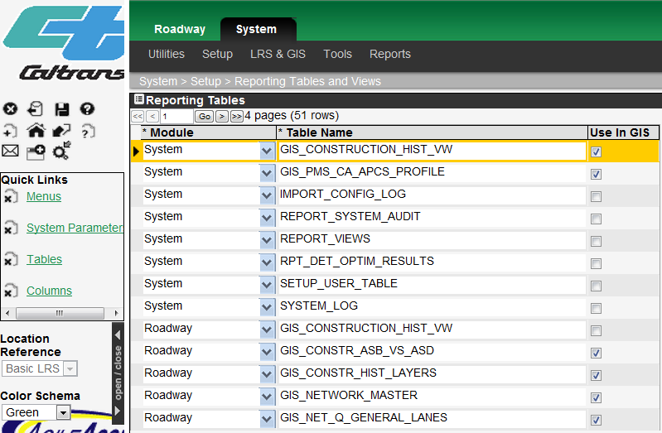

#### Window-based Jasper Reports

The system allows the administrator to configure window based Jasper Reports for any given window within the system. This configuration is currently done in back end of the application. First the desired Jasper Report should be created and tested externally to the application and then uploaded into the list of available Jasper Reports. Then the following procedure is used to add the report to a specific window:

1. Find the report ID in the SETUP\_WEB\_REPORT (after you have added the report in any of the Jasper Report windows).
2. In the database (using an editor or by developing an SQL script) insert a new row into the WEB\_WINDOWS\_REPORT table, edit the columns as follows:
   1. Window ID enter the window identifier of the window where the report will appear (may be found in the web\_windows\_objects table)
   2. Object ID is the object where the command should appear within the window. Remember that many windows within the system have multiple panes again may be found in web\_windows\_objects.
   3. Report ID is the report number in SETUP\_WEB\_REPORT
   4. Parameters – semi-colon delimited list of values to be passed to the report. If the values are to be parametric (that is related to the row the user clicks upon) the values should be COLUMN\_ID values from the row within the current data pane.

Note: Window based reports must take all the required input parameters from the data pane from which it is called. Window Based Jasper Reports do not prompt the user for information.